Export the bookings you are looking at
Turn the management calendar's bookings into a spreadsheet: pick a period from a named range, choose the columns — organizer, host, check-in times, your own form fields — see the sheet before you commit, and download it as XLSX, XLS or CSV.
2026-09-23 · https://offision.com/help/en/booking/export-the-bookings-on-the-calendar/
The analytics pages answer questions about bookings. This one hands you the
bookings themselves — one row each, the columns you choose — for the finance
system, the facilities meeting, or somebody who simply wants a list.
Before you start:
Read access to booking management. The file covers the resources the calendar is
showing you, so filter the calendar first if you want less than all of them.

1. Open Export
Export sits on the calendar header, beside the view menu.
Where in Offision: admin app → booking/calendar (Management calendar)
The dialog has your choices down the left and a live sheet on the right — the
real columns, with real rows in them, redrawn as you change your mind.
There is a second way in. Search the calendar
and an Export appears beside the result count, opening the same dialog with
your period, your keyword, your resources and your statuses already applied.
One chip does not travel: Organizer. A file taken with an organizer picked
is wider than the list you were looking at, so narrow by organizer in the
spreadsheet rather than expecting the export to have done it.
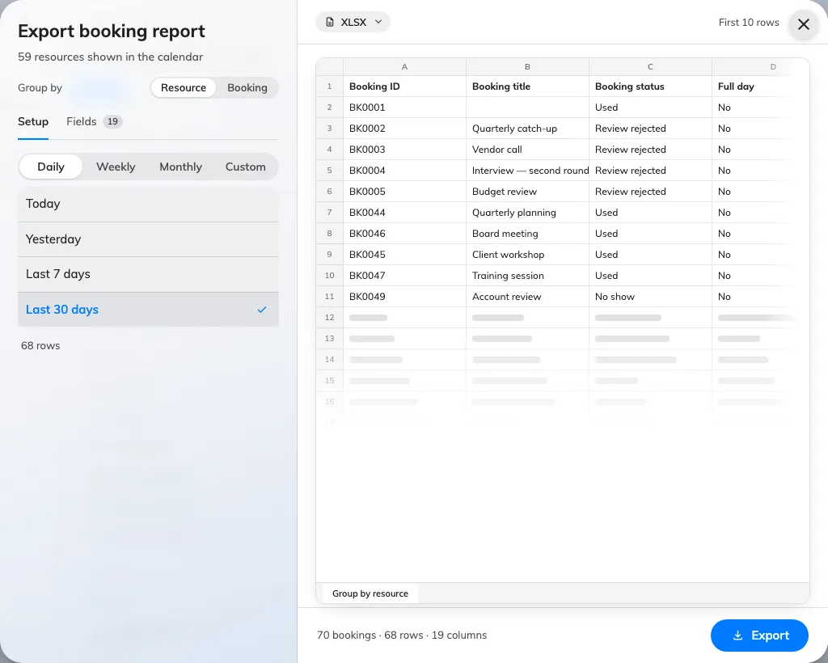
Export booking report: choices on the left, the sheet they produce on the right.

2. Choose what a row is
Group by at the top decides the shape of the file, and with it which columns
are on offer:
- Resource — one row per resource per booking. A meeting holding three rooms
is three rows. This is the one for room-by-room reporting.
- Booking — one row per booking, however many resources it holds, with
Number of resources and Resources columns in place of the single
resource, floor and building.

3. Choose the period
Pick the grain first — Daily, Weekly, Monthly, Quarterly or
Custom — and the named ranges under it narrow to the ones that make sense:
Grain | Ranges
Daily | Today, Yesterday, Last 7 days, Last 30 days
Weekly | This week, Last week, Next week
Monthly | This month, Last month, Next month
Quarterly | This quarter, Last quarter, Next quarter — calendar quarters, January to March and so on
Custom | Custom range, two dates of your own

Both directions are offered on purpose: the same dialog reports on what happened
and hands somebody a list of what is coming.
The limit is rows, not months:
There is no cap on the period. What is capped is the size of the file, and the
dialog counts it for you: under whichever range you pick it reports how many rows
the sheet would hold, recounted whenever you change the grouping. Past 50,000 it
says large file and still downloads. Past 200,000 it refuses, and the sheet on
the right is replaced by a panel telling you to shorten the period or turn fields
off. The refusal is enforced on the server too, so it cannot be talked round.

4. Choose the columns
Fields lists every column, grouped: Booking, Resource, Time,
Check-in, Organizer, Host, Attendees, and Form fields for the
extra questions your own booking form asks. Each has a switch, and the sub-line
counts how many of the total are on.
Drag a row to reorder it — the sheet is written in the order you leave them in.
Default puts the selection back; All turns everything on.
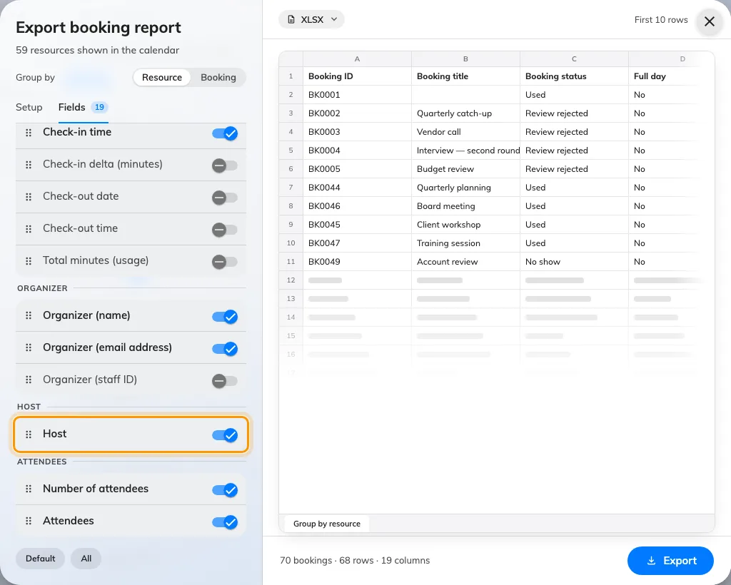
The Host column, in a group of its own between Organizer and Attendees.
Some useful columns start switched off, because most files do not want them:
Organizer (staff ID), Check-in delta (minutes), Check-out date and
time, Total minutes (usage), Notes and Series ID.
Host is not the organizer:
Host is its own column and its own idea: the attendees flagged as hosts on
the booking, by name, several separated by /. The organizer is included when
they are also a host — which they are by default on most forms — so the column is
rarely blank. Attendees still lists everybody, hosts and organizer included,
so Number of attendees is not a count of guests.
A faster way to drop a column you can see: click its header in the sheet on the
right.

5. Pick the format and export
The format chip sits on the sheet itself — XLSX, XLS or CSV. The
footer counts what you are about to get, as bookings and as columns. Export
downloads it.
XLS carries a ceiling of its own: the old sheet format holds 65,535 rows, so a
bigger export is refused up front and asks you to choose XLSX instead.
Your column choice and order are remembered, per grouping, so the next export of
the same shape opens the way you left it.

What this does not cover
- A feed. This is a file somebody downloads, not an integration. To keep a
reporting tool in step, see
Get booking and usage data into your BI tool.
- A whole round trip. The columns here are a report's, not the import
template's, so an exported sheet cannot simply be fed back in. The exception is
Series ID, which deliberately carries the import sheet's own header so a
repeating booking can be exported, edited and imported again — see
Import bookings from a spreadsheet.
- Rates and rankings. Usage rates, no-show rankings and heat maps are the
reporting pages' job — see
Which report answers which question.
- Visits. Visitor invitations export from their own calendar — see
Export the visits you are looking at.

