Combine two rooms into one bookable room
Set up a room that is really two or three adjoining rooms with the partition open, so people can book the whole space in one go. Booking the combined room takes its parts with it, and booking a part makes the combined room unavailable.
2026-08-18 · https://offision.com/help/en/booking/combine-rooms-into-one/
A ballroom that divides into three. Two meeting rooms with a folding wall
between them. A training suite that opens up for the quarterly all-hands — the
same problem every time: people need to book the big space sometimes and one
end of it the rest of the time, and the two must not be bookable at once.
A combine room is how Offision holds that. It is an ordinary room in every
respect but one: instead of standing on its own, it is made of other rooms. Book
it and a booking lands in each of its parts. Book a part and the combined room
goes unavailable, because half of it is now somebody else's.
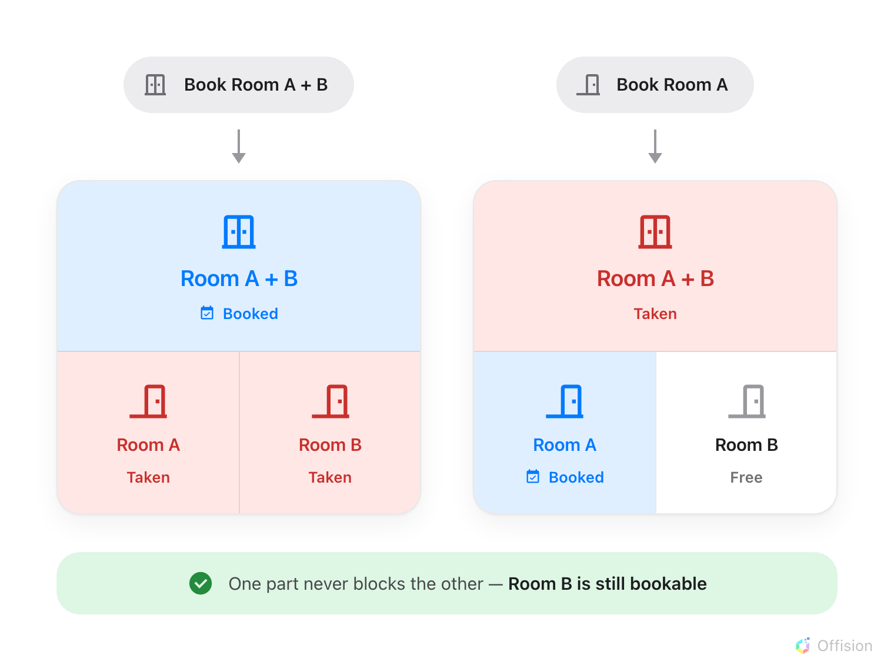
Booking either end takes the other with it. One part never takes its sibling.
That last part is the rule people get wrong: the parts do not block each
other. Room A and Room B can be booked by two different teams at the same
time. All that happens is that nobody can have the whole thing while either is
in use, which is exactly how a folding wall behaves.
Before you start:
You need booking management access, and the rooms it will be made of must
already exist — see Add a room.

1. Open Combine rooms
Where in Offision: admin app → booking/combine-room (Combine rooms)
It sits under Rooms in the booking menu, beside the ordinary Rooms page,
and it is not pinned by default — which is the usual reason people conclude the
feature is missing.
The list looks like the rooms list with one column added: Combine, naming
the rooms each row is made of. There is no Import button and no menu behind
Add, because a combined room is always assembled by hand.
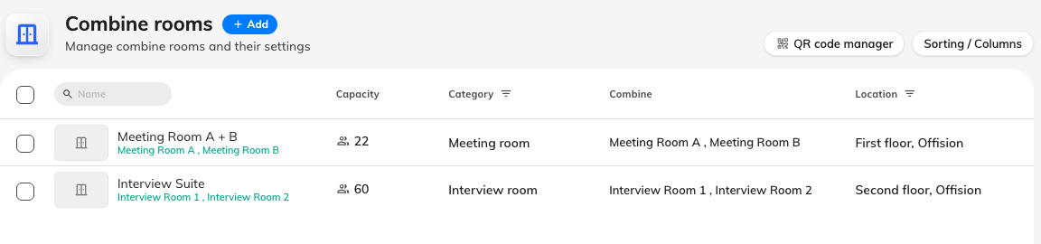
One row per combined room, with the rooms it is made of named in the Combine column.

2. Name it, and pick the rooms it is made of
Add opens the resource form on its Basic page. Name it for the space
people will ask for — Ballroom, Meeting Room A + B — and not after the
mechanism; nobody books a "combine room".
Under the name is the one field this form has that the ordinary room form has
not: Combine. Pick two or more rooms. It is required, and it is the whole
point of the record.
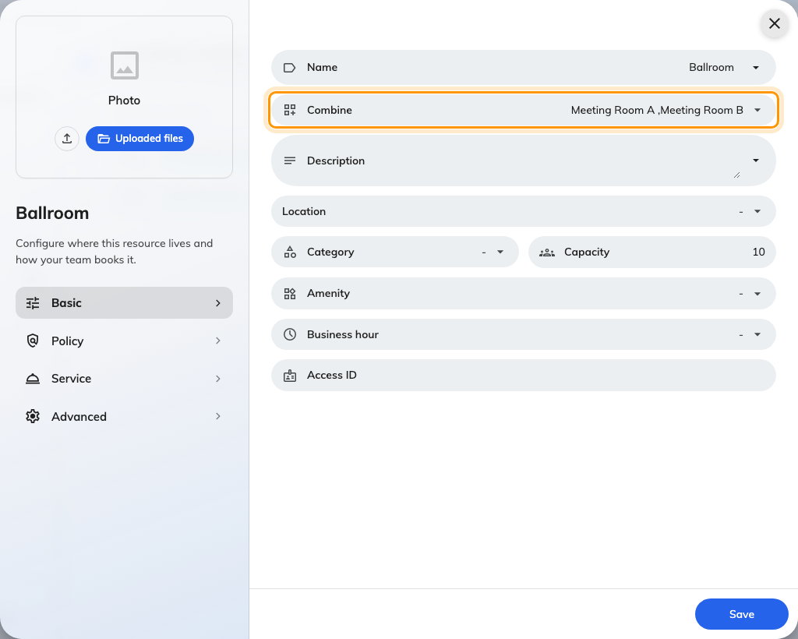
Basic, with Combine under the name — the only field an ordinary room does not have.
The picker offers ordinary rooms only. A combined room cannot be built from
another combined room, and a room that is assigned rather than booked is not
offered either.
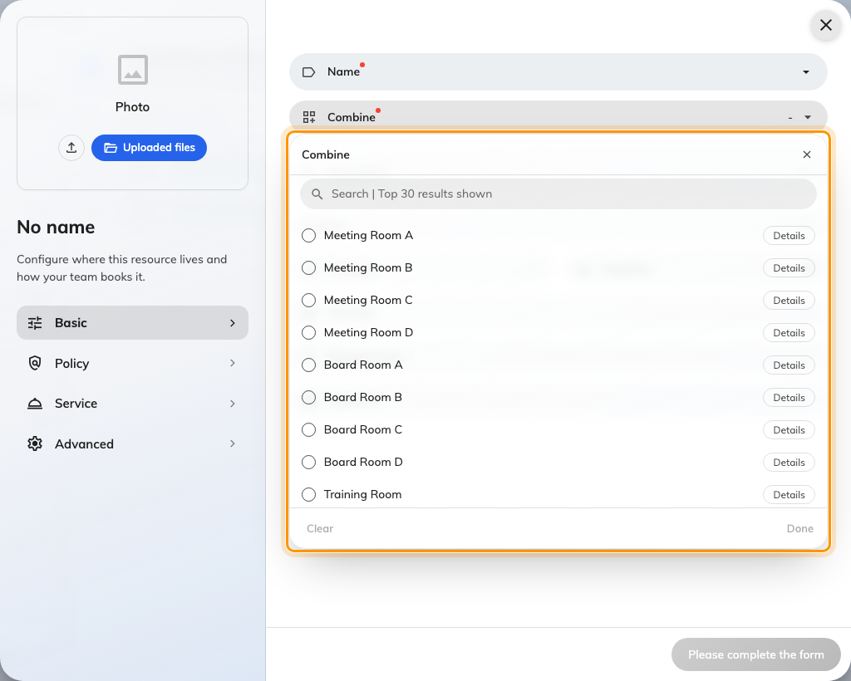
Only ordinary rooms are on offer — combined rooms are not in the list.
Note:
If the rooms you pick are synchronised from different calendar systems, the form
refuses them: Contain resources are not allow using different calendar
integrations. A combined room and its parts have to live on one calendar,
because one booking has to reach all of them.

3. Fill in the rest as an ordinary room
Everything below Combine is the normal resource form, and the combined room
carries its own answers rather than inheriting them from its parts.
Capacity is not added up for you. Two rooms of ten are rarely a room of
twenty once the wall is folded away and the chairs are re-laid — put in the
number the space genuinely seats, because that is what people filter on.
Give it a Location so it appears on the right floor. It gets no pin on the
floor plan: a room that is really three rooms has no one place to sit, and the
parts are already drawn there.
The Category, Amenities, booking policy and business hours are all set
here too, and none of them come from the parts. A combined room that should be
found under Event space has to be put there itself.
Note:
A combined room needs no resource licence of its own and consumes no monthly
quota — both are charged to the parts, which are the rooms actually being used.
For the same reason it reports no usage figure in the resource list.

4. Check it worked
Book the combined room for an hour in the Offision app, then open one of its
parts on the resource calendar. You should find that hour blocked there, marked
Combined. That single test proves the record, the links and the direction
that matters most — one booking reaching every part.

What people see
Once it exists, the combined room behaves like any other room in the pickers and
lists, marked with a Combine room badge. What is new is on the calendars.
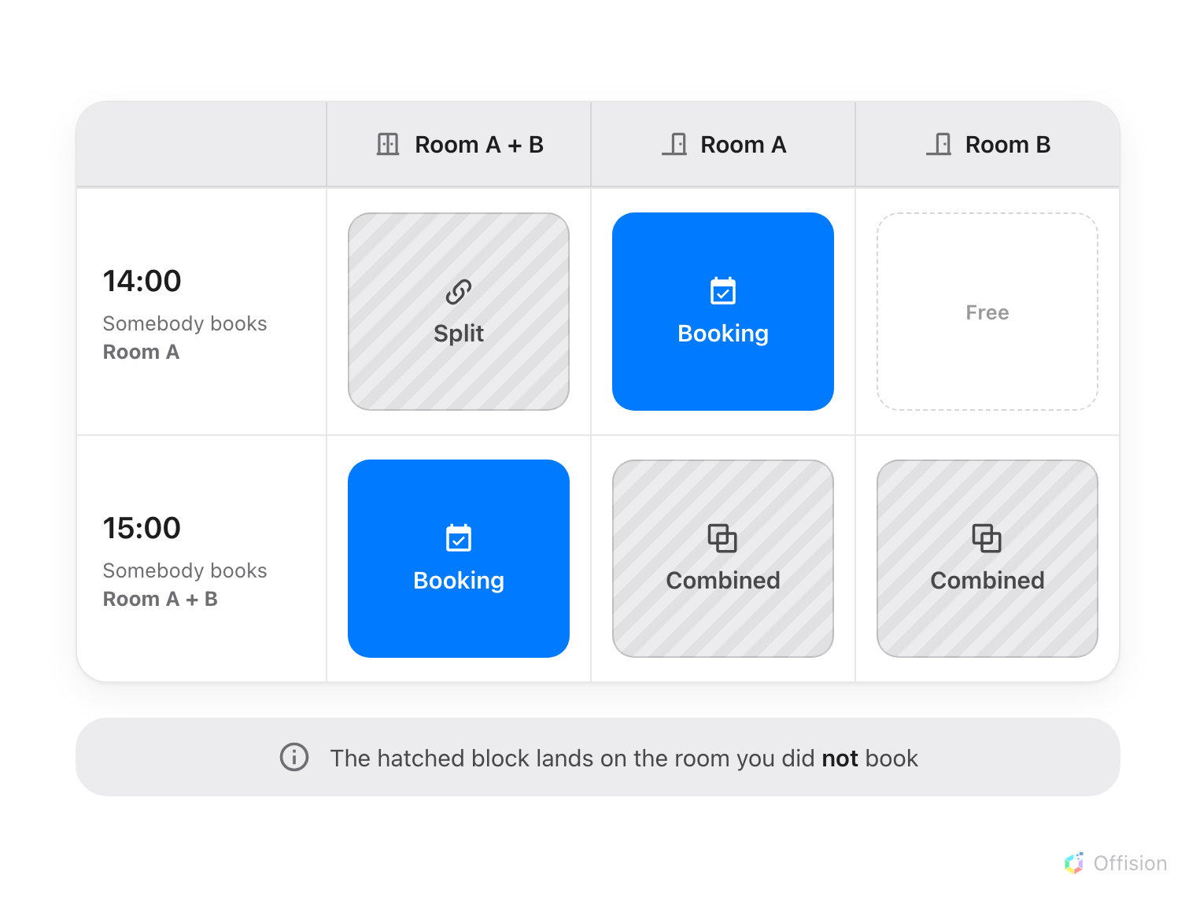
Which column the hatched block lands on tells you which end was booked.
Two hatched blocks, and the label says which way round it is:
Block | Where it appears | What it means
Split | on the combined room | One of its parts is booked, so the whole space is not available
Combined | on a part | The combined room is booked, so this part is spoken for

Neither is a booking. They cannot be opened, dragged or resized, and clicking
one does nothing — they are the consequence of a booking somewhere else. Each
carries the subject of that booking and the name of the room it happened in, so
somebody staring at an apparently busy room can see exactly where the time went
and who to ask.
The combined room also announces itself in the column header, with a Combine
tag beside its name.
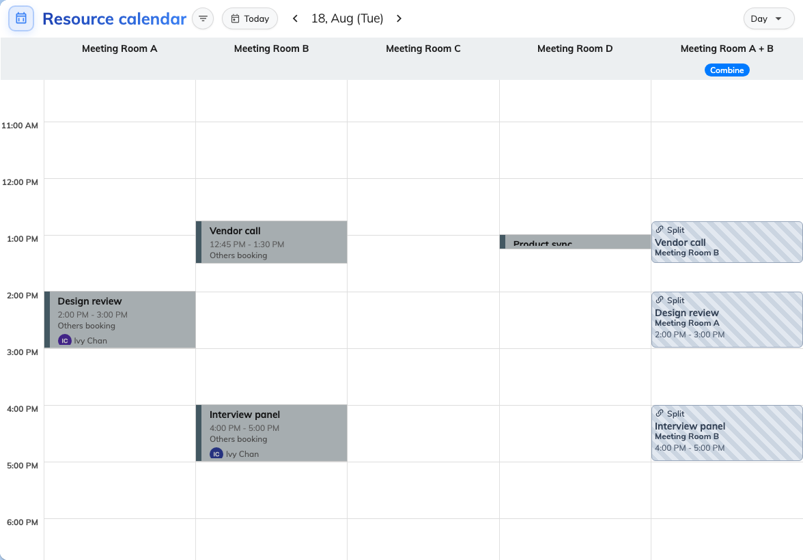
The combined room and both its parts, side by side: a Split block, a real booking, and two Combined blocks.
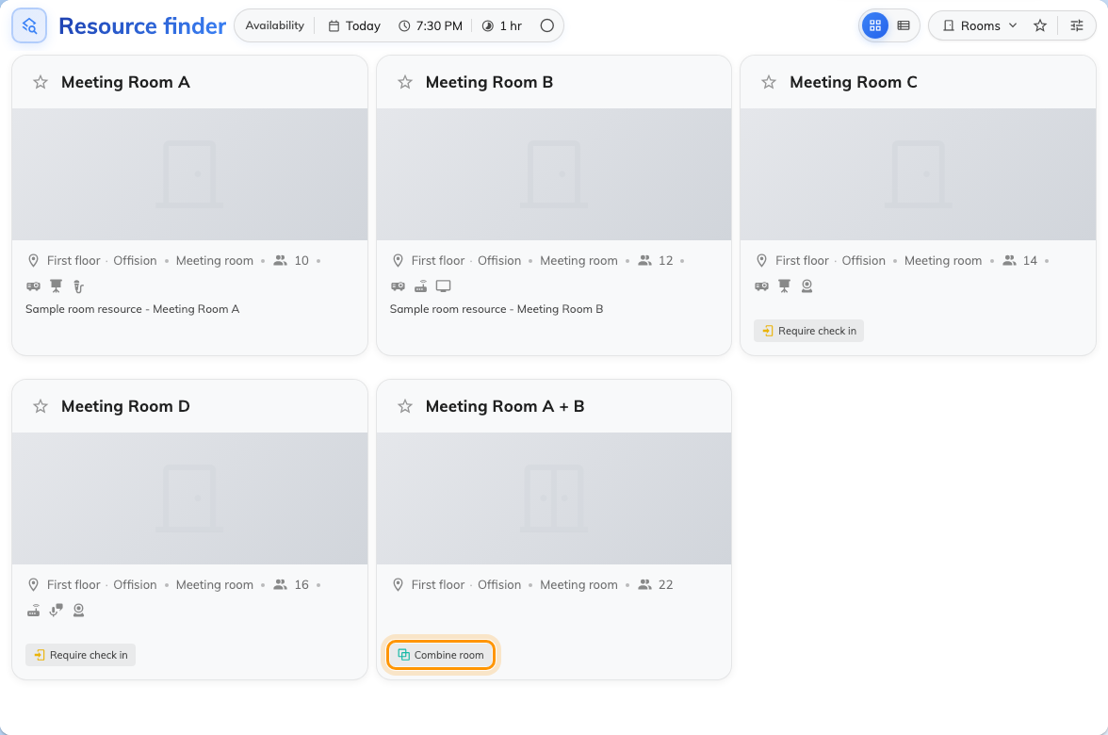
In the room list, a combined room carries its own badge.
Where a tenant has combined rooms, a Combine / Single filter appears beside
the other room filters — in the room list, on the home resource calendar and in
the booking form. It is the quick way to say show me only the big spaces, or
to get them out of the way when they are cluttering a search.
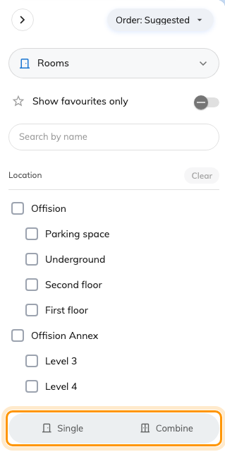
Combine / Single — shown only on tenants that actually have a combined room.
The same mark follows it into the booking form's room picker, where it is the
one thing distinguishing the whole space from the rooms it is made of — all
three are in the list, under similar names.
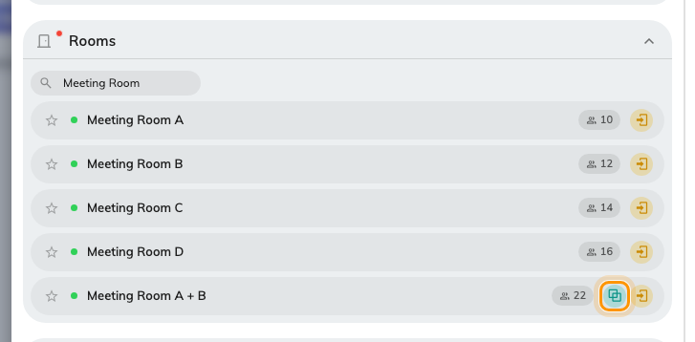
In the picker the mark is on its own, without the wording — hover it and it says Combine room.

What this does not control
Nothing is inherited from the parts. Capacity, category, amenities, the
booking policy, business hours and approval are all set on the combined room
itself. Changing a part later does not change the whole.
The parts stay independently bookable. Combining rooms does not stop two
teams taking Room A and Room B at the same time — it only stops either of them
being taken while the whole space is booked.
One booking cannot hold both ends. Choose the combined room and its parts
disappear from the picker; choose a part and the combined room disappears. There
is no way to book Room A + B and Room A together, and nothing to gain from it —
the first already includes the second.
A part cannot change type. While a room belongs to a combined room, Offision
refuses to turn it into a desk or anything else: Cannot change since it is
linked with a combined resource. Take it out of the Combine field first.
This is not how you group rooms for browsing. If you only want people to
find the rooms on floor 3 or the rooms with a projector together, that is
categories and amenities — see Set up the categories and amenities people
filter by. A combined room is for a space
that is genuinely bookable as one.
There is no on/off switch. The feature is just this page;
a tenant with no combined rooms simply never sees the badge or the filter.

