Colour-code the calendar by booking purpose
Give each booking purpose its own colour and its own card lines, so a client meeting is visibly not a stand-up — on the grid people book from and on the console's own calendar. About fifteen minutes.
2026-08-27 · https://offision.com/help/en/booking/colour-code-the-calendar-by-purpose/
Somebody scanning a shared floor wants one thing: which of these is a meeting
they can interrupt, and which is a client in the building. On a calendar where
every block is the same colour, the only way to find out is to open them.
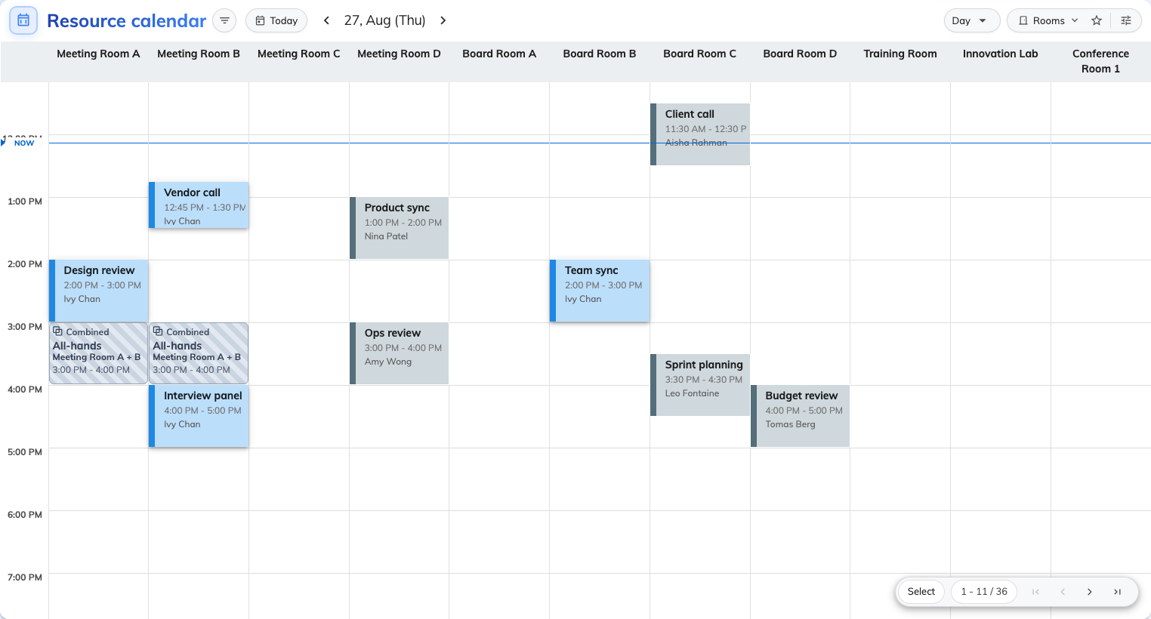
Before. Nothing here says what kind of meeting anything is.
Giving each booking purpose its own colour fixes that in one pass, and it is
the only colour setting that reaches a colleague at all — see What decides how a
booking looks.
Before you start:
You need booking management access, and the purposes must already exist — a
purpose cannot be given a colour before it is a purpose. Decide first which
distinctions are worth a colour; four or five is a legend somebody can hold in
their head, twelve is wallpaper.

1. Check the purposes you want to colour exist
Where in Offision: admin app → booking/booking-purpose (Booking purpose setting)
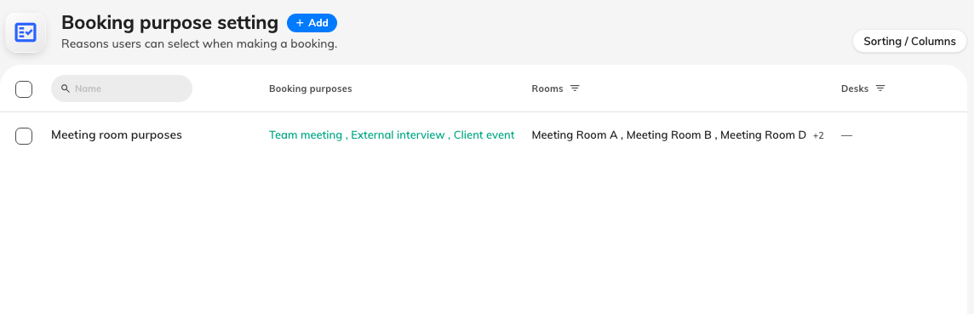
The purposes list. Every row here can be given a card of its own.
If the list is empty, start at What a booking purpose
changes — with no purposes, the section you
are about to use has nothing to offer and its Add button stays greyed out.

2. Set the colour everything else falls back to
Where in Offision: admin app → ui-customization/resource-calendar (Resource calendar)
Under Booking card, Color is the colour of a booking with no
purpose. Pick something deliberately quiet here — it is the background your
coloured purposes have to stand out against, and on the grid people book from it
paints only the viewer's own bookings anyway.
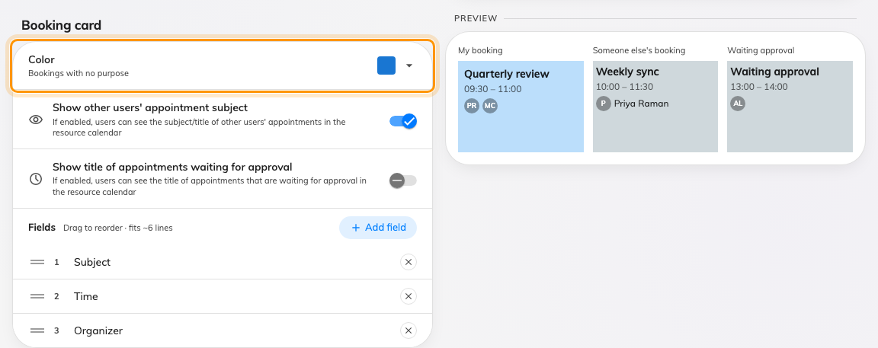
Booking card, with Color — what a booking with no purpose is drawn in.

3. Give one purpose a card of its own
Below the booking card is Booking purpose card. Add creates one override,
and the new card's heading is the picker — click the purpose name to change
which purpose this card is for. There is no labelled dropdown to hunt for.
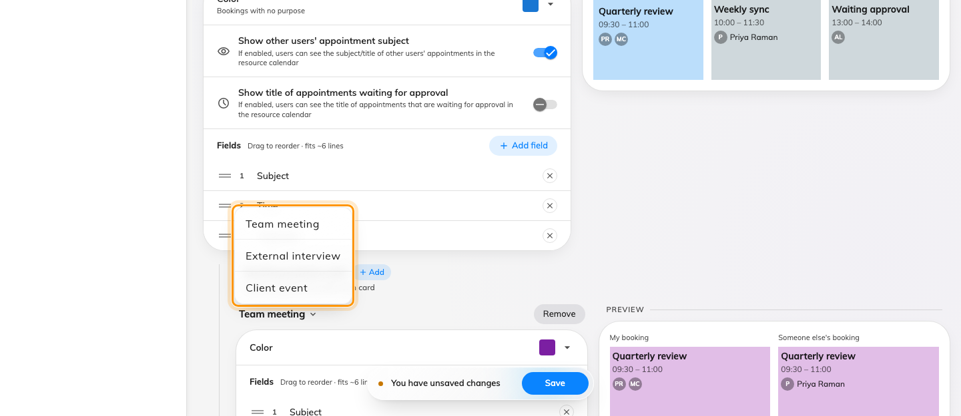
The card's own title opens the purpose list. A purpose already taken by another card is not offered.
A new card starts as a copy of the booking card above it — the same fields, in
the same order — so you are editing a departure rather than filling in a blank.
Set its Color, and the preview beside it redraws as you choose.
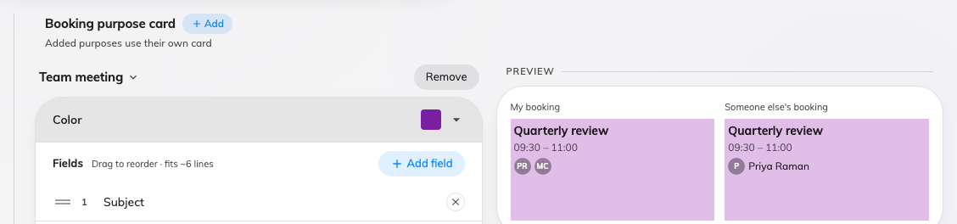
One finished purpose card, with its sample drawn beside it.
Repeat for each purpose that has to stand out. Purposes with no card of their
own use the booking card, so there is no need to add one per purpose — add the
ones people need to spot from across the room, and leave the rest.

4. Choose what that purpose's card prints
Each purpose card carries its own Fields list, so a colour is not the only
thing that can differ. Add field offers what is not already on the card,
under Booking and People — and a third group, Custom fields, wherever
your own booking forms have fields this card can draw. Drag the rows to reorder
them; the order you leave is the order the card prints, and a new field always
joins the bottom rather than rearranging what is already there.
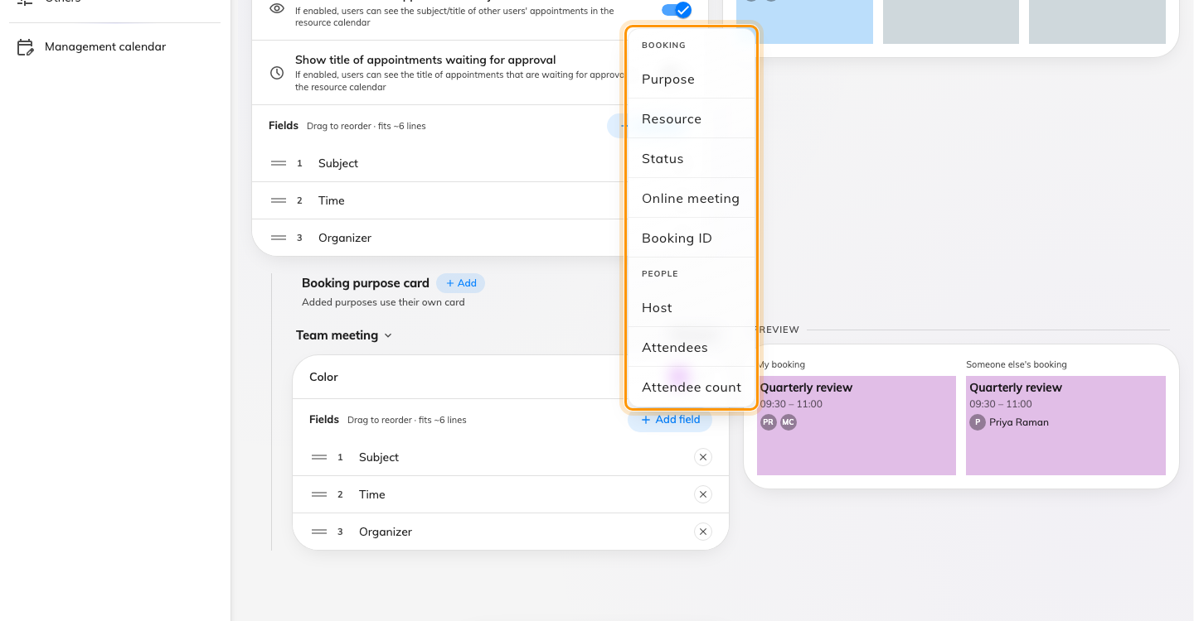
Add field offers only what the card has not got. Fields already on it are absent from the menu.
A purpose that swaps the form offers only that form's fields:
Where the purpose replaces the whole booking form, the hint beside Fields
reads From "«form name»" and only that form's custom fields are on offer.
Bookings of that purpose were filled in with that form, so any other field could
only ever print an empty line. See Which form a booking
uses.
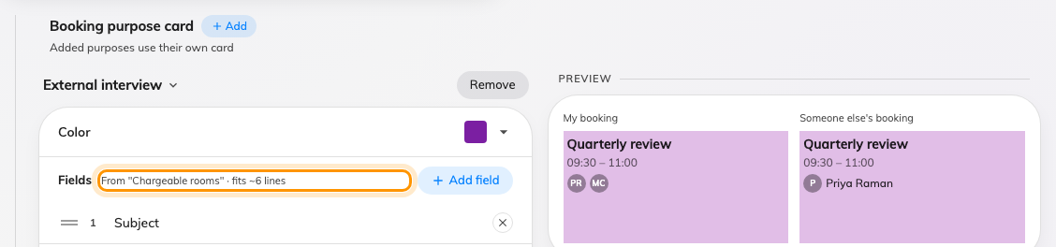
A purpose that swaps the booking form says so, and offers that form's fields only.
Leave the card with nothing on it and it falls back to the booking card's lines
rather than printing an empty block — an empty list means "no departure", not
"show nothing".
Save from the footer at the foot of the page. Nothing reaches anybody until you
do.

5. Do the same for the console's calendar
The management calendar is configured separately, on its own page, with the same
Booking purpose card section. It is worth spending the five minutes: this is
the screen a booking manager lives in.
Where in Offision: admin app → ui-customization/management-calendar (Management calendar)
Two differences to expect. Every block on the console takes the purpose colour
whoever booked it — a manager reads the whole estate, not just their own
bookings — and the left edge of every block is the booking's state, which no
colour you pick here can change.
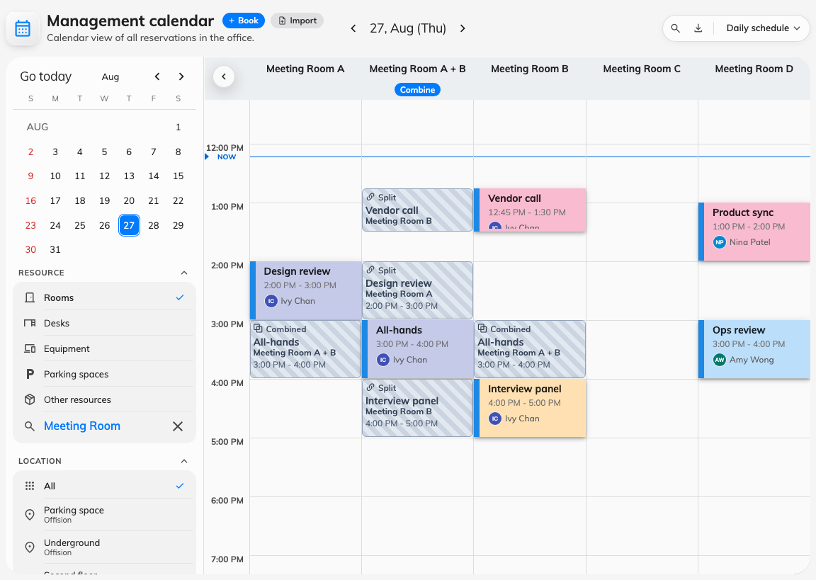
The console's calendar, colour-coded. The left edge still carries the booking's state.

6. Check it worked
Open the booking calendar in the user portal on a day that has bookings of at
least two of the purposes you coloured.
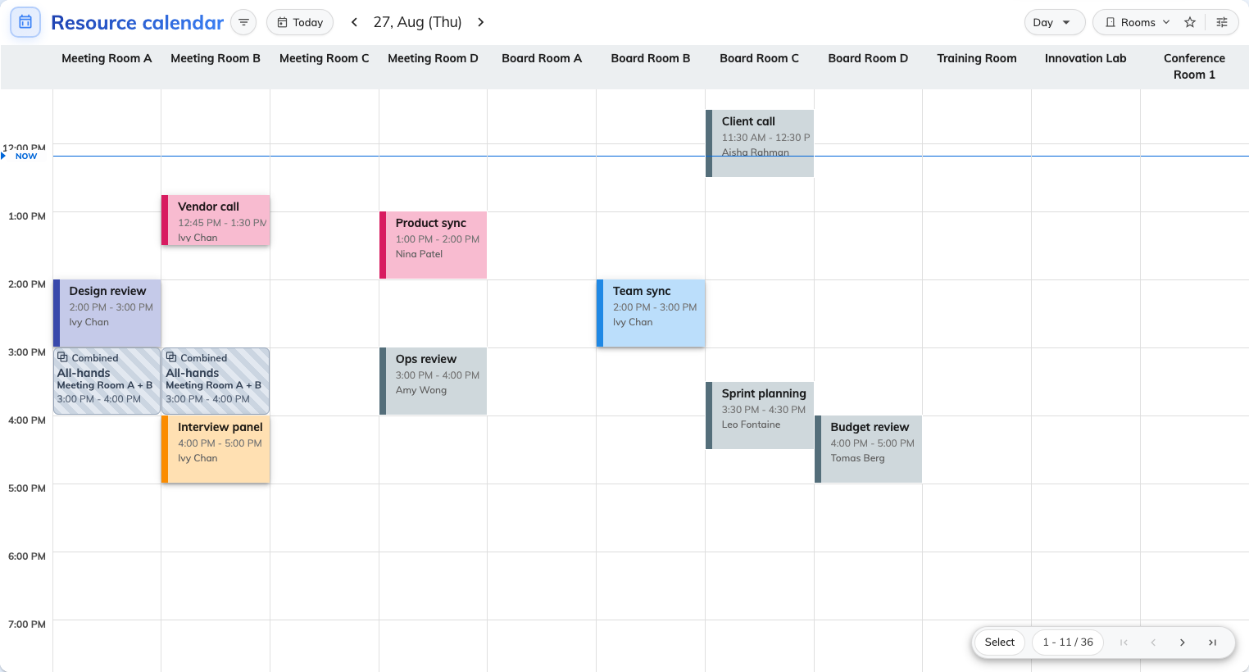
After. The same day as the first figure, with each purpose carrying its own colour.
Three things worth checking before you call it done:
- A booking of a purpose you coloured carries that colour for a colleague as
well as for you. That is the test the whole exercise rests on.
- A booking with no purpose is still quiet.
- Your own booking that is waiting for approval is blue-grey even though its
purpose has a colour. That is correct and deliberate — not confirmed yet
outranks what kind of meeting it is.

What this does not control
- Which purpose a booking gets. That is asked on the booking form, and can
be defaulted per resource — not here.
- Anything outside the two calendars. Room panels have Design by purpose
of their own, in the panel configuration; boards, emails and reports do not
print the purpose at all.
- The status stripe on a console block. Deliberately not settable.
- The field tables themselves. Every field on both screens is listed in the
UI customization settings
reference.

