Choose which booking emails go out
Six switches on one page decide whether a booking mails anybody, whether the calendar invitation rides along, and who else is told. All of them sit on the policy, so they apply to a class of space rather than to one room.
2026-08-25 · https://offision.com/help/en/booking/choose-which-booking-emails-go-out/
Before you start:
These switches live on a booking policy, and a policy is shared by every
resource pointing at it. A floor of meeting rooms and a floor of desks want
opposite answers to most of what is below, so give them separate policies before
you start rather than compromising on one.
Know what each mail is and who receives it first —
What Offision emails when someone books.

1. Open the policy and find the Email section
Open Booking policy, click the policy those resources use, and choose
Edit. In the rail down the left of the editor, the last of the ordinary pages
is Others — everything in this article is at the top of it, under the heading
Email.
Where in Offision: admin app → booking/advance-policy (Booking policy)
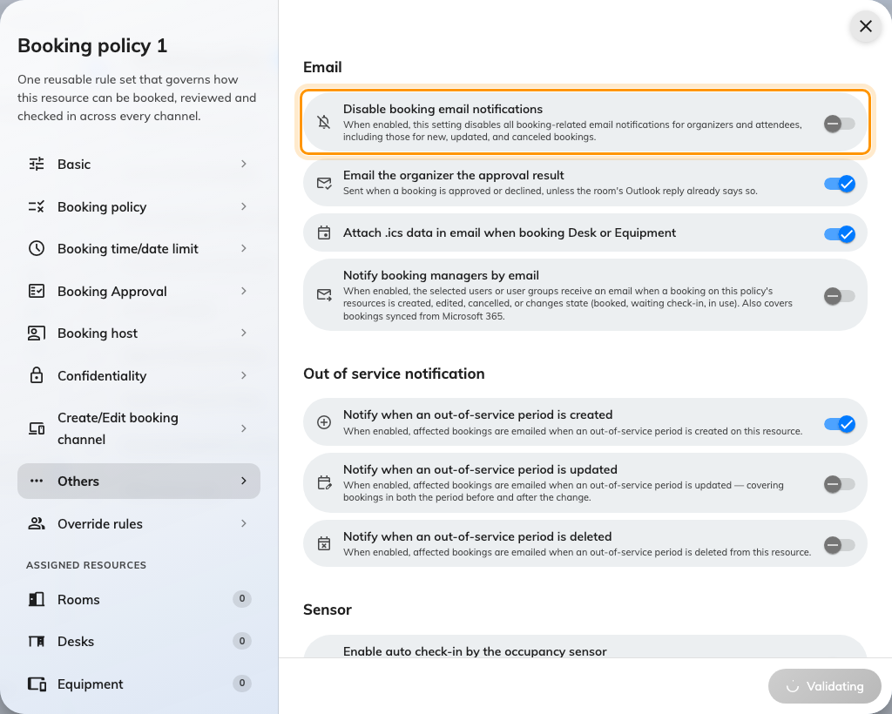
The Email section, at the top of the Others page.

2. Decide whether a booking mails anybody at all
Disable booking email notifications — "this setting disables all
booking-related email notifications for organizers and attendees, including those
for new, updated, and canceled bookings." It is the blunt one: nothing goes out,
to anybody, for any resource on this policy.
Turn it on for desks and equipment, where the mail tells one person something they
already know and is the commonest complaint about a new desk floor. Leave it off
for meeting rooms, where the mail is how five people find out where to be.
It is read across the whole booking, not one resource:
A booking that holds a room and a projector at once is checked against both
policies, and either one having this on silences the entire booking — organiser
and attendees alike. So a projector quietened for its own sake takes the room's
mail with it whenever the two are booked together. If mail stops for some
bookings and not others, this is why.

3. Keep or drop the approval result
Email the organizer the approval result is on unless you turn it off, and
sends Booking approved or Booking rejected once somebody decides. It only
means anything on a policy that
requires approval in the first
place.
The one reason to turn it off: where the room is an integrated mailbox, the room's
own calendar reply already tells the organiser the answer, and two messages
saying the same thing is worse than one.

4. Decide whether desks and equipment carry the invitation
Attach .ics data in email when booking Desk or Equipment is the only switch on
the whole policy that names a resource type in its label, because it applies to
nothing else — a room booking always carries the calendar invitation and this
does not change that.
Leave it on where people plan their week around a desk and want it in their
calendar. Turn it off where they book one every morning, since a month of desk
bookings arriving as calendar entries buries everything else. The desk floor's
full set of settings is
Set the rules a hot-desk floor needs.
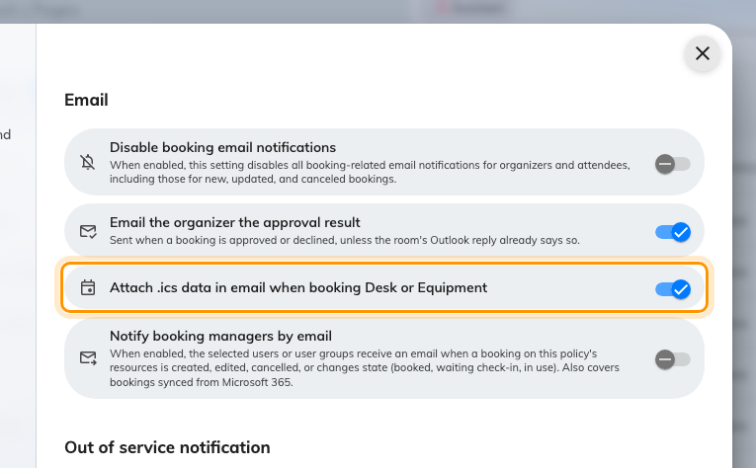
The .ics switch names Desk and Equipment because rooms are never affected by it.

5. Tell the people who have to prepare the space
Notify booking managers by email mails a named list every time a booking on
these resources is created, edited, cancelled, or changes state — booked, waiting
check-in, in use. Bookings that arrived by sync from Microsoft 365 count too.
Turning it on reveals Booking manager user(s) or user group(s) underneath.
Name a user group rather than individuals, so the list survives somebody going
on leave.
This is a different question from step 2. Silencing the organiser's mail on a desk
floor does not silence this; they are separate switches and the manager can keep
being told while nobody else is.
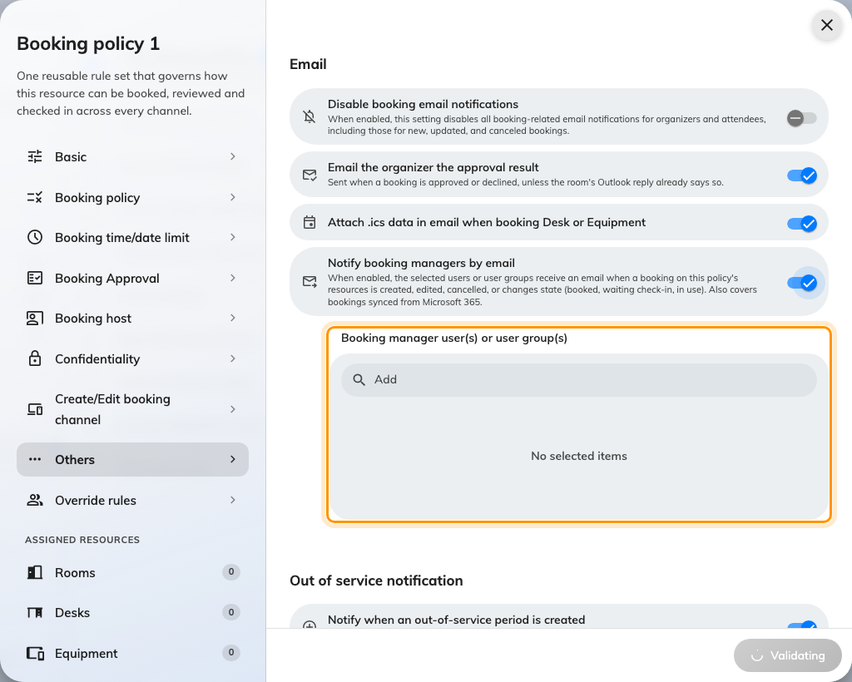
The recipient list appears only once the toggle above it is on.

6. Decide how loudly a closure is announced
Under Out of service notification, three switches decide whether the people
who already booked are emailed when the resource is
taken out of service — when a closure is
created, updated, or deleted.
Creation is on by default and should stay on: somebody whose meeting has just lost
its room needs to know. The other two are for spaces whose closures move around; on
a room that is closed once a year they are noise.
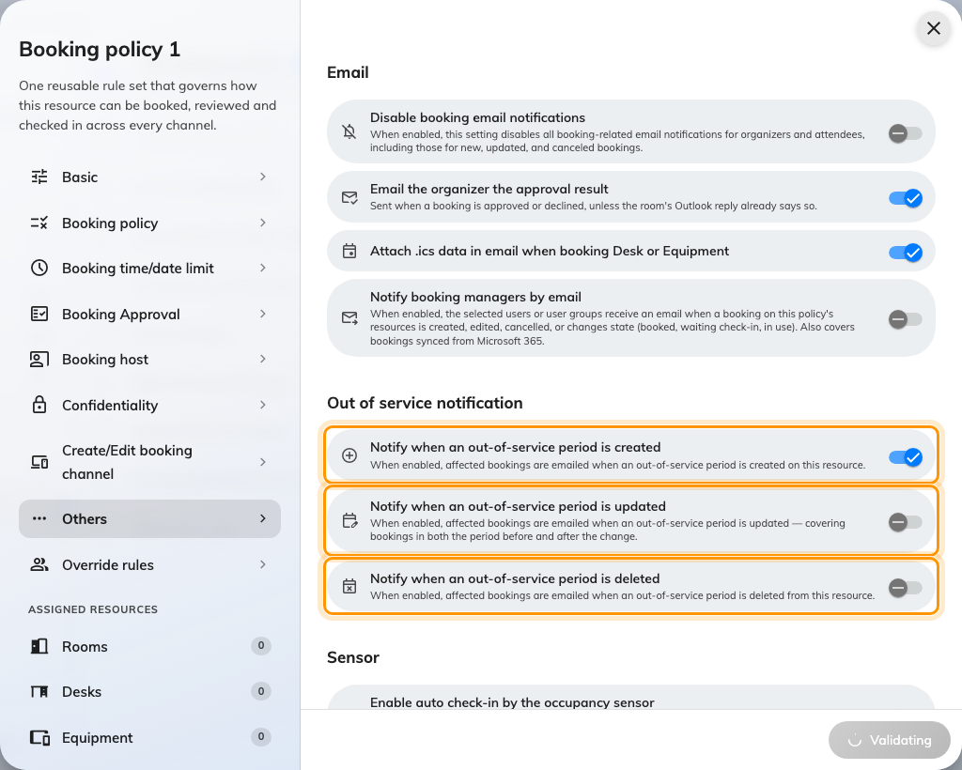
Out of service notification: created, updated and deleted are three separate decisions.

7. Save, and check it worked
Save the policy, then do it for real rather than reading the form back. Book one
of these resources as an ordinary account, with somebody else as an attendee, and
open both inboxes:
- The organiser should have Booking created, or nothing at all if step 2 is on.
- The attendee should have Meeting invitation.
- Anybody named in step 5 should have their own copy.
- Cancel the booking and confirm the cancellations arrive too — that is the half
people forget to test.
If the calendar invitation is not visible as an attached file, that is expected on
most sites and not a fault:
the invitation is usually not a file.

What this does not control
- What the mail says. Subjects and body text are set once for the whole site,
under Change the wording of an Offision email.
- Reminders. The mail sent before a booking starts, or when it is about to be
released for a no-show, is switched on the booking settings page and applies to
the whole site rather than to a policy.
- Approval requests. The mail asking an approver to decide is part of
requiring approval; only the
result mail is on this page.
- The forecast digest. A scheduled summary for managers is a subscription of
its own — Email your managers a forecast of upcoming bookings.
- Whether mail leaves the building. The sender, and whether the invitation
arrives as a file, are set under
Send email from your own address.

