Choose where a resource can be booked from
Three toggles decide which surfaces may create a booking — the admin console, the User Portal and the panels — and the three arrangements people ask for: bookable only from the app, only by scanning the sticker, and not from the portal at all.
2026-08-25 · https://offision.com/help/en/booking/choose-where-a-resource-can-be-booked-from/
Every booking is created from one of three places: the admin console, the User
Portal, or a panel on a wall. The policy decides which of the three a resource
will accept, and it is the answer to a family of questions that sound different
and are the same one — make this desk bookable only from the app, let people
take it only by scanning the code on it, stop anyone booking it in the portal.
Before you start:
The rooms or desks already exist and are assigned to a booking policy. A policy
is shared by every resource pointing at it, so if only some of them should
change, make them a policy of their own first rather than editing the one they
all use.

1. Open the policy those resources use
Where in Offision: admin app → booking/advance-policy (Booking policy)
Select the policy and choose Edit in the panel that opens on the right, then
choose Create/Edit booking channel from the list of pages down the left — the
seventh one. Three toggles, all on when a policy is new.
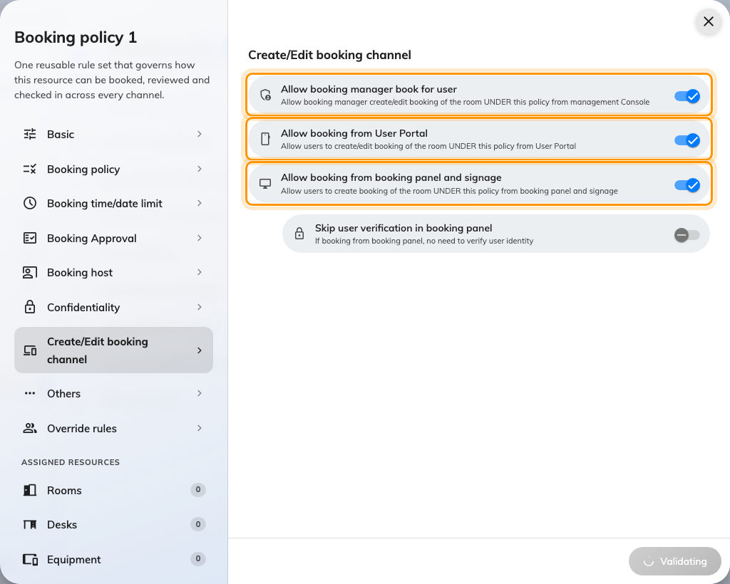
Create/Edit booking channel. Three toggles, one per surface, all on to begin with.

2. Which surfaces each toggle covers
This is the step worth reading slowly, because two of the three cover more than
their names suggest.
Toggle | What it covers
Allow booking manager book for user | The admin console, and only the admin console
Allow booking from User Portal | The web app, the mobile app, Teams, Outlook — and a sticker scan. One channel, not five
Allow booking from booking panel and signage | Room panels, desk panels and check-in kiosks. Shown where panel hardware is enabled

Two things follow from that middle row, and both catch people out:
- There is no mobile-only channel. The mobile app is a shell around the same
pages the browser shows, so a policy cannot let a phone book a desk and refuse a
laptop. If you need to vary who may book from where, vary it by person — an
override rule on this policy reopens a channel for named users or user groups.
- The printed sticker rides on the User Portal. Scanning a desk opens the
portal on the phone, so scan-to-book is the same channel as booking from the
app. Turning Allow booking from User Portal off stops the sticker booking
anything.
Off does not mean the same thing on every row. Switch off the admin console
or the User Portal and the resource stops appearing on that surface — it is
absent from the list rather than greyed out. Switch off the panel and the
resource is still on the panel's screen; the refusal comes when somebody tries.
Skip user verification in booking panel is not a fourth channel:
It sits under the panel toggle and reads like a lock, but it only decides whether
the panel asks who is booking before it books. It never restricts a channel. Every
field on this page is in
Booking rules reference.

3. Bookable only from the app
Turn Allow booking manager book for user and Allow booking from booking
panel and signage off, and leave Allow booking from User Portal on.
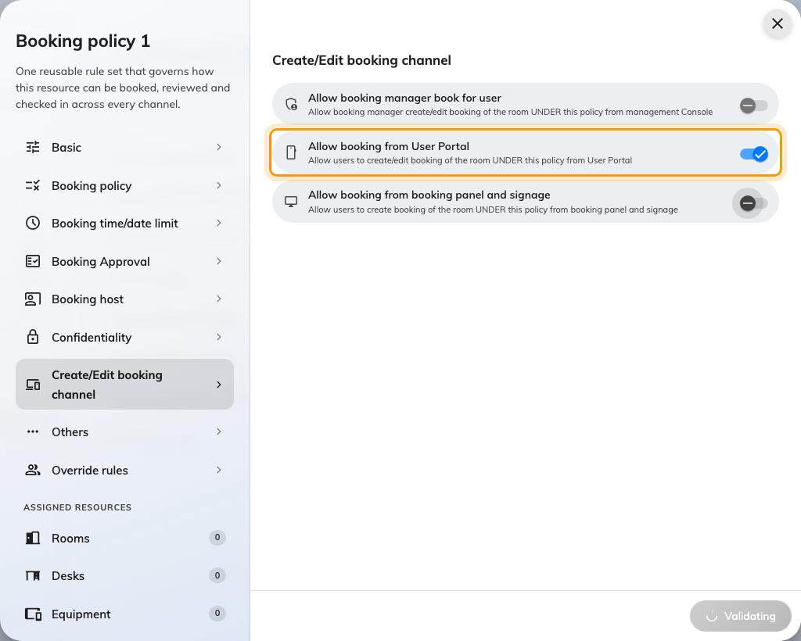
App only: the User Portal left on, the other two off.
What this gets you is self-service only — nobody can book it on somebody's
behalf from the console, and nobody can claim it at a panel. What it cannot give
you is phone only, for the reason in step 2: a browser on a laptop is the same
channel as the app on a phone.
A booking manager who tries anyway is told Not allow booking from management
Console — the message names the channel that refused, which is how you tell
this apart from a resource somebody simply cannot see.

4. Bookable only on the spot, by scanning the sticker
There is no require QR switch. What produces this is a combination, and the
piece that does the work is on a different page.
Go back to Booking policy — the second page — and turn on Walk-in Only:
"This resource can only be booked in (walk-in). Advance booking is not
available." The resource now refuses any booking made ahead of time, and drops
out of the booking form.
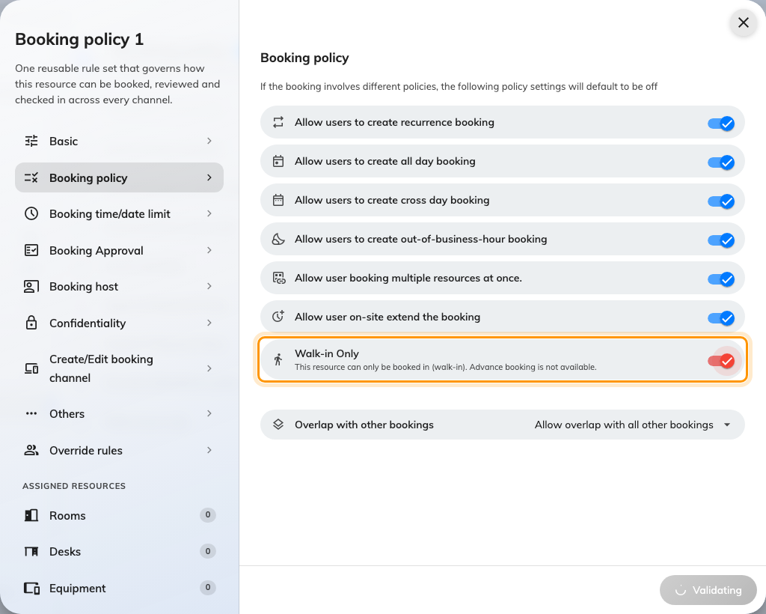
Walk-in Only, on the Booking policy page rather than the channel page.
Then, on Create/Edit booking channel:
- Leave Allow booking from User Portal on. The sticker needs it. This is the
toggle people reach for when they read "only by QR", and it is the one that
breaks it.
- Turn Allow booking from booking panel and signage off. Walk-in Only means
on the spot, not by scanning — a panel is on the spot too. Switching it off
is what leaves the sticker as the only remaining way in.
Finally, on Others, set User Portal check-in IP restriction to your office
addresses. A printed code never changes, so anybody who photographs one can scan
it from home, and a desk booked from a sofa is worse than no booking at all.
GPS will not do this job:
Require GPS check-in applies to checking in, checking out and extending. It
is not consulted when a booking is created, so it will not stop a remote scan
taking a desk. The IP restriction is the lever that does — see
Checking in by QR code, and proving you are there.
Walk-in Only also does not hide the resource everywhere. It disappears from the
booking form, but stays on the resource calendar carrying a Walk-in only
badge and refusing to be dragged — someone who sees it there has not found a
setting that failed.

5. Not bookable from the portal
"Portal" means two different screens to two different readers, so decide which
one you mean before switching anything off.
- The admin console — turn off Allow booking manager book for user. The
resource stops appearing on the console's booking form, and a manager can no
longer create or edit one of its bookings for somebody else. People carry on
booking it themselves in the app.
- The user-facing portal — turn off Allow booking from User Portal. The
resource vanishes from the app's resource list, and an attempt that gets that
far is answered with Not allow book from APP. The same refusal is worded
Not allow booking from User Portal on the admin console, which is the same
channel described from the other side.
Switching the User Portal off takes the sticker with it:
A scan opens the portal, so the same toggle governs both. There is no arrangement
where the portal cannot book a desk but its sticker still can. If what you wanted
was "not planned in advance, only claimed at the desk", that is step 4 — Walk-in
Only, with the portal left on.

6. Attach the policy to the resources
The policy changes nothing until a resource points at it. Open each resource's
Policy page and choose it, or assign a batch from the policy's own resource
pages.
This is where these three arrangements usually go wrong: a policy is shared, so
switching a channel off here switches it off for every resource under it. One
desk that has to behave differently from the floor around it needs a policy of
its own.

7. Check it worked
Prove the refusal, not the success — a resource that still books tells you
nothing about which toggle is doing it.
- App only — sign in as an ordinary account and book it. Then open the same
resource on the admin console's booking form: it should not be in the list.
- Scanning only — the desk should be missing from the booking form entirely,
and scanning its sticker should still offer to book it. If the form still
offers it, Walk-in Only is off or the policy is not attached.
- Off in the portal — the resource should be absent from an ordinary
account's resource list. Then scan its sticker, and expect that to refuse as
well; if you needed the scan to keep working, go back to step 4.

What this does not control
- Who may book it at all. That is team space, set on the resource — a channel
toggle decides from where, never by whom. See
Give a department its own rooms.
- Whether the booking is shaped legally — the window, the duration, all-day,
recurrence, business hours. Those are the rest of the policy:
Booking rules reference.
- Check-in. A scan that checks somebody into a booking they already have is
not a booking, and none of these toggles touch it. See
How check-in and no-show work.
- The sticker itself — printing it, placing it and reissuing a code that has
been photographed: Print and put up resource stickers.
- A booking purpose that overrides the policy. A purpose can carry its own
policy, and an override left empty means no policy rather than this one.

