Check in by tapping a staff card
Turn the method on, get a card number against every person, and connect the reader. One tap then does whatever the room needs, with no second screen.
2026-09-04 · https://offision.com/help/en/booking/check-in-by-tapping-a-staff-card/
Before you start:
The room needs a panel outside it, and its policy needs Require check-in on —
without that a booking never waits for anybody, so there is nothing to tap into.
See How check-in and no-show work.
A staff card is the quickest way in and out of a room: nothing to type, nothing
to scan, no phone. It is also the only credential most people are already
carrying, which is why it is usually the method that actually gets used.
It is also the only one that does the whole job in a single gesture. The card
says who you are and the panel does whatever the room needs next, without asking
a second question.
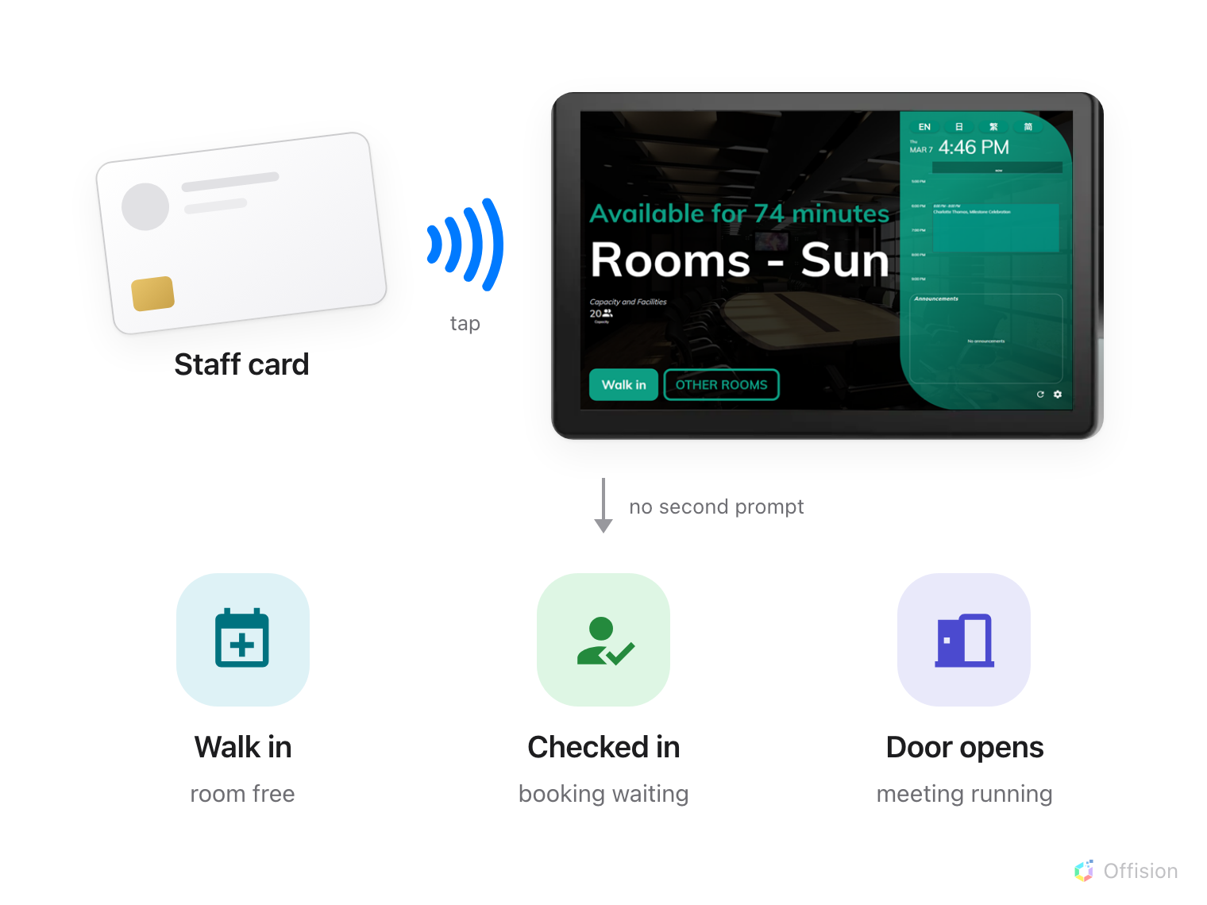
One tap. What it turns into follows the room, not a menu.
There are four things to set up, and they live on four different screens.

1. Turn on Staff Card for the organisation
Check-in methods are set once for everybody, on User identify settings. Turn
on Staff Card — "Tap staff card on card scanner to validate identity".
Where in Offision: admin app → device/check-in-method (Check-in method)
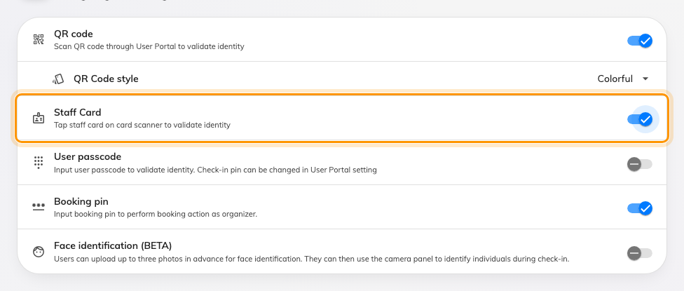
Staff Card, beside the methods that need a phone or a keypad.
At least one method has to stay on; the page refuses to save with none. Leaving
QR code on alongside cards is worth doing anyway — it is what a visitor with no
card falls back to.

2. Decide whether this panel follows the organisation
Open the panel's configuration and go to its Check-in method page. The first
switch there is Override the system user identification settings.
Leave it off and the panel uses what you just set. Turn it on and the panel's own
list replaces it, Staff Card included — which is how one lobby panel ends up
accepting only cards while the rest of the building accepts everything. The
booking pin is the exception: it is set once for the organisation and cannot be
overridden on a single device.
Where in Offision: admin app → device/booking-panel/configuration (Panel configurations)
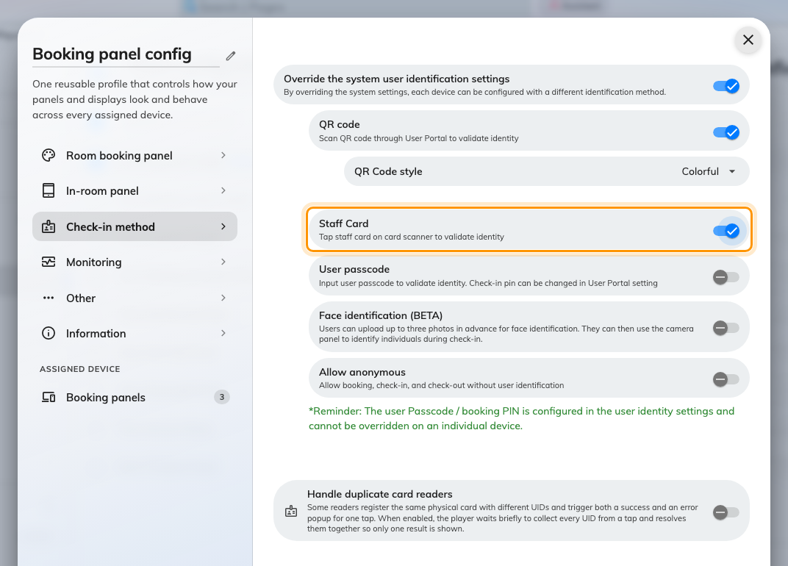
With the override on, this panel's methods replace the organisation's.
A bare tap is more forgiving than the menu:
The override decides what the panel offers once somebody presses Check in.
A tap with no button pressed first is accepted if either the organisation or the
panel has Staff Card on — so a panel can quietly accept cards it never offers.
A configuration is shared by every panel assigned to it, so saving raises a
confirmation listing the devices about to change. Read it before agreeing.

3. Give people a card number
A tap is only an identity if the number on the card is stored against somebody.
Every person has three slots — User card 1, User card 2 and User card
3 — and a card number belongs to one person across the whole account.
That work lives in Directory, not here, because a card belongs to the person
rather than to the room:
- One at a time, from either the Access cards page or the person's own
record — Issue an access card to someone.
- Five hundred at a time, from a spreadsheet —
Import card numbers in bulk.
- What the seven card types are and which of them you issue —
How access cards work.
Where in Offision: admin app → directory/access-card (Access cards)
Which number goes in the box:
An ordinary MIFARE, NTAG or DESFire card has no printed number — what the panel
reads is the chip's UID, in hexadecimal. An HID Global card read by an iAdea
panel supplies its own encoded card number instead, which is the one printed on
it. Upper and lower case do not matter, so a number enrolled either way matches.
If you are unsure what a batch of cards will produce, enrol one, tap it, and read
what the panel accepted before you import the other five hundred.

4. Connect the reader
Whether a panel needs anything plugged into it depends on what the panel is.
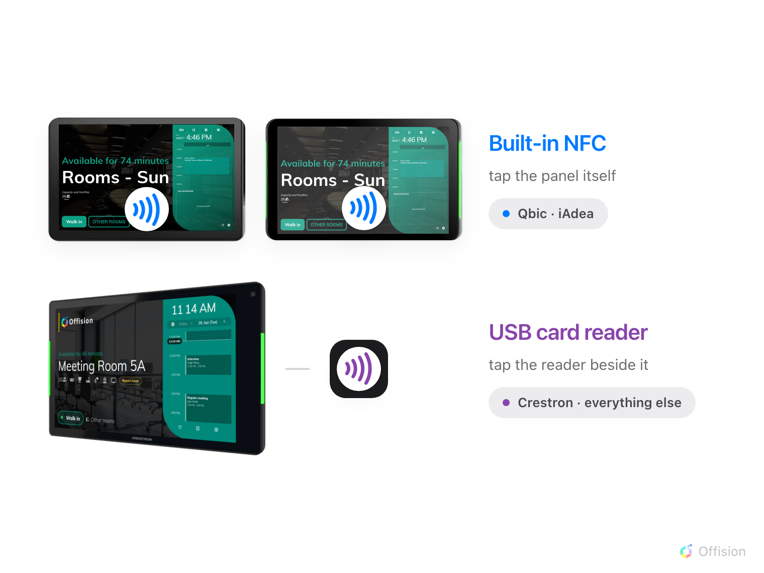
Qbic and iAdea read the card themselves. Everything else needs a reader.
Panel | Reads a card by | Where people tap
Qbic Android panels running the Offision app | Built-in NFC | The panel itself
iAdea Android panels running the Offision app | Built-in NFC, including HID Global cards | The panel itself
Everything else | A USB reader | The reader

Not every Qbic and iAdea panel is ordered with the reader, and the HID version is
a separate part number. Which models have it, whether yours needs the H version,
and where the tap spot sits on each of them is in
Which booking panel hardware Offision supports.
A USB reader needs no driver and no setting. It behaves as a keyboard: it types
the card number and presses Enter, and the panel treats that as a tap. Any reader
that works that way will do — which is most of them, and is worth checking on the
box before you buy a hundred.
Readers that never press Enter:
Some readers type the number and stop. Qbic and iAdea panels in browser mode
allow for that and act on the number once it stops arriving; other panels wait
for the Enter that never comes and nothing happens. If a reader is silent on a
Crestron and works on a Qbic, this is why — set the reader to send a carriage
return.

5. Let cards act on the room
The last switch is on the room's policy: Allow access by registered user
cards — "Allow user check-in, check-out and extend booking by registered user
card." It is what tells the panel that cards may act on this particular
resource, and it is separate from everything above.
Where in Offision: admin app → booking/advance-policy (Booking policy)

6. Check it worked
Book the room in your own name, wait for the check-in window to open, and tap
your card at the panel. The booking should check in with no further tapping and
the panel should show it in use.
Then try the other two states, because they are the ones nobody tests: tap on a
free room and you should get the walk-in form; tap during your own meeting and
you should get the extend and check-out choice — or the door, if Card scan
opens door during meeting is on for that panel.
If nothing at all happens when you tap, work through
Tapping a staff card does nothing.

What this does not control
- Who may book the room. A card gets somebody into a booking they already
have; it does not give them the right to make one.
- Whether attendees may use it. Only the organiser may act on a booking
unless the policy says otherwise — see
Checking in at the booking panel.
- Opening the door. A panel wired to a lock unlocks alongside check-in; a
panel with no access hardware still checks people in perfectly well. See
Connect an AXIS door lock.
- Whether check-in is required at all. That is Require check-in on the
resource's policy.

