Checking in at the booking panel
The panel is the only check-in that proves somebody was at the door. What it offers is decided by two separate screens, which is why a button can go missing.
2026-08-16 · https://offision.com/help/en/booking/check-in-at-the-booking-panel/
The panel outside the door is the only way of checking in that proves somebody was
physically there. Everything else — the app, a QR code, a sensor — can be satisfied
from somewhere else in the building, or from home.
{/* Product photo shipped with the app, not a captured screen — hence no figures:
entry. Source: Web/offision-application/assets/images/players/qbic_room_panel.png */}
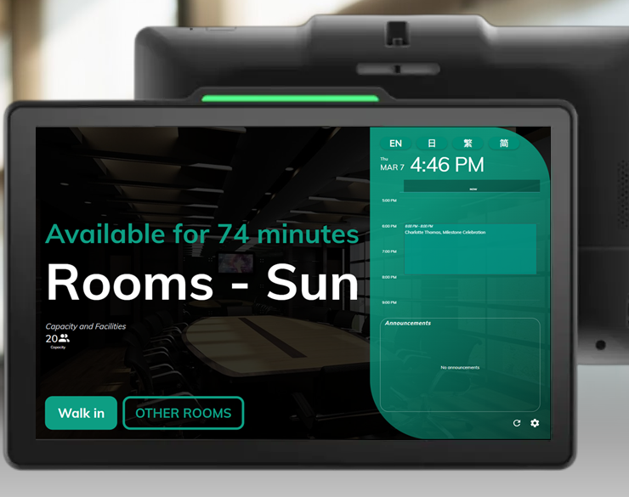
A booking panel by the door. What it offers follows the room — this one is free, so it offers a walk-in.

What the panel offers changes with the room's state
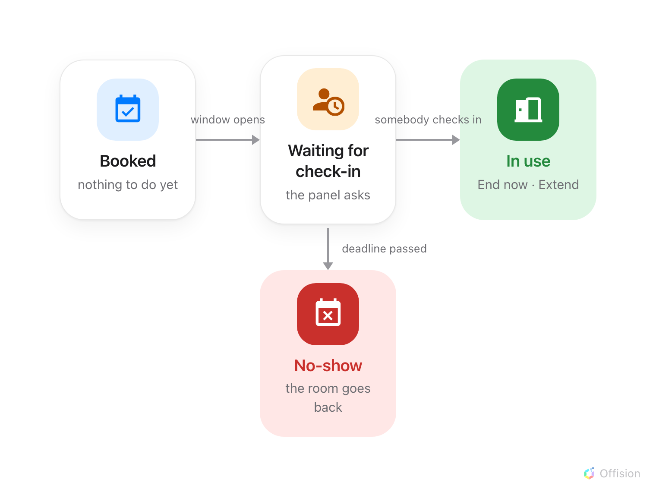
A booking that is never checked into does not stay booked — it leaves by a different door.
While a booking is waiting, the panel shows Check in, and beside it the
Auto-release in countdown. That badge is worth knowing about: it is the only
place in the product where the no-show deadline appears as a running clock, and it
is drawn from the policy's Can check-in after (in mins).
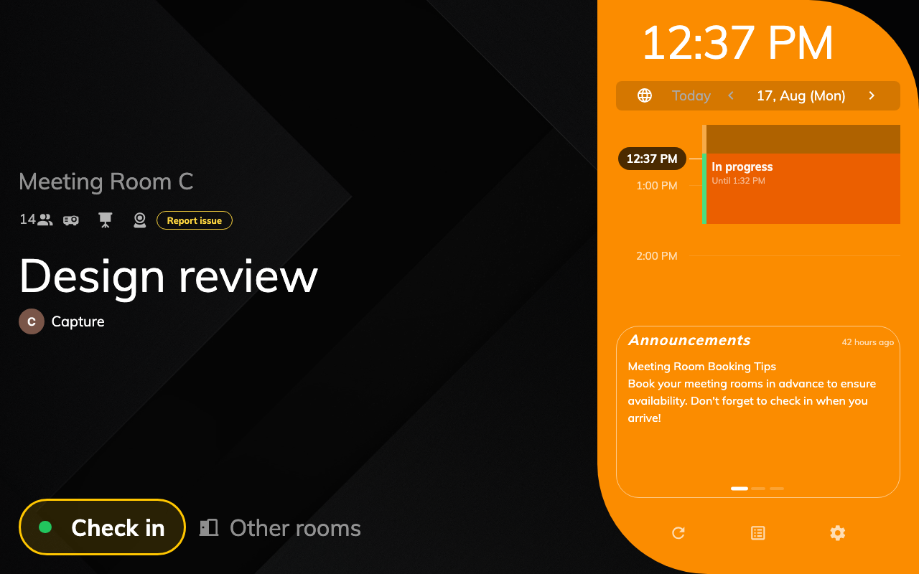
Waiting: Check in, and the Auto-release countdown beside it.
Once checked in, the same panel offers End now and Extend. On a free room it
offers Walk in instead — and a walk-in never needs checking in, because whoever
pressed it is standing there. Setting that up is
Let somebody take a free room at the panel.
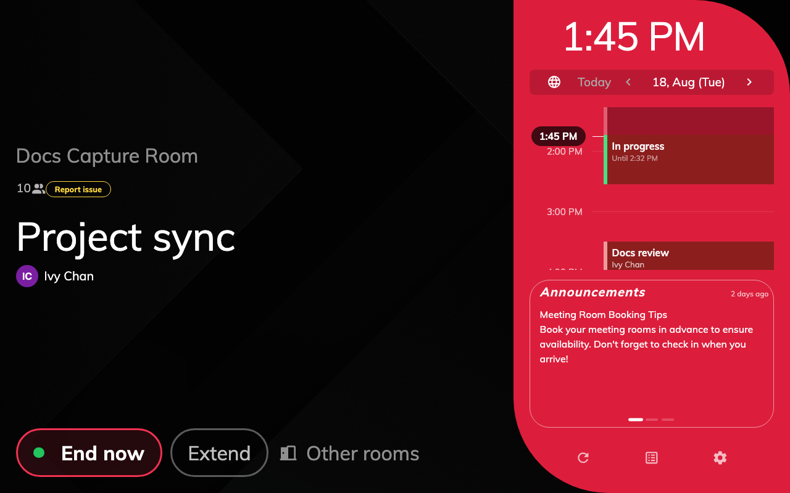
In use: the same booking, one check-in later — now End now and Extend.

Two screens decide what it asks for, and neither is the policy
This is the part that produces "the button has disappeared" reports, because the two
screens live in different sections and either one can remove a button the other
enabled.
User identify settings decides, for the whole organisation, which credentials
prove who somebody is: QR code, Staff Card, User passcode, Booking
pin and Face identification. At least one must stay on. Setting up the card
one end to end is its own page —
Check in by tapping a staff card.
Where in Offision: admin app → device/check-in-method (Check-in method)
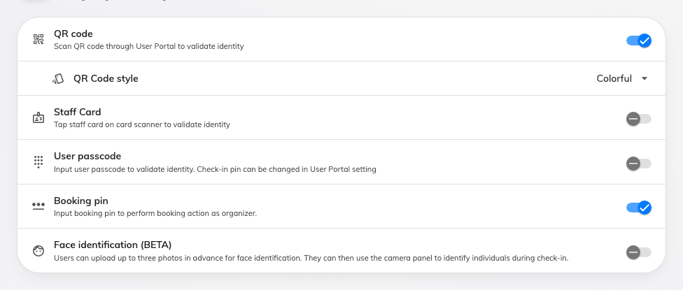
The methods a panel may ask for, set once for the organisation.
Where more than one is enabled, the panel asks which before it asks for anything
else. Where exactly one is, it goes straight to it.
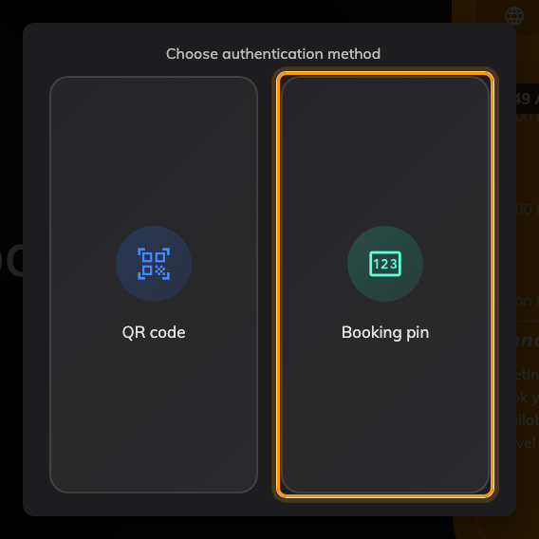
With several methods enabled, the panel asks which one first.
The booking panel configuration then decides, per panel, whether the buttons
appear at all — Show check-in button, Show check out button, Show extend
button, and whether each needs a confirmation tap.
Where in Offision: admin app → device/booking-panel/configuration (Panel configurations)
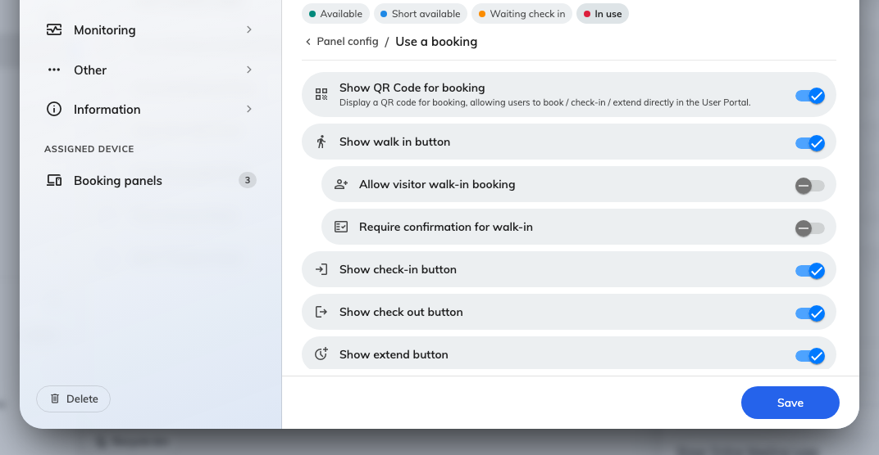
A panel can be told to hide a button the organisation has enabled.
So a panel with no check-in button is usually not a broken panel. It is a
configuration that hides it, a policy that does not require check-in, or a room with
nothing to check into.

Attendees are a separate permission, twice
Only the organiser may act on a booking unless the resource's policy says otherwise,
and it says so in two places that read almost identically:
- Allow attendees to check-in / check-out / extend at the booking panel — the
panel.
- Allow attendees to check-out / extend in User Portal & check-in via QR — the
app, and note that the app version grants check-in only by QR code.
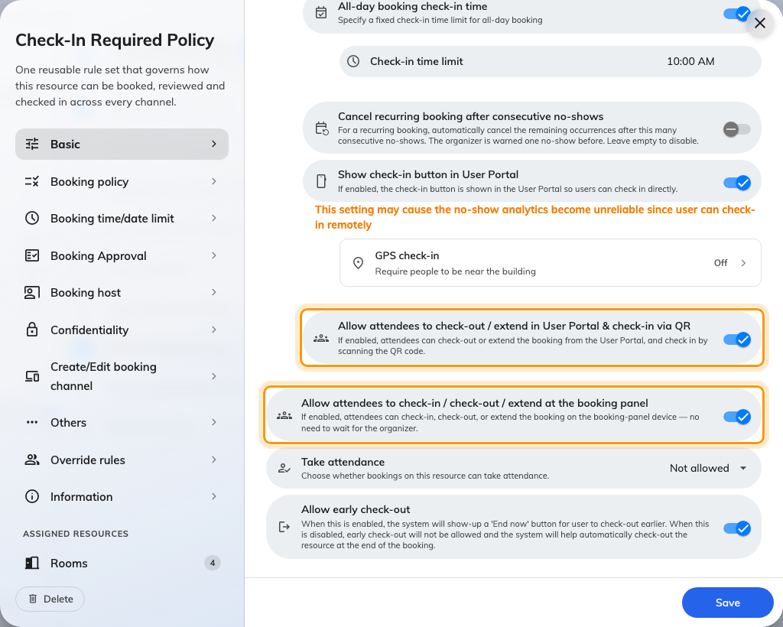
The two switches, one above the other: the User Portal one, then the booking panel one.
They are independent. Turning on the app one does nothing at the door.
An outside attendee has no credential:
Someone from another company has no staff card, no passcode and no account for a QR
code to match. The booking pin is the one method that identifies the booking
instead of a person — see
Let outside attendees check in with a booking pin.

What it does not control
- Who may book the room. A person can be allowed to check in and not allowed to
book, and the other way round.
- Whether check-in is required at all. That is Require check-in on the
resource's policy — see How check-in and no-show work.
- Opening the door. Where a panel is wired to a lock, unlocking is a separate
action that rides along with check-in; a panel with no access hardware still checks
people in perfectly well.
- What the panel looks like. Skin, logo and idle screen are the panel's design
settings, not its check-in behaviour.

