Let an occupancy sensor check in, check out and extend a booking
Leave early and the room can hand itself back: once the sensor has reported it empty for long enough, the booking is shortened and the leftover time is free for somebody else. The same sensor can also check a booking in when somebody arrives, and keep the room while a meeting overruns. The three settings are not on their own page — they are on the policy's Check in/out page, under Sensor.
2026-09-21 · https://offision.com/help/en/booking/check-in-and-out-by-occupancy-sensor/
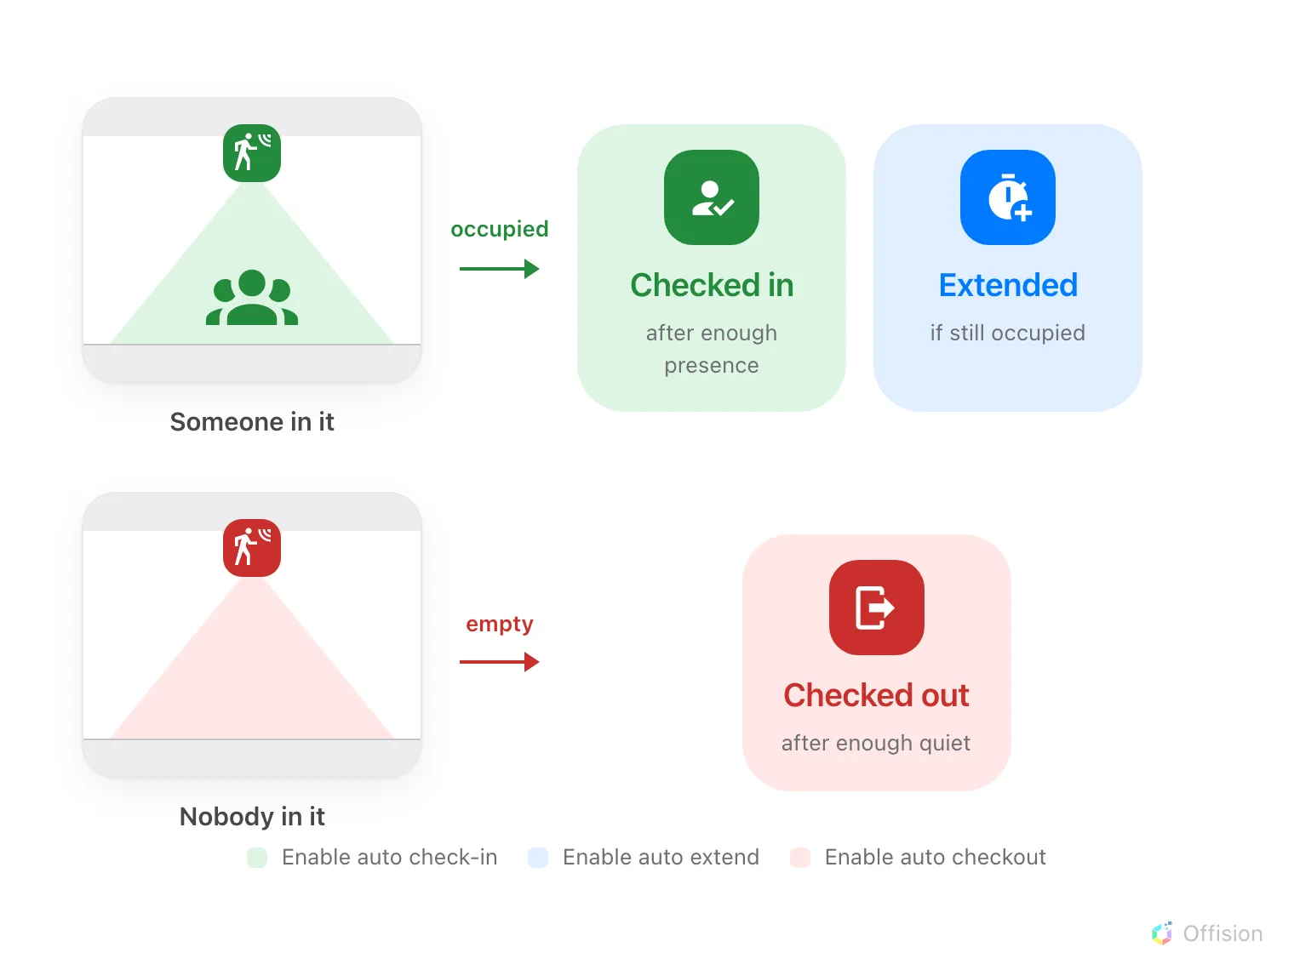
The sensor only ever reports occupied or empty. Three separate settings decide what the booking does about it.
Before you start:
A sensor must already be reporting into Offision and linked to this room or desk
as a Resource — a sensor bound as a Location reports the floor, and no booking
follows from it. Which sensors report occupancy, and how each one is linked, is in
Which occupancy sensors work with booking.

They are not on the check-in page
Require check-in, Allow early check-out and the cancel rules are on the
policy's Basic page, in a group called Check in/out. The sensor settings
are not there.
They are on the Check in/out page, under Sensor, below the cancellation
rules. That is the commonest reason somebody concludes Offision cannot do this at
all. (Before 4.5.18 the same group sat on a page called Others.)

1. Open the policy's Sensor group
Open Booking policy, select the policy the room uses, then Edit. In the
dialog's left rail choose Check in/out, under Rules & limits, and scroll
to Sensor.
Where in Offision: admin app → booking/advance-policy (Booking policy)
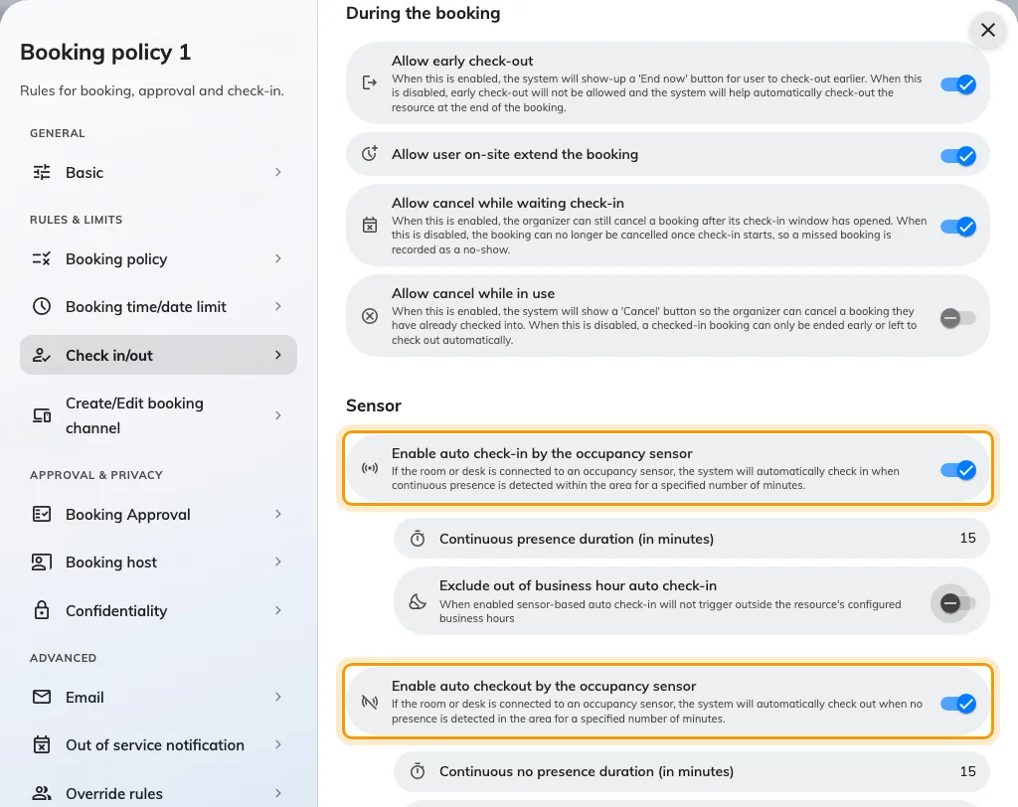
The Check in/out page, with all three sensor automations on and the minutes each one reveals.
Each of the three works on its own. Turning on check-out does not require
check-in, and nothing here changes how people check in by hand.
They are not independent of the policy around them, though. Allow early
check-out, back on Basic, has to be on for auto check-out to do anything —
see the callout in step 3.

2. Check in when somebody arrives
Enable auto check-in by the occupancy sensor checks a waiting booking in once
the sensor has reported somebody for long enough.
Continuous presence duration (in minutes) is how long. Five minutes is the
lowest it accepts. Too short and somebody crossing the room claims a booking that
is not theirs; too long and people decide check-in is broken and press the panel
anyway.
Exclude out of business hour auto check-in stops cleaners and security
tripping it overnight.
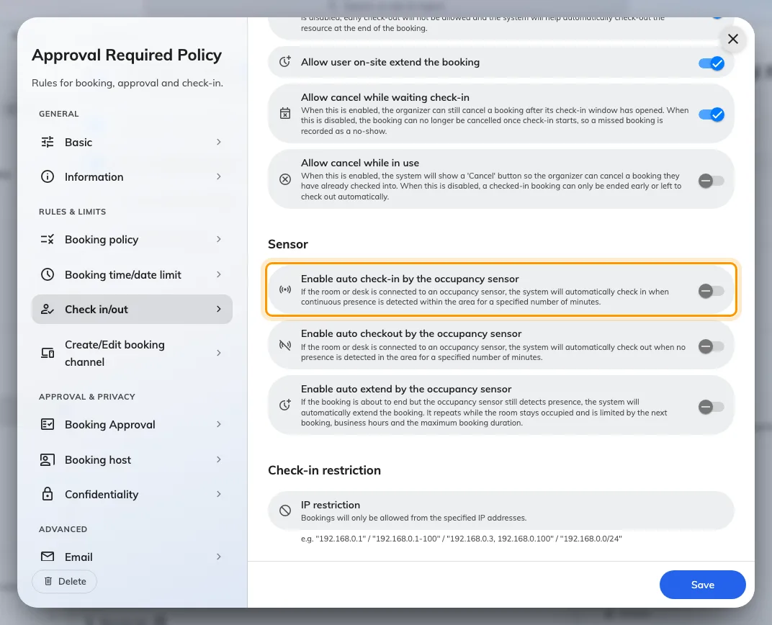
Enable auto check-in by the occupancy sensor: nobody presses anything.
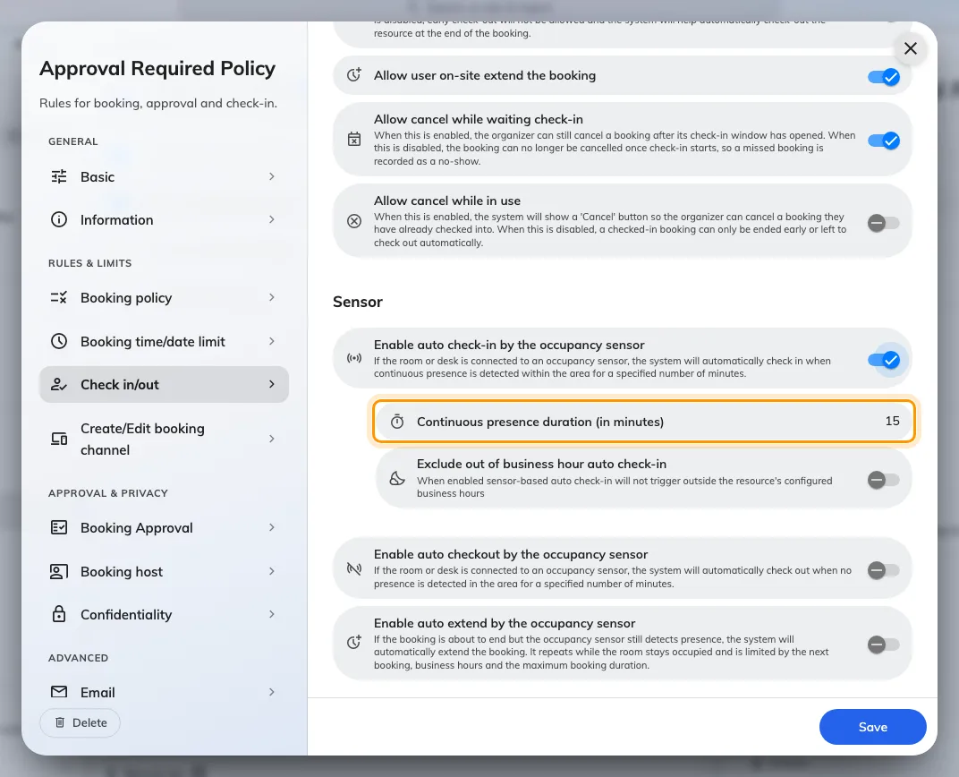
Continuous presence duration — how long somebody must be there before it counts.
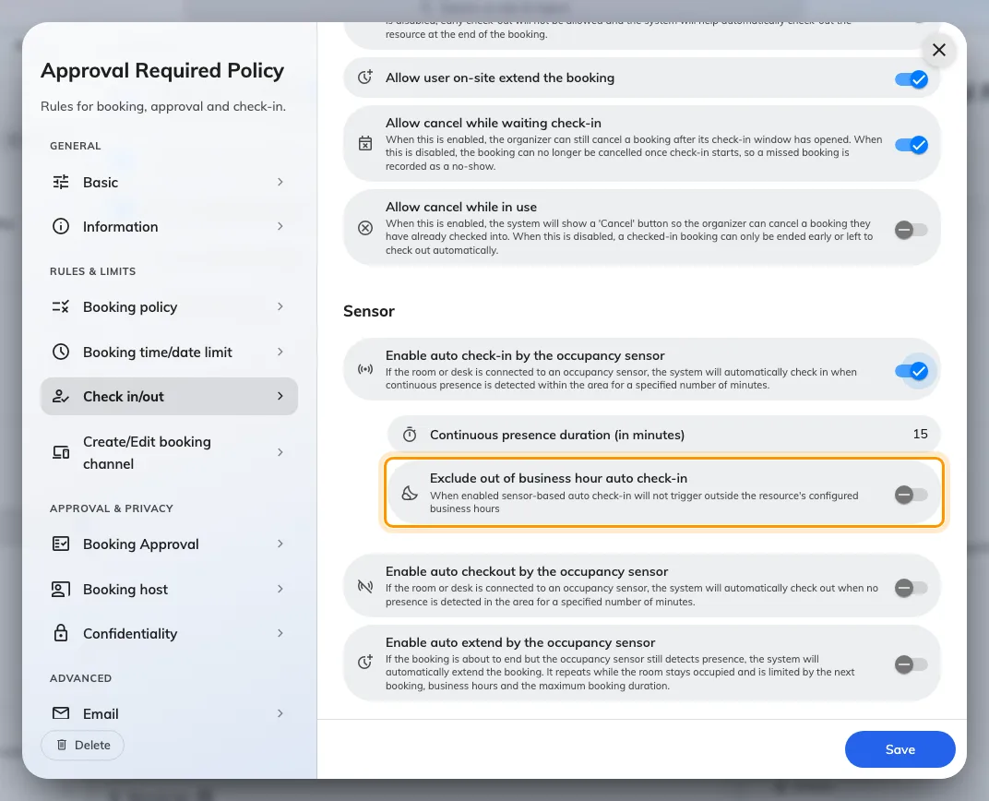
Exclude out of business hour auto check-in, for the cleaner who walks through at night.

3. Check out when the room empties
Enable auto checkout by the occupancy sensor releases the room once the
sensor has reported nobody for long enough.
It only ever acts on a booking that is already checked in. A booking nobody
arrived at is released by the check-in window instead, which is a different
mechanism with a different timer — see
How check-in and no-show work.
Continuous no presence duration (in minutes) is how long the quiet has to
last, counted from the booking's start or the last reading, whichever is later.
Set it long enough to survive a coffee run.
Allow early check-out has to be on:
The sensor releases a room by checking it out, so the policy's Allow early
check-out — on the Basic page, under Check in/out — gates this as well
as the End now button. With it off, a room is held to its booked end time
whatever the sensor reports, and nothing on this page changes that.
Two settings stop it firing when it should not:
- Ignore occupancy sensor auto check-out for all-day bookings. An all-day
booking begins at midnight in an empty room, so without this it releases itself
before anybody arrives. Leave it on wherever all-day bookings are used.
- Exclude out of business hour auto check-out, the pair of the check-in
equivalent.

A meeting can keep the room
Auto check-out is not silent about what it is going to do. The room's panel
carries a badge for the whole of an in-use booking: Auto check-out on while
the sensor can still see somebody, and Auto-release in, counting down, once
it cannot. Tapping it suspends the release for that booking only — there is
no confirmation — and the badge changes to Auto check-out off. The policy is
untouched and the next booking is governed as before. On the Meeting assistant
the same choice arrives as a Still here? screen with one button, I'm still
here.
That is the answer to the quiet room that is still in use — a workshop where
everybody is at a whiteboard out of the sensor's view, or a long call taken from
one corner. The tap is sticky rather than a snooze, and the two panel designs
differ over whether it can be undone, so the details are on
Keep the room when the sensor says it is empty.
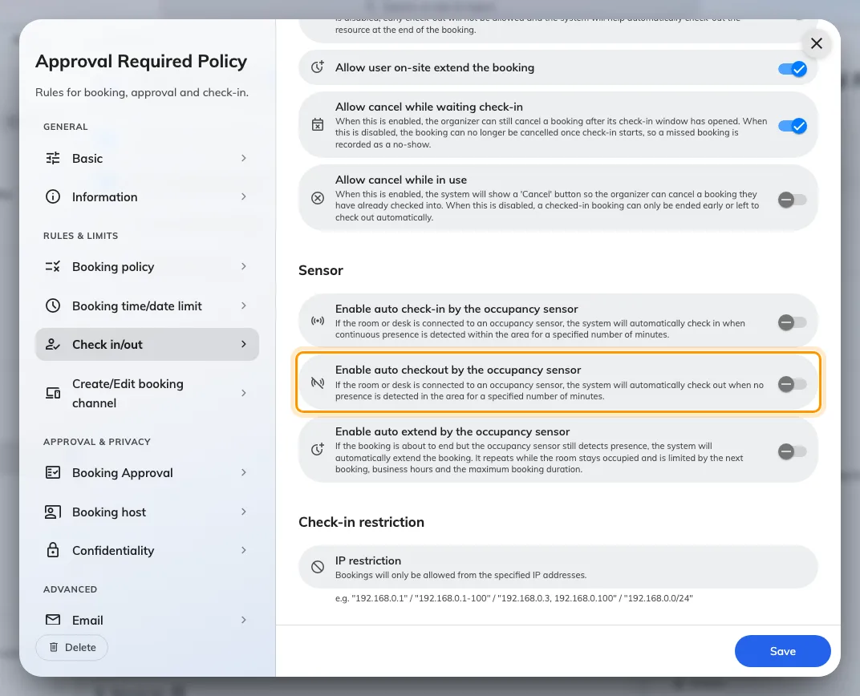
Enable auto checkout by the occupancy sensor, which acts only on a booking already checked in.
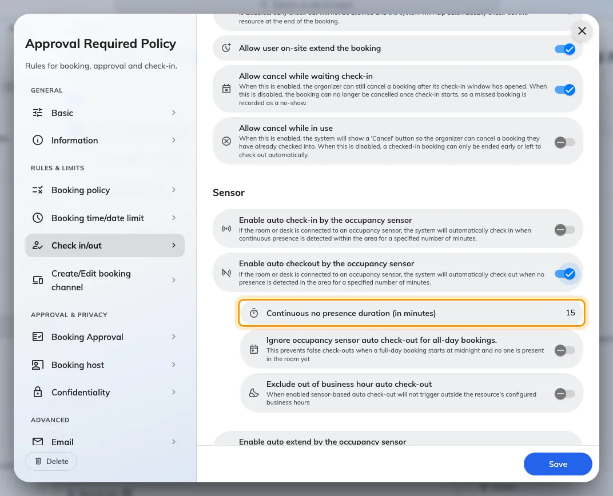
Continuous no presence duration. Too short and a coffee break ends the meeting.
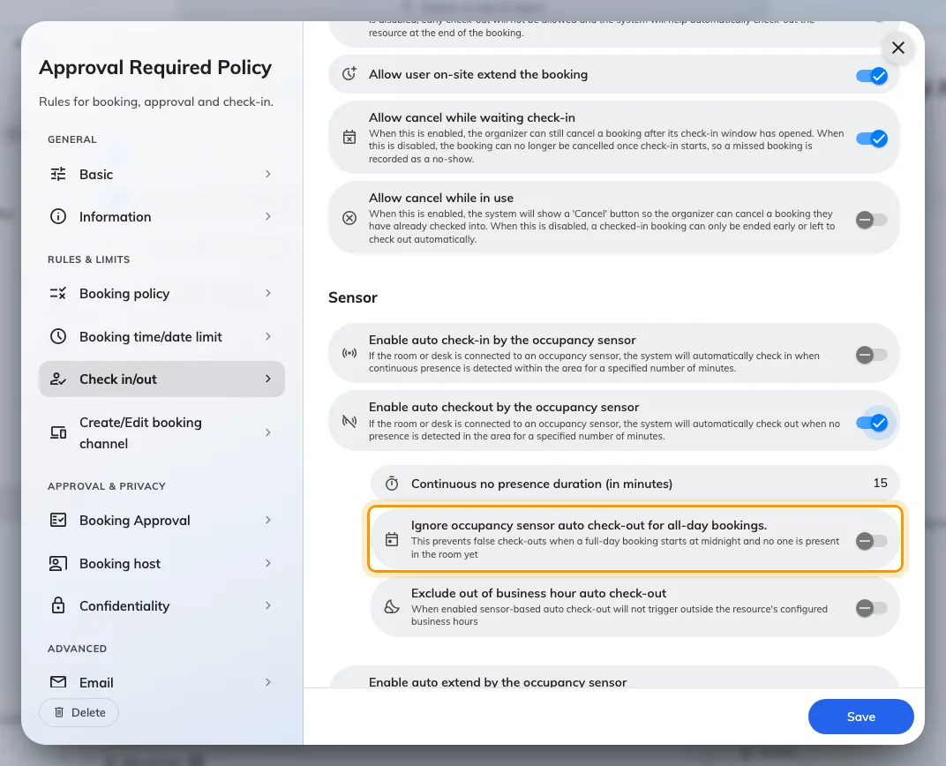
Ignore auto check-out for all-day bookings, so an empty desk is not released overnight.
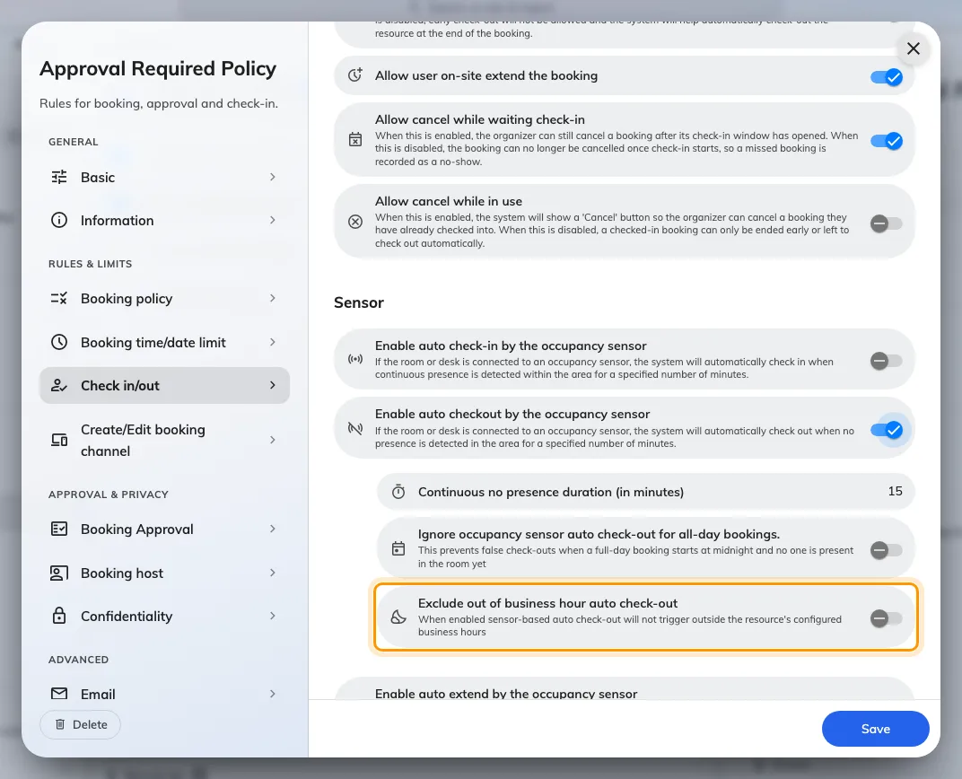
Exclude out of business hour auto check-out, the pair of the check-in setting above.

4. Extend while the meeting is still running
Enable auto extend by the occupancy sensor pushes the end of a booking back
while the room is still occupied, rather than turning a meeting out mid-sentence.
Trigger when ending within (in minutes) is how close to the end the check
happens. Extend by (in minutes) is how much each extension adds. It keeps
extending while people stay, and stops at the next booking, the end of business
hours, or the resource's maximum booking duration. Small increments give an empty
room back sooner.
This is not Allow user on-site extend the booking, on the Booking policy page.
That one is the button a person presses.
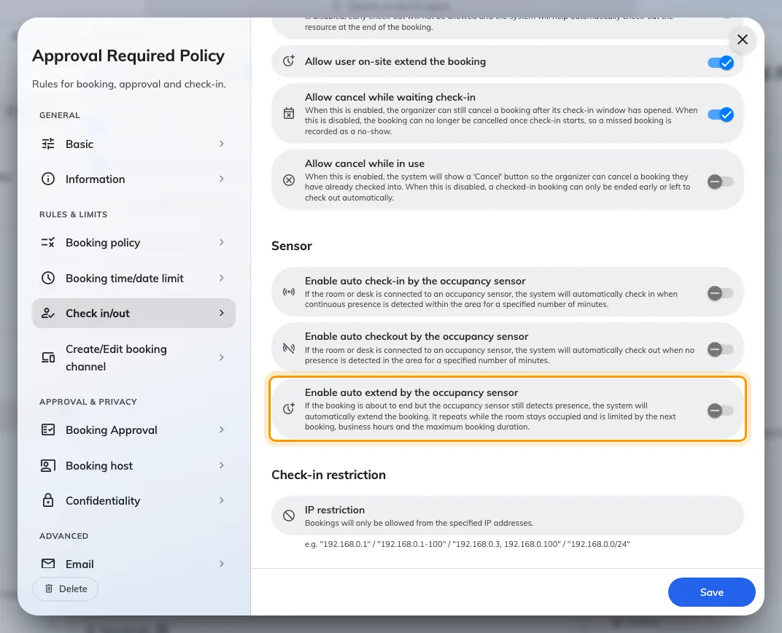
Enable auto extend by the occupancy sensor, for the meeting that runs over.
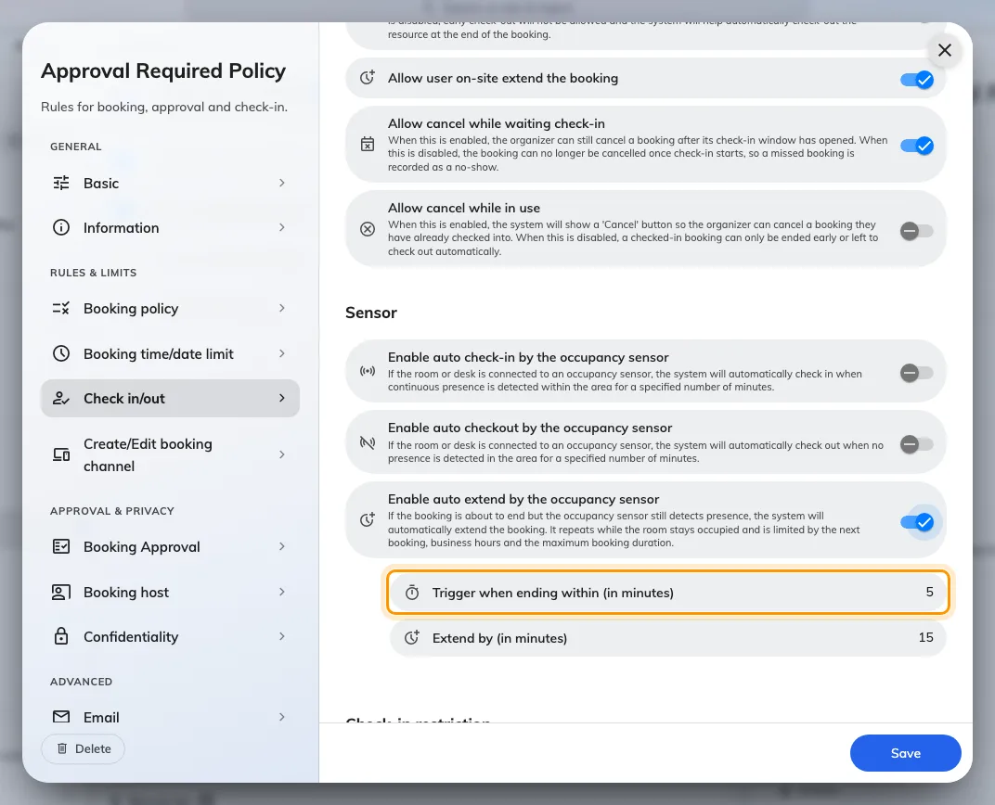
Trigger when ending within: how close to the end the room is checked.
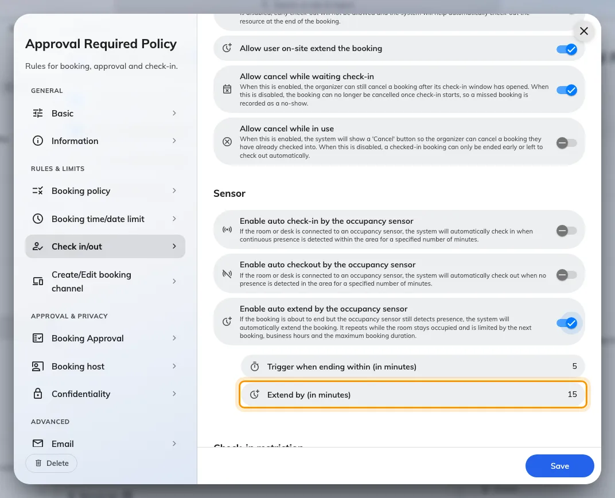
Extend by: small increments, so an empty room is given back quickly.
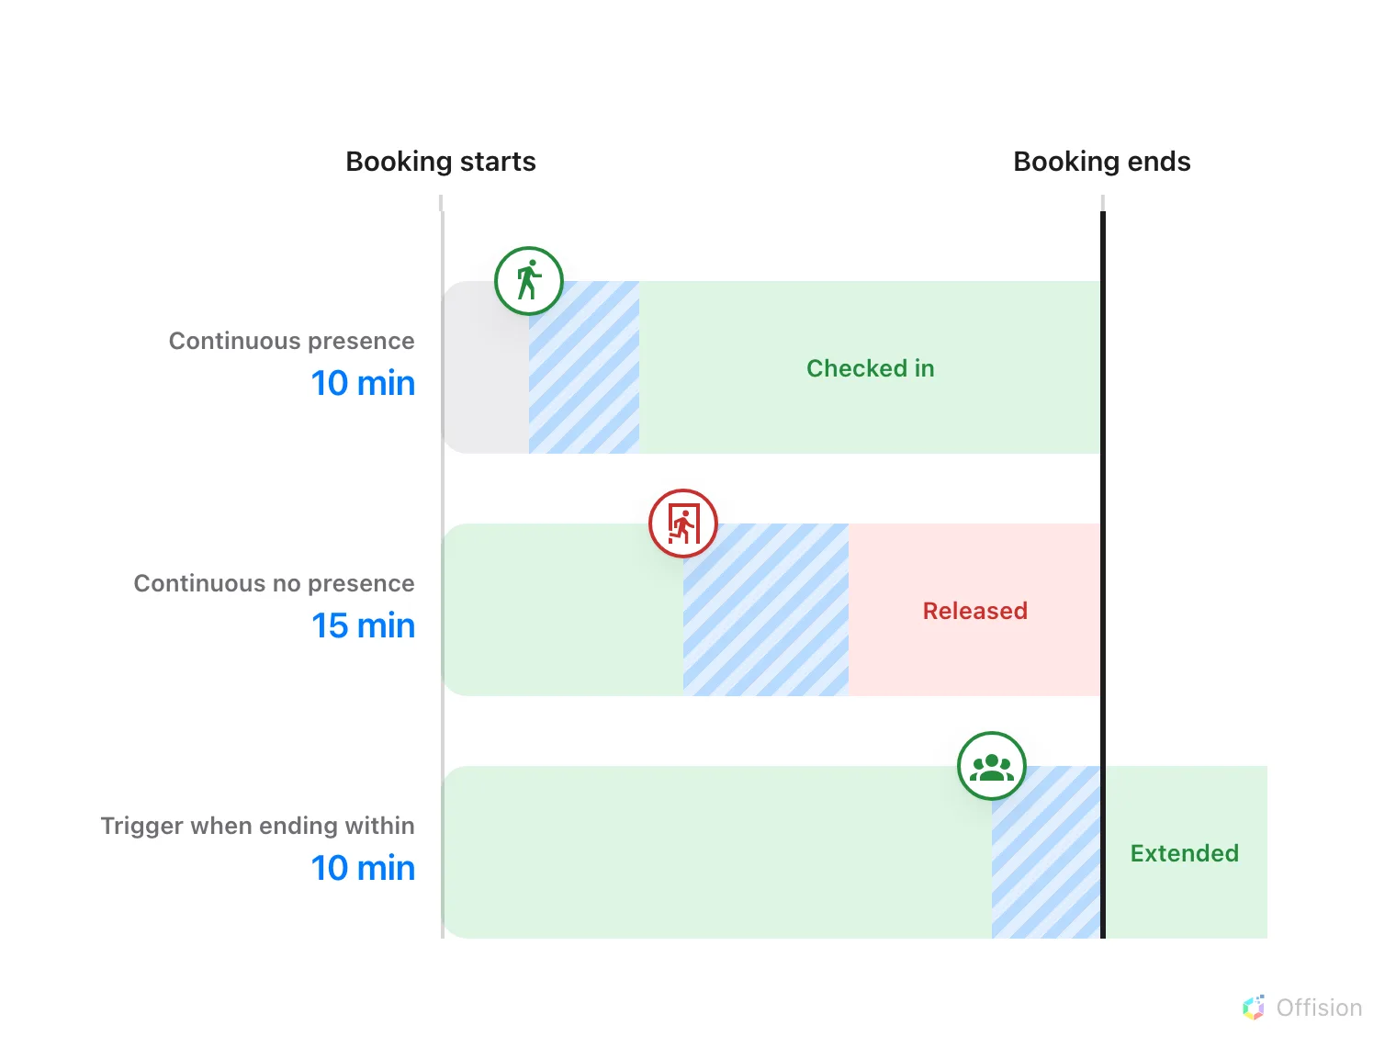
All three are the same quantity — a stretch the sensor has to keep reporting. Only where it is measured differs.

5. Check it worked
Book the room, sit in it, then leave. After the no-presence duration the booking
releases itself, and its history records the release as Auto Check out — see
Trace what happened to a booking.

What this does not control
- A booking nobody turned up to. That is the check-in window, in
How check-in and no-show work.
- The buttons people press themselves, End now and extend — see
Extend or end a meeting early.
- Which sensor watches which room. That is set on the sensor itself — see
Which occupancy sensors work with booking.
- How many people are in the room. An occupancy sensor reports occupied or
not, and nothing here needs more than that —
a people counter is a different device.

