Charge desks and rooms from separate budgets
A second quota unit gives desks their own budget, so a month of hot-desking cannot eat the meeting-room allowance — and neither can pay for the other.
2026-08-25 · https://offision.com/help/en/booking/charge-desks-and-rooms-separately/
One budget for everything bookable has an obvious failure: somebody who hot-desks
five days a week arrives at the quarter with nothing left for the one meeting
that mattered. Giving desks a quota unit of their own fixes it, because units
never pay for each other.
Before:
You need rooms and desks already set up, and the booking quota
overview read — this page assumes you know
what a resource quota policy and a user quota policy do.
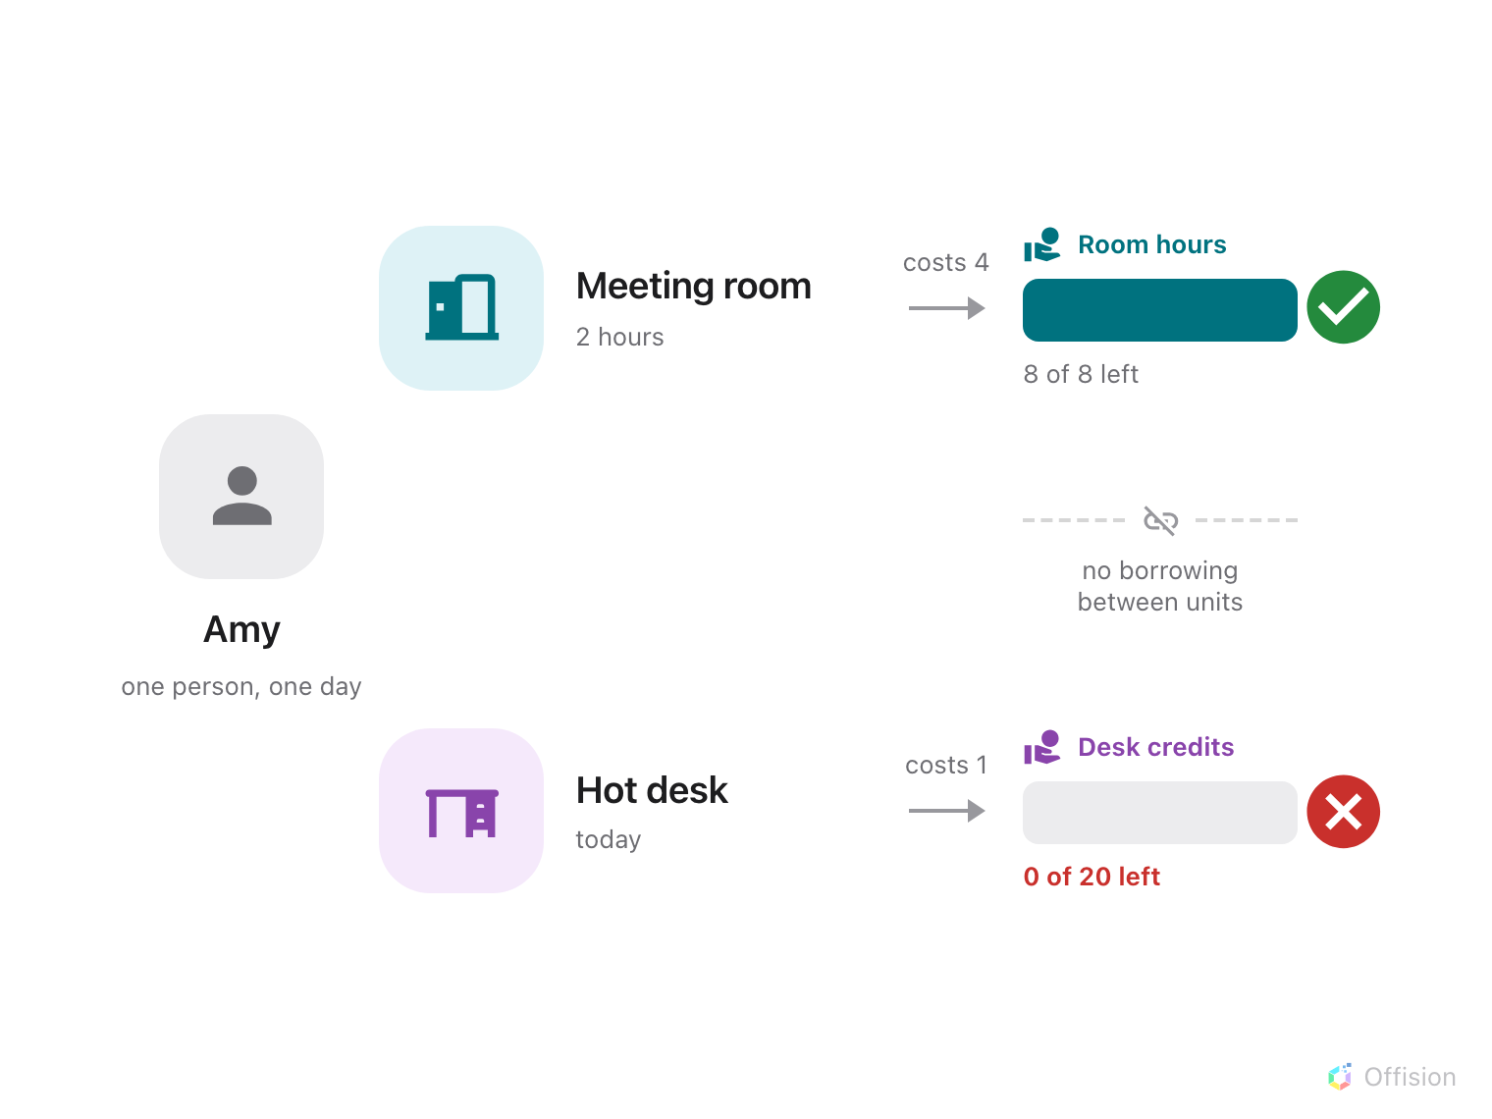
Each quota unit is its own budget — running out of Desk credits stops the desk booking and leaves the Room hours untouched.
A booking has to satisfy every unit it touches. That is what makes this work
in both directions: an empty desk budget cannot be topped up from the room
budget, and a heavy month of meetings still leaves the desks bookable.

1. Create a unit for each budget
Open Quota settings — under Booking → Settings → Booking rules,
choosing Show more if it is not in the sidebar — and go to the Quota unit
tab.
Where in Offision: admin app → booking/quota-policy (Quota settings)
Add one unit per budget you want to keep apart. A unit is nothing but a name, so
name it after what it counts and how it is counted: Room hours and Desk
credits read better in a charge banner than Point 1 and Point 2, and the
name is what the person booking sees.
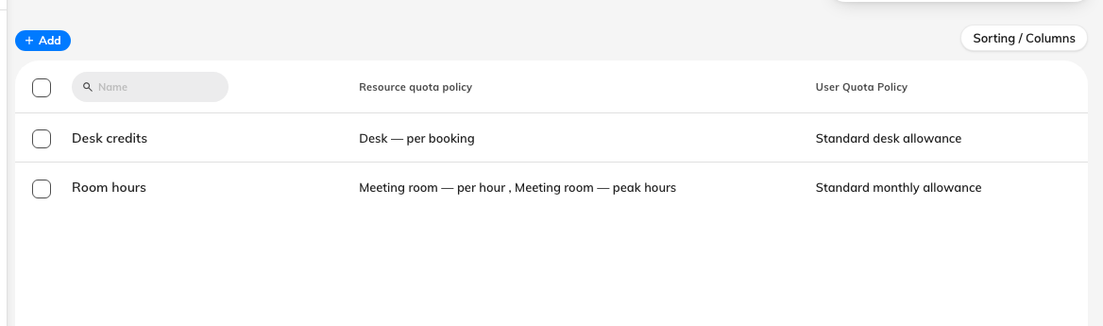
Two units, two budgets. The name is what appears on the booking form.
Two is usually enough. Every extra unit is another balance to grant to every
person, and a resource charging in a unit somebody has no policy for simply
refuses their booking.

2. Price each resource type in its own unit
On the Resource Quota Policy tab, add one policy per unit:
- Meeting room — per hour, in Room hours, Charge by Per hour.
Duration is what you want people to economise on for a room.
- Desk — per booking, in Desk credits, Charge by Per booking. A
desk is booked for a day, so what you are rationing is days, not hours.
Note:
Quota unit appears only while a policy is being created. It cannot be changed
afterwards — moving an existing policy onto a new unit means deleting it and
creating it again. Get the units in place before you build the policies.

3. Attach each policy to its resources
Open a policy and use the Assigned resources pages in its left rail — one
page per resource type, each with a count. Attach the rooms to the room policy
and the desks to the desk policy.
A resource can carry only one quota policy, so a resource cannot be charged in
two units at once. If a booking covers a room and a desk, it is charged in both
units — one from each resource — and both have to be affordable for it to save.

4. Grant both budgets to each person
On the User Quota Policy tab, add one policy per unit. The unit is chosen
here too, and it is fixed here too, so a person who should be able to book both
needs two policies — one granting Room hours, one granting Desk credits.
Set each period independently. Desks and rooms rarely want the same rhythm: desk
credits usually reset monthly, meeting-room hours quarterly.
Note:
Somebody with no policy in a unit has a balance of zero in it, not an exemption.
When you add a second unit, everybody who should still be able to book those
resources needs granting on it — otherwise the new unit reads as a lockout on the
day you switch it on.

5. Check it worked
Open a booking on a room and on a desk. The charge banner lists one row per
quota unit, so a booking that touches both shows both, each with its own
remaining balance.
Then check the separation actually holds: spend a person's desk credits down to
nothing and confirm they can still book a room. That is the whole reason for
doing this, and it is the one thing a single-unit setup would fail.
Where in Offision: admin app → booking/quota-history (Quota usage history)
Quota usage history can be filtered by quota unit, which is how you check one
budget's spending without the other in the way.

Retiring a unit
A quota unit cannot be deleted while any policy still uses it — the console
refuses with The quota unit cannot be deleted as it is assigned to some
policies. Delete or re-point the resource policies and the user policies first,
remembering that re-pointing means re-creating them.

