Booking form reference
The screen that decides what people are asked when they book — every built-in field you can switch off, reorder or rename, and every setting on a field you add yourself.
2026-09-01 · https://offision.com/help/en/booking/booking-form-reference/
This is the screen where a booking form is built: the built-in fields you switch
off, reorder and rename, and the fields you add yourself. Which of your forms a
given booking ends up using is decided elsewhere — see
which form a booking uses.
Where in Offision: admin app → booking/booking-form (Booking form)
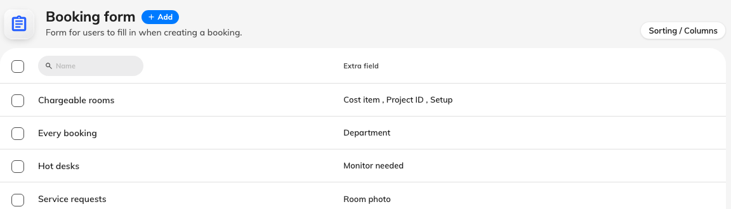
One row per form, with the fields it adds beside it.

The form itself
The editor opens on Settings, and these three sit above the field list.
Setting | What it does | When to change it
Name | Names the form in the list and on each resource that uses it | Name it after the group of resources it serves, not after its fields — the fields change, the group does not
Branch management | Limits the form to one branch of the organisation | Only on a multi-branch site where each branch runs its own forms. It appears only where branch management is licensed
Default display form | Makes this the form people see before they have picked a resource | Turn on for the one form whose questions apply almost everywhere. At most one form per site can hold it

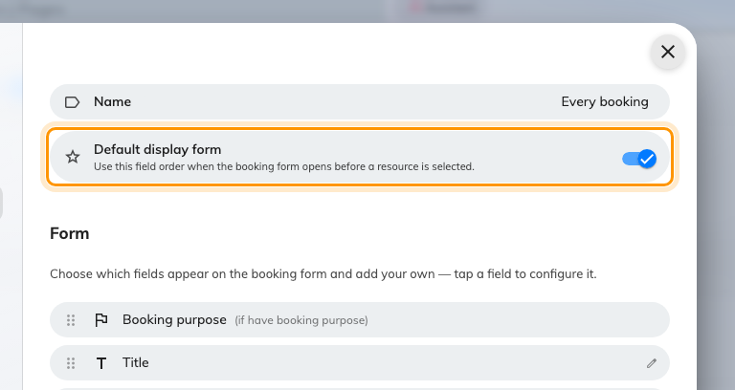
Default display form, on the one form that holds it.
The rest of the editor's rail is one page per kind of resource — rooms, desks,
equipment, parking, other — each carrying a count of the resources assigned to
this form. That is where a form is attached to the space it serves.
Below the settings sits the field list: every built-in field and every field you
have added, in the order they appear on the booking form. Drag to reorder, select
a field to configure it, and choose Add field for one of your own.

Built-in fields
These exist on every form. Some can only be reordered; the rest open a small
editor when selected.
Field | What you can change | Notes
Booking purpose | Order only | Appears only when the resource has booking purposes
Title | Where it appears, Allow private booking, and its own name | The subject of the booking
Period | Order only
Resources | Order only
Number of room users | Show manual participant count, and Require manual participant count | Appears only when the resource is a room. Required only bites while the field is also shown, and is enforced everywhere — the panel, the mobile app and the booking API, not just the web form
Online meeting | Where it appears
Service | Order only | Appears only where booking services exist
Organizer | Order only | Appears only where a delegated user exists
Attendee | Where it appears, and an Alias name
Host | Its own name only | Shown only when the resource policy allows inviting a host, which is why it has no visibility switches of its own
Visiting purpose | Order only | Appears only with visitor management
Notes | Where it appears, and its own name | The free-text body of the booking

Where a field appears
Five switches, one per kind of resource: Show when room booking, Show when
desk booking, Show when equipment booking, Show when parking booking
and Show when other booking. Notes and Online meeting carry all five.
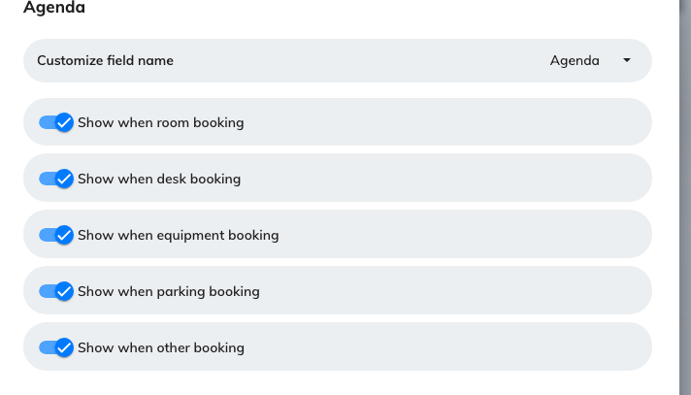
Notes, with all five kinds of resource to choose from.
Title and Attendee are the exception: desk, equipment and parking still
appear in their lists but are fixed off, because a title and a guest list only
make sense for a room or an "other" resource. So a desk booking never asks for
either, whatever the rest of the form says.
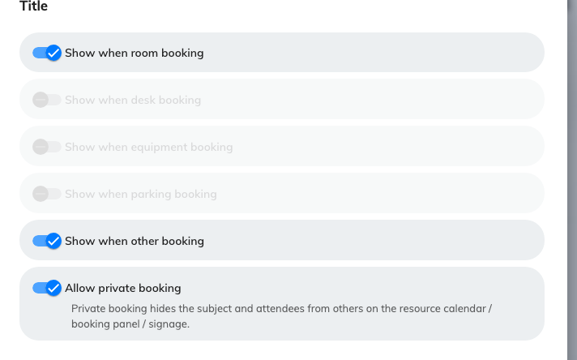
The Title field: where it appears, and whether a booking may be private.
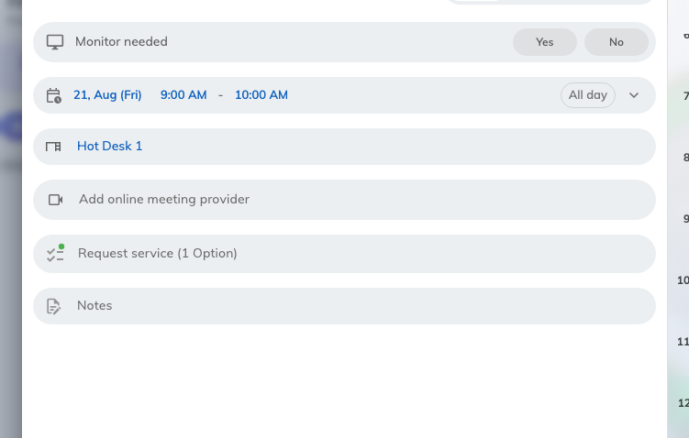
The same site, booking a desk: no title, no attendees.

Allow private booking
On Title. It lets the person booking hide what the meeting is about — the
subject, the notes and the attendee list — from everybody else. It does not hide
the booking. On the form it arrives as a Private control beside the title;
which screens it comes off, and who can still read it, is What a private
booking hides.
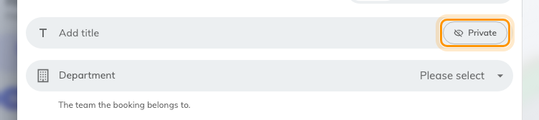
What the switch produces: the person booking decides, one booking at a time.

Alias name and Customize field name
Two labels for one job — they replace the wording of a built-in field without
changing what it does. Attendee calls it Alias name; Title, Notes
and Host call it Customize field name. Use them where your organisation's
word differs from ours: Guests rather than Attendee, Agenda rather than
Notes.
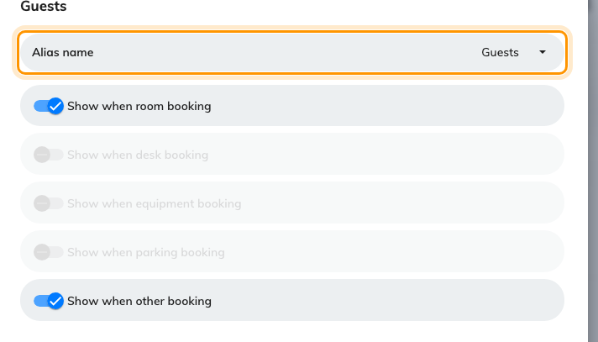
Attendee, renamed.
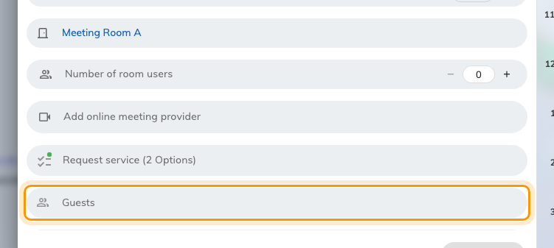
The renamed field on the booking form. It still invites attendees.
Note:
Fill the name in for every language your site uses. A name given only in
English renders in English on a Japanese screen.

Fields you add yourself
Every field you add carries the same settings. Building one end to end is
Ask for a cost item and project ID on every booking.
Setting | What it does | When to change it
Name | What the person booking sees | Always fill it in for every language your site uses
Description | A one-line hint under the field | Use it for the rule people get wrong, not to restate the name
Icon | The mark beside the field | Pick something recognisable; it is how people find the field in a long form
Field type | What kind of answer is accepted — see the table below
Select option | The choices, for Select and Multiple select | For a short fixed list. A long or shared list belongs in a data set
Data set | Which reusable list backs an Autocomplete field
File type | Limits an upload to images, PDFs, or both
Required | The booking cannot be saved without an answer | Turn on for anything you intend to reconcile or report on later
Show in email | Puts the answer in booking confirmation emails
Show in User Portal (Resource schedule) | Colleagues viewing that resource's schedule can read the answer | Leave off for anything commercially sensitive
Show for service staff | The answer reaches the people fulfilling service requests
Show for service manager | The answer reaches service managers

Three of those appear only for the field type that uses them: Select option
for Select and Multiple select, Data set for Autocomplete, and
File type for the two upload types.
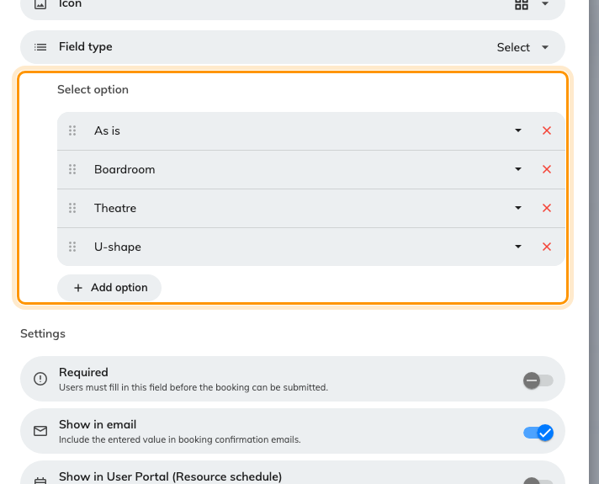
A Select field, with its options listed on the field itself.
Required and Description are what the person booking actually meets: a
mark against the field they cannot save without, and the line of guidance under
it.
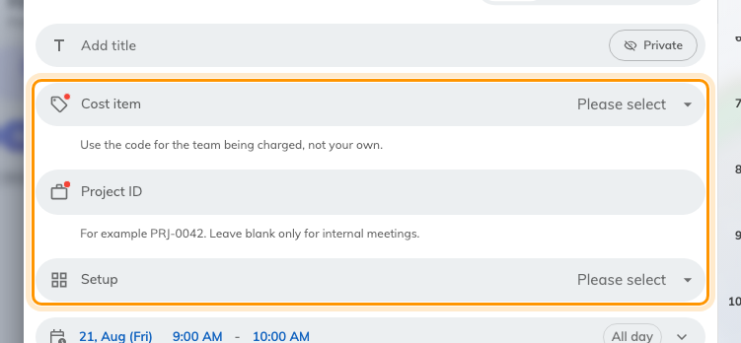
Three added fields. The two with a red mark cannot be left blank.
Whatever the four Show switches say, the answer always reaches the booking's
own detail, the approval screen, and the booking export — one column per field.

Field types
Field type | Accepts
Text | One line of free text
Rich text | A formatted paragraph
Number | A number. Drops leading zeros and prefixes, so not for identifiers like PRJ-0042
Phone number | A telephone number
Date | A calendar date
Time | A time of day
Date & time | Both together
Yes / No | A single switch
Select | One choice from the options set on the field
Multiple select | Several choices from those options
Autocomplete | One entry from a data set, searched as the person types
Upload file | One file, of the accepted types
Upload multiple file | Several files

A Select renders as a row of pills only while it has three options or
fewer and they are short enough to fit one row; a fourth option, or a label
long enough to overflow, turns it into a dropdown. That is decided from the
options themselves and there is no switch for it. The width is judged on what
the labels actually occupy, so a Chinese or Japanese option counts about double
an English one of the same length.

What this does not control
- Which form a booking gets. Three routes decide that, and none of them is
on this screen — see
which form a booking uses.
- Who may book at all. Team spaces and resource policies, not the form.
- Whether the Host field appears. The resource policy decides; this screen
only names it.
- Whether a reviewer can read your fields. The resource policy carries its
own switch for that.
- The resource's own description. It belongs to the resource, not the form,
and whether it prints beside the picker is a UI customization setting — see
Show a room's description on the booking form.
- Visitor forms. Visiting has its own form builder, and the two never share
fields or data sets.

