Booking data set reference
A data set is a reusable list of options that Autocomplete fields read from — a key, a display text, and an import. Every setting on the screen, and when to use one instead of a Select field.
2026-08-20 · https://offision.com/help/en/booking/booking-data-set-reference/
A data set is a reusable list of options that Autocomplete fields read from.
Define it once and every booking form can point at it — which is what separates
it from a Select field, whose options live on the one field that declares
them.
Where in Offision: admin app → booking/booking-auto-complete (Data set)
Booking and Visiting keep separate data sets. A set built here is offered to
booking form fields only; the visiting form has a screen of its own.

The data set itself
The editor opens on Settings, and the entries live on the second page of its
rail.
Setting | What it does | When to change it
Name | Names the data set in the picker on a field | Name it after what it holds — this is all somebody configuring a field sees
Branch management | Limits the data set to one branch of the organisation | Only on a multi-branch site where each branch keeps its own lists
Entries | The rows themselves, on the second page of the rail

An entry is a pair
Setting | What it does | When to change it
Key | The code stored alongside the answer | Set it to whatever your other system reconciles on. Renaming the display text later then leaves past bookings intact
Display text | What the person booking reads

Both matter, and for different reasons. The key is what gets written next to the
booking, so it is the half your finance or facilities system will match on; the
display text is the half a person recognises. Give the display text in every
language your site uses — one given only in English renders in English on a
Japanese screen.
Note:
An entry may be saved with no key. It then shows as (No key) in the list, and
the booking stores only the display text — which is fine for a list nothing else
reconciles against, and a problem for one that does.

Import and export
The entries page carries Import and Export buttons, and an empty data set
offers Import from Excel directly.
Setting | What it does | When to change it
Import | Loads the rows from a spreadsheet | For any real list — a chart of accounts is not worth typing
Export | Writes the rows back out | Take one before a bulk change, so a bad import can be undone
Add row | Adds one entry by hand | For a correction, not for the initial load

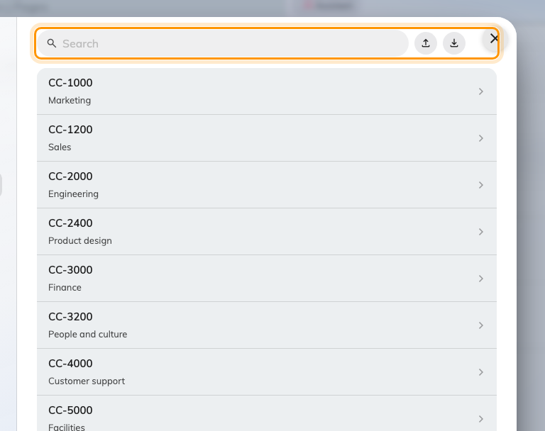
The entries, with Import and Export above them.

What people see
A field of type Autocomplete names one data set, and the person booking
searches it as they type rather than scrolling a list. That is the whole reason
to prefer a data set over a Select field once the list is long, shared
between forms, or maintained by somebody other than you.
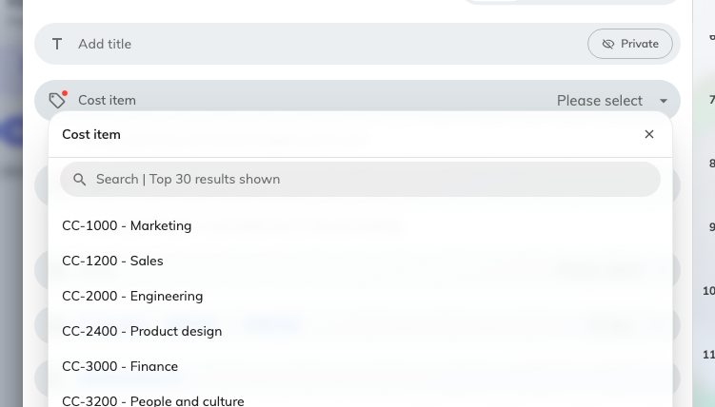
The same set on the booking form, searched as the person types.
Pointing a field at a data set is done on the field, not here — see
Fields you add yourself, and
Ask for a cost item and project ID on every booking
for the whole job end to end.

What this does not control
- Which fields use it. A data set is offered to every booking form; the
fields that read it are the ones you point at it.
- Whether the answer is required. That is Required, on the field.
- Who can read the answer. The field's own Show switches decide that.
- Visiting's data sets. A separate screen, and the two never share entries.

