Approve or reject a booking request
Someone has asked to book a room you approve for. Where the request is waiting, what happens when you decide, and what the organiser is told.
2026-08-16 · https://offision.com/help/en/booking/approve-or-reject-a-booking-request/
Before you start:
Someone must have named you, or a group you belong to, as an approver on the
room's booking policy. If nothing ever reaches you, that is the setting to check
— see Require approval before a room is booked.

1. Find the request
You are told three ways, and any of them gets you to the same place:
- An email, Booking approval request. Its link opens the request directly.
- A notification in the app.
- A count on the Booking approval list, which is where requests pile up if
you have been away.
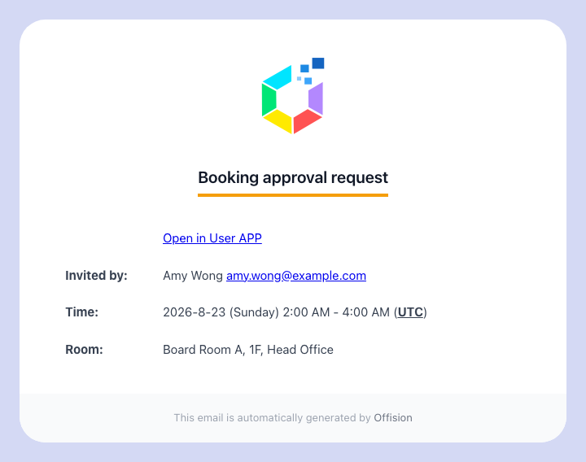
The email an approver receives.

2. Decide, from wherever you already are
Most approvers work from the Booking approval list in the app. It has two
tabs: the requests still waiting for you, and Approval History — everything
already decided, including anything the system auto-rejected.
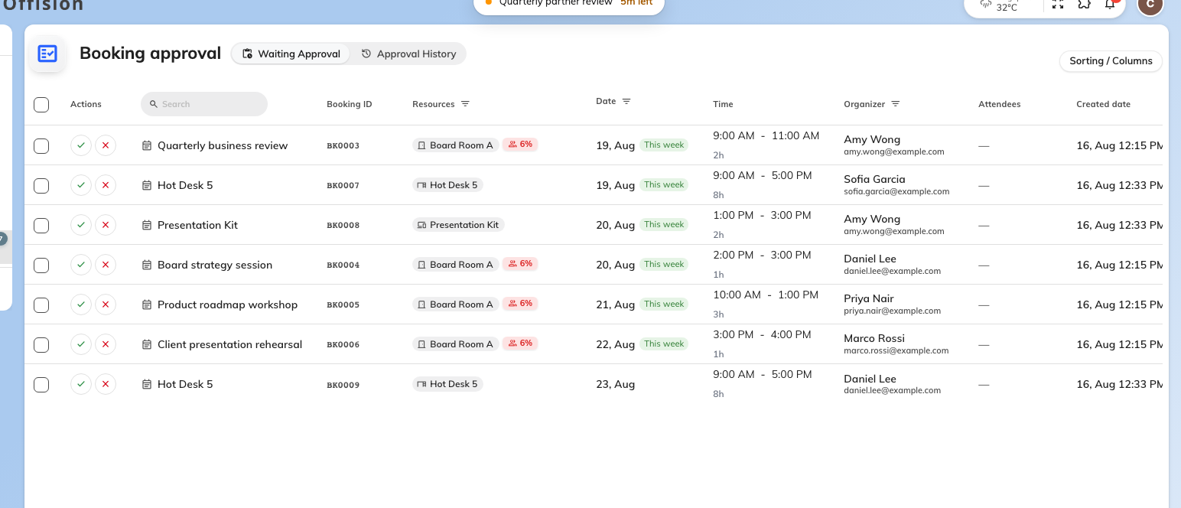
The Booking approval list, with what is waiting for you.
Open a request to see who asked, for which room and when, and the answers to
whatever the booking form asked them. Then Approve or Reject.
A repeating booking is one request:
Approving a repeating booking approves every occurrence, not the single date
shown on the row. Check the dates before you approve. If the organiser later
moves one occurrence, that date comes back to you as a separate request.

3. Approving
Approve, and the room is booked. The organiser is emailed that the booking is
approved, and it starts behaving like any other booking.
Two things can interrupt it:
- Cannot approve — something else has taken the slot since the request was
made. This is what happens on a policy that does not hold the time slot while
it waits. Reject the request and tell the organiser to rebook.
- A conflict with another booking you can also approve — you are offered to
reject the clashing one at the same time. Read that prompt carefully; it
rejects someone else's booking.

4. Rejecting
Rejecting asks for a Reason for rejecting, and it is required. That reason
goes to the organiser in the rejection email — it is the whole difference between
a rejection people accept and a rejection they escalate.
You can also Suggest an alternative: a different time, a different room, or
both. It arrives with the rejection, so the organiser can rebook without another
round of messages. Use it whenever you are rejecting because of when rather
than whether.

5. If you administer Offision
Booking managers get the same requests as a full page in the admin console, with
Waiting Approval and Approval History tabs, sortable columns, and
Approve all / Reject all for clearing a backlog.
Where in Offision: admin app → booking/approval (Booking Approval)
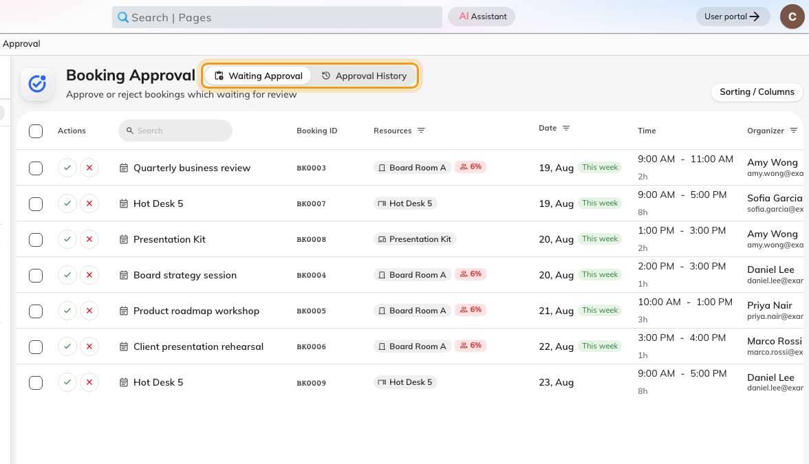
The admin queue: waiting requests, and everything already decided.
Select a row and the request opens over the list, with Approve and
Reject on it.
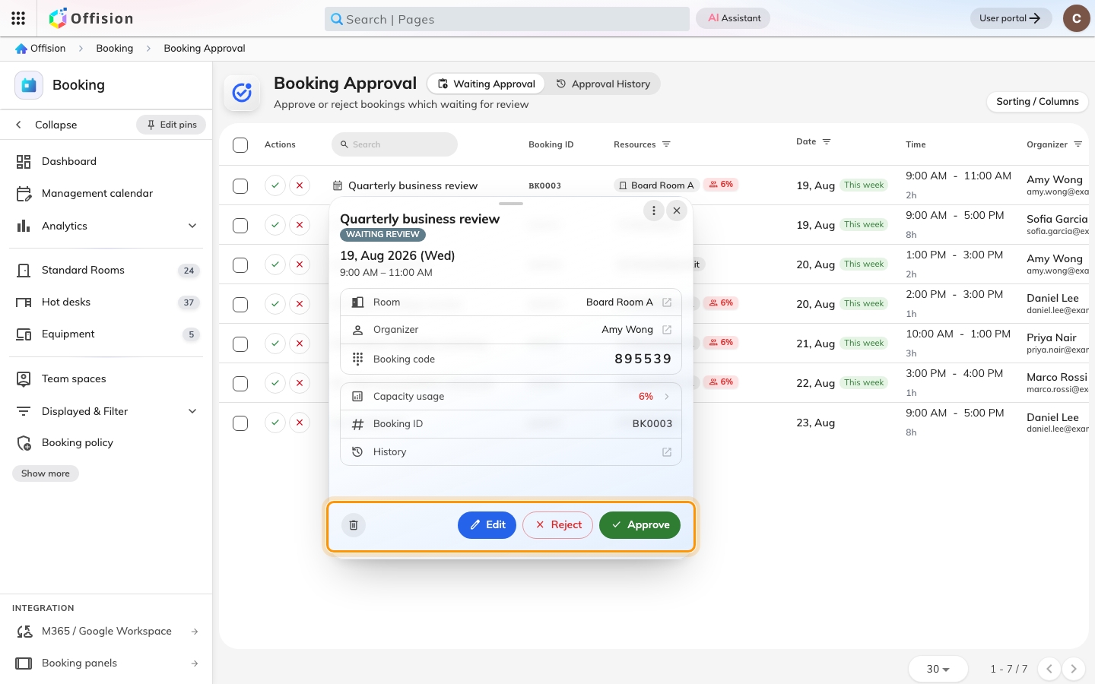
The request opens over the list. Decide from here.
This page needs the Booking manager permission. If you approve bookings but
do not administer Offision, you will not have it, and the app list in step 2 is
your queue — not a lesser version of this one.

6. What the organiser sees
Until you decide, their booking reads Waiting review and is not confirmed.
Approve, and they get the ordinary booking confirmation. Reject, and they get
Booking rejected, carrying your reason and any alternative you suggested.
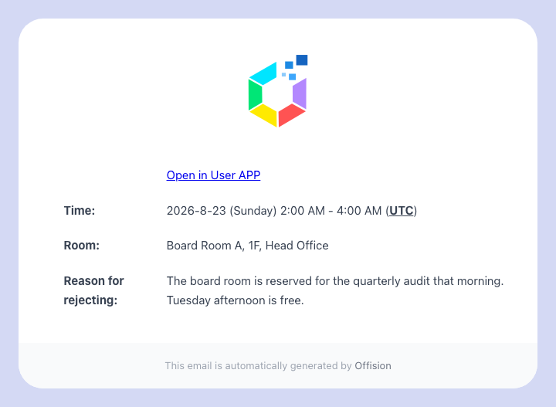
The rejection the organiser receives, with your reason.
Requests do not wait indefinitely. Each policy can set a number of days after
which an unanswered request is rejected automatically; the organiser is told it
was Auto rejected: no approval before time was up. If that phrase is turning
up in Approval History, requests are reaching nobody — check that the
approvers on the policy are still the right people.

