Add equipment, parking spaces and other resources
Make a projector, a loan laptop, a car park bay or an iPad bookable. Each has its own list but the same editor as a room; this page is the handful of fields that differ, where each type can and cannot go — floor plans, panels, stickers, import — and how people actually book them in the app.
2026-08-26 · https://offision.com/help/en/booking/add-equipment-parking-and-other-resources/
Rooms and desks are where most tenants stop, but anything that one person at a
time should hold can be a resource: the portable projector, the two loan
laptops, the visitor bays by the door, the iPad the sales team share. Offision
files them under three lists, and every one of them is made on the same editor
as a room — so this page is written as the differences from
Add a room, not a second copy of it.
Before you start:
Booking management access, and a building with a floor to put things on. Read
Add a room first if you have not made a resource before —
the add panel, the editor's pages and the Policy switch are all the same
here.

1. Pick the list
Three lists sit beside Rooms and Hot desks in the booking menu. Which
one you use decides which fields the editor shows and which app filter the
thing appears under, so pick by what it is rather than what is convenient.
Where in Offision: admin app → booking/equipment (Equipment)
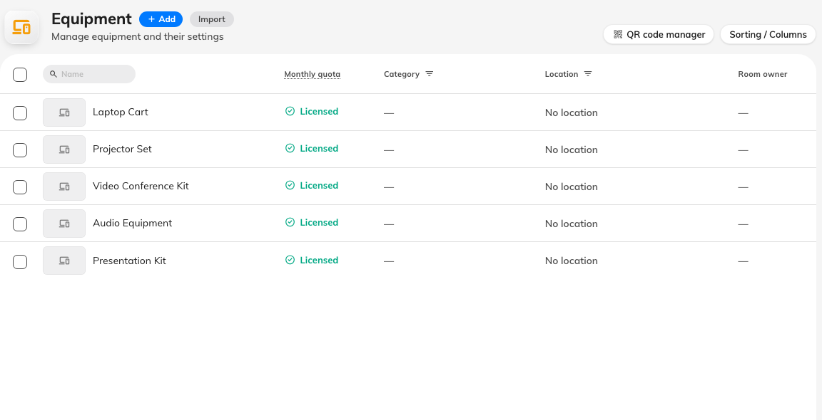
The Equipment list — the same shell as Rooms.
List | The product's own description | Use it for
Equipment | Items that can be used in an office. | Things that go with a meeting or a person — projectors, whiteboards, laptops, tablets, phones, a pool car, a locker
Parking spaces | List of spaces for car parking. | Bays. One bay, one resource, sized for a vehicle
Other resources | Miscellaneous office items for reservation, such as iPad, computer, and parking lot. | Anything that fits neither — a whole car park booked as one unit, a studio, a piece of lab kit

Add on each list opens the same one-field panel as a room's — Add
equipment, Add parking space or Add resource — with the next number
filled in. Save, then click the row and Edit.

2. Fill in what differs from a room
The editor's pages — Basic, Policy, Service, Advanced, Out of
service period, Information — are identical to a room's, as are
Location, Description, Amenity, Business hour, Access ID
and the photo. The differences fit in one table:
Field | Room | Equipment | Parking space | Other resource
Capacity | Required | Not shown | Not shown | Not shown as a saved value
Parking space size | — | — | Required. Motorcycle, Car, Medium vehicle or Large vehicle; Car is preselected | —
EV charger | — | — | A checkbox. Tick it on bays with a charger, so a booker filtering for one finds it | —
Category | Room categories | Equipment categories | Parking categories | Other categories

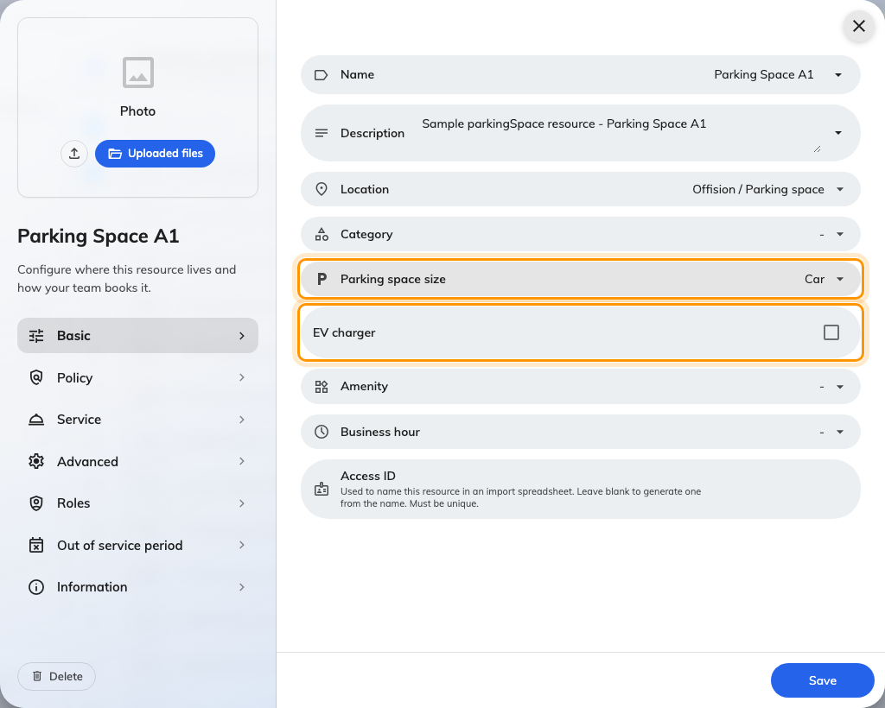
A parking space on Basic: Parking space size and EV charger are the fields a room does not have.
Category is worth a moment. Categories belong to a type, so the picker only
offers the ones made for that list, and each category carries a Type for
analysis that the usage reports group on. The analysis types available to
each list are the product's own idea of what belongs there:
- Equipment — TV, Projector, Whiteboard, Digital whiteboards, Laptop,
Computer, Tablet, Mobile phone, Car, Locker, Other equipment type.
- Parking spaces — Bike space, Ordinary space, Truck space, EV charging
space, Bicycle space, Disable parking space.
- Other resources — Others, and nothing else.
Make the categories first, under Categories, and they are ready in the
picker — see Set up categories and amenities.
Then Policy, exactly as for a room: Booking settings on, and a booking
policy if the default is not right — a loan laptop that must be checked in, a
parking bay that can be booked a month ahead. Save.

3. Place it, badge it, put a panel on it
All three types can be placed on a floor plan through Location, and all
three get QR code manager in the list header and QR Code sticker in the
detail panel — see Put up resource stickers. A
sticker on a locker door or a projector case is usually how people book these
at all.
A booking panel can be bound to a room, a desk, equipment or an other
resource. It cannot be bound to a parking space.
Import works on every list with the same sheet — ID, Name and one
column per extra language — plus Has EV Charger for parking spaces. There
is no capacity or size column for these types; set those on the resource
afterwards.

4. Know how people will book them
This is where equipment and parking differ most from rooms, and it is worth
explaining to the people who will use them.
- Equipment is usually booked alongside a room. The booking form offers
equipment as a second row of choices under the room being booked, so the
projector goes with the meeting rather than being a separate booking. It can
also be booked on its own from the Equipment entry in the app's type
picker.
- A parking space pairs with a desk in the same way — book a desk, and the
form offers a bay under it. Bays also have their own Parking spaces entry
in the picker.
- Other resources are not in that picker. People reach them from the home
screen's filters and quick actions, and the app's search box says Find
resources rather than naming the type. If nobody can find one, that is
usually why.
Whichever way it is attached, an attached item is checked for conflicts and
closures like the room it goes with: a projector already promised to another
meeting refuses, and a bay under an out of service period warns or blocks.

5. Check it worked
Open the user app and book one of each type the way a colleague would: a room
with a piece of equipment attached, a desk with a parking space under it, and
an other resource from the home screen. Then book the same equipment from a
second account over the same hour — it should be refused. If the type is
missing from the picker, the picker hides itself when only one type exists, and
an other resource is never in it: use the home filters.

What does not exist
- A quantity on equipment. Three identical trolleys are three resources.
Name them Trolley 1, 2 and 3 and give them the same category.
- A number plate on a parking booking. A plate is only asked for on a
visitor's vehicle, in the visitor section of a booking form; an employee
booking a bay is not asked.
- A locker module inside Booking. Lockers with electronic doors are a
separate part of Offision. Locker as an equipment category is how you
model an ordinary lockable cupboard that people reserve.
- A bike module. Bike and bicycle spaces are parking-space categories.

