Add a room
Create a bookable meeting room, put it on a floor, and switch it on for booking. Adding it takes a name and nothing else. The same form makes every other kind of resource, so a desk starts here too. About ten minutes.
2026-09-01 · https://offision.com/help/en/booking/add-a-room/
Before you start:
A building with at least one floor — see
Add a building and its floors.
A resource will save without one, but it then has no location anywhere in the
product, so do the building first.

1. Open Standard Rooms
Where in Offision: admin app → booking/room (Standard Rooms)
Every other resource is made on this same form:
Hot desks, equipment, parking spaces and other resources each have their own
list, but all of them open the form described below — one entity, one editor,
a different type. So read this article for the mechanics wherever you are
adding from, and read the one page for the type that differs:
Add a desk.

2. Add it — the name is all it asks for
Add opens a small panel with a single Name field, already filled in with
the next number in the list — Room 6. Change it or accept it.
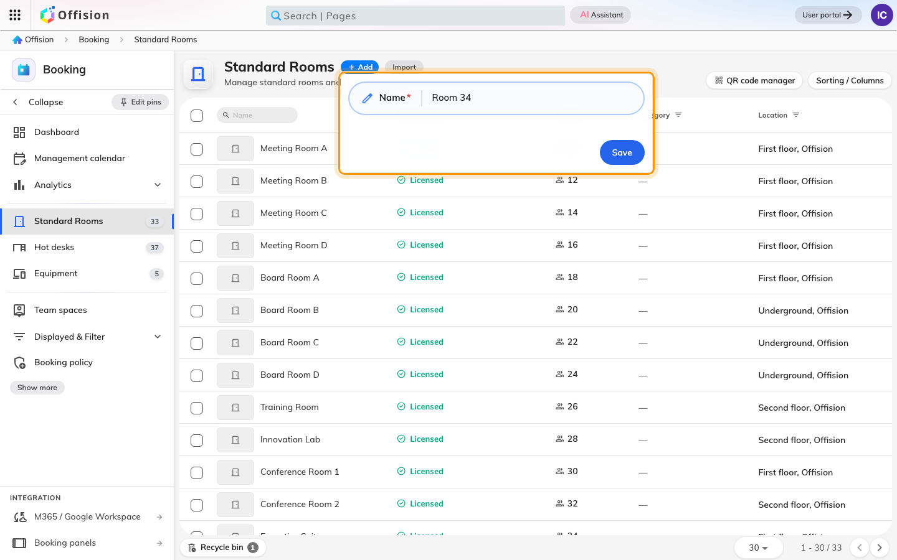
Add asks for a name and nothing else.
Save creates the resource and closes the panel. It does not open the
settings, and nothing announces that it worked beyond a new row in the list. That
is the point people most often think it failed and add a second one — check the
list before clicking Add again.
If Add opens a menu instead:
On a tenant with Microsoft 365 or Google Workspace connected, Add asks which
kind first. Offision calendar is the manual resource described here; the
other rows invite a room mailbox from that provider instead, and ask for an email
address rather than a name — see
Sync rooms from Microsoft 365.
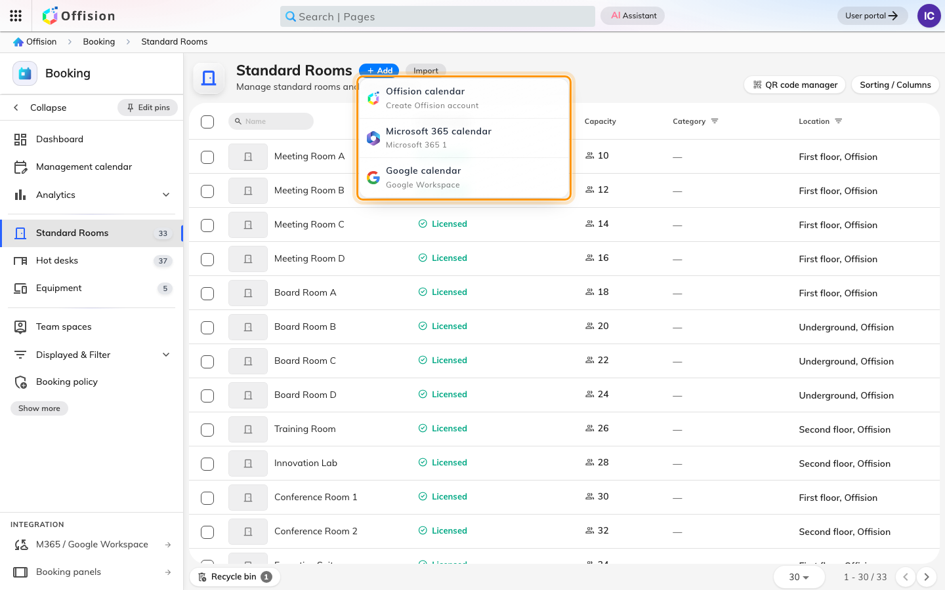
With an integration connected, Add asks which kind of room first.

3. Open the row and fill in Basic
Click the new row, then Edit. The editor has its pages down the left —
Basic, Policy, Service, Advanced, then
Out of service period and
Information — with the resource's photo above them rather than on a page
of its own.
Location is the field to get right, and it is not a text box. It opens a
picker: choose the building, then the floor, then click the room's area or a
point on the floor plan. That placement is what puts the resource on a floor
plan, filters it by floor in the user app, and lets people find it from a map.
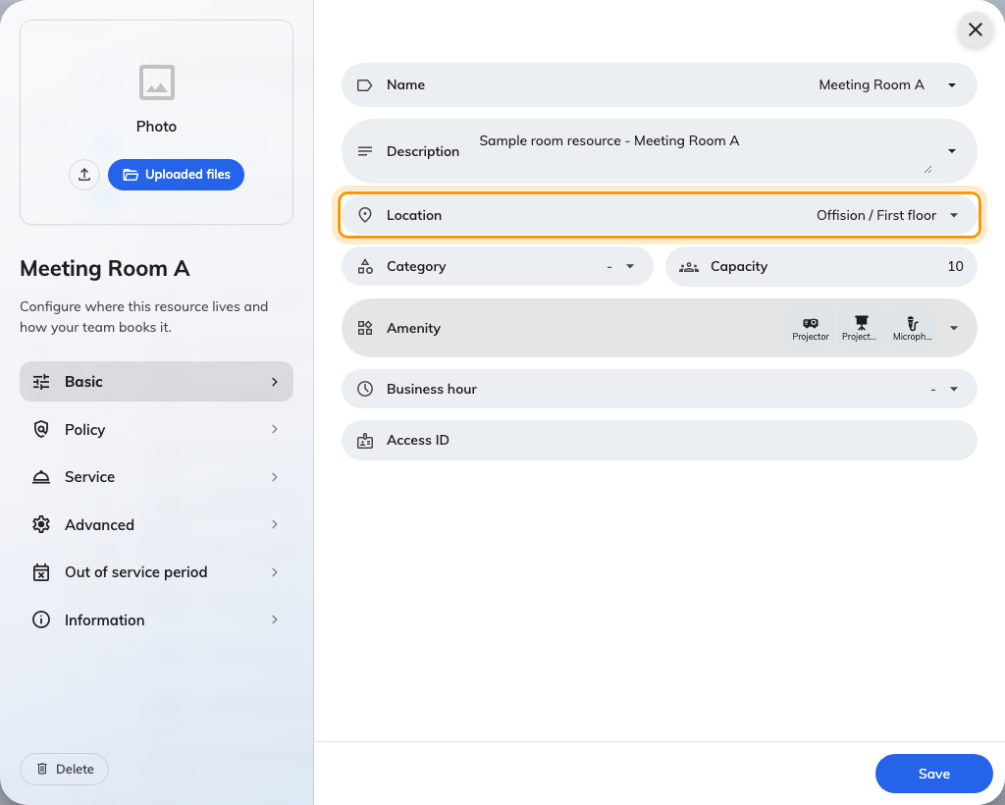
Basic, with the Location picker that puts the resource on a floor.
The rest of the page:
Field | Worth knowing
Name, Description | One value per enabled language. A blank one falls back to English. The description can also be printed on the booking form — see Show a room's description on the booking form
Category | Meeting room, Interview room, Phone booth, Lounge and the rest. The options are filtered by resource type, so this list is the rooms' own
Capacity | Required. It is what "fits 8 people" searches match, and what warns a booker who has invited more people than the room seats
Amenity | What the room has — projector, whiteboard, microphone. People filter on these
Business hour | The hours this resource may be used at all, on top of any booking policy
Access ID | The handle a spreadsheet uses to name this resource on import

4. Switch it on for booking
Open Policy. The first thing to look at is the Booking settings toggle,
because it decides whether the rest of the page exists.
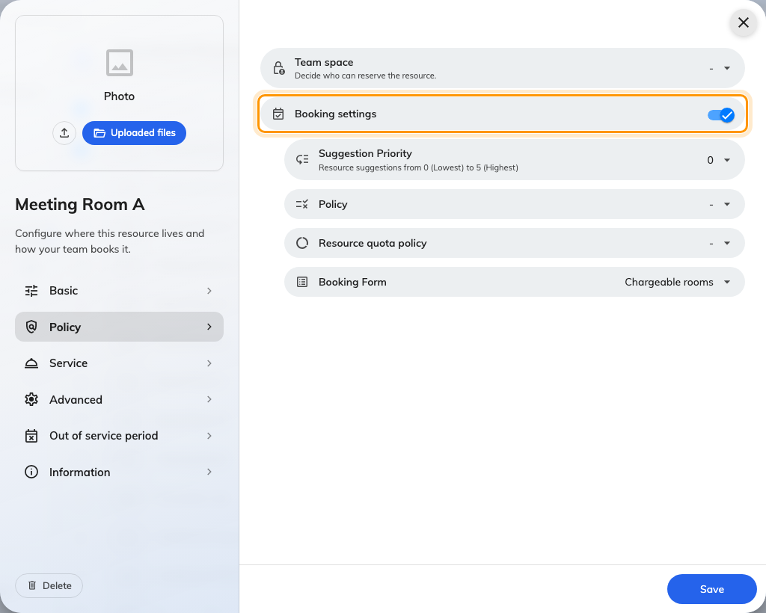
Booking settings off replaces the rest of Policy, and all of Service.
Turn it off and everything below it — plus the whole Service page — is
replaced by This resource will not be available for booking. That is the
setting to reach for when a space exists but nobody should be claiming it, and it
is also the first thing to check when a resource refuses to appear in the user
app.
With it on, four pickers decide how the resource behaves. None of them is
required, and all four point at shared objects rather than settings on this
resource, which is why a room you have not touched still obeys rules:
- Policy — the booking window, check-in, no-shows, approval. This is the big
one, and it is documented in
Booking rules reference.
- Resource quota policy — how much of this resource one person may claim.
- Booking Form — the extra fields people fill in when booking it.
- Team space, at the top of the page — "Decide who can reserve the
resource". A resource on no team space is bookable by everyone, which is the
default for everything you create here. See
Give a department its own rooms.
Suggestion Priority is the odd one out: 0 (Lowest) to 5 (Highest), nudging
this resource up or down when Offision suggests a room. It changes nothing about
whether a booking is allowed.
Save. One save covers every page.

5. Check it worked
Do not check in the admin console. It shows you every resource whatever state it
is in, so a room that is invisible to your colleagues looks perfectly fine there.
Open the user app's resource finder, search for the resource by name, and book
it. If it does not come back:
- Booking settings is off — step 4.
- It is on a team space you are not a member of. That is intended behaviour,
and it is worth confirming with an account that should have it.

Add many at once
For a whole floor — or a whole building, when
moving in from another system
— use Import, beside Add. It creates and updates resources of the list's
type in one pass, from one spreadsheet.
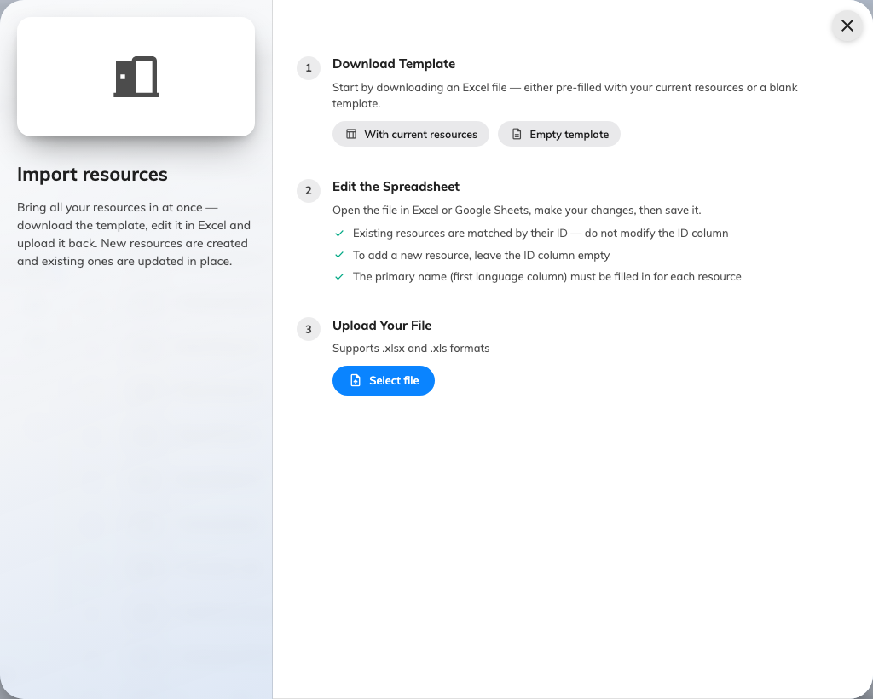
Import: download a template, edit it, upload it back.
Download a starting file first — With current resources to get everything
you already have, which is also the easiest way to rename in bulk, or Empty
template to begin from nothing. Three things decide whether an import behaves:
- Existing resources are matched by the ID column — never edit it. A row
with an ID updates that resource; a row with a blank ID creates a new one.
- The first Name column must be filled on every row. The other language
columns fall back to it when blank.
- The only other columns are Capacity for rooms and Has EV Charger for
parking spaces. Everything else — location, policy, amenities, Access ID —
is set on the resource afterwards, per step 3.
Before anything is written you get a preview counting what is new and what is
an update, row by row. Read it — a sheet that matches nothing reports no
changes rather than creating duplicates.

What this does not cover
- The panel outside the door is a separate device with its own setup — the
room does not create one.
- Approval is set on the booking policy, not on the resource — see
Require approval before a room is booked.
- Hot desks are added from their own page and behave differently in four or
five places — see Add a desk.
- Combine rooms, equipment, parking spaces and other resources are added
from their own pages. They share this form, but each has fields this article
does not cover — for a room made of other rooms, see
Combine two rooms into one bookable room.
- Creating bookings in bulk is the management calendar's own import — see
Import bookings from a spreadsheet,
which names rooms by the Access ID set in step 3.

