Add a desk
Creating a hot desk, and the five places it behaves differently from a room — no capacity, its own category list, a floor-plan point that matters more than a name, the sticker instead of a panel, and the separate page for a desk that belongs to one person — then what booking one looks like in the user app.
2026-09-02 · https://offision.com/help/en/booking/add-a-desk/
A desk is a bookable resource like a room, made on the same form, held to the
same rules and photographed by the same screens. So this article is short on
purpose: it is the handful of places a desk is not a room, and
Add a room is everything else.
Before you start:
A building with at least one floor, and — for a desk more than for anything
else — a floor plan uploaded to that floor. A desk saves without one, but
step 4 explains why a desk with no point on a plan is much less useful than a
room with none. See
Add a building and its floors.

1. Open Hot desks
Desks have their own page in the console — Hot desks, Manage desks and
their settings — sitting beside Standard Rooms under Resources.
Where in Offision: admin app → booking/desk (Hot desks)
It is the same list you already know, minus one column: there is no
Capacity here, because a desk does not have one. Add, Import, the
QR code manager and the columns chooser are all where they are on the room
list.
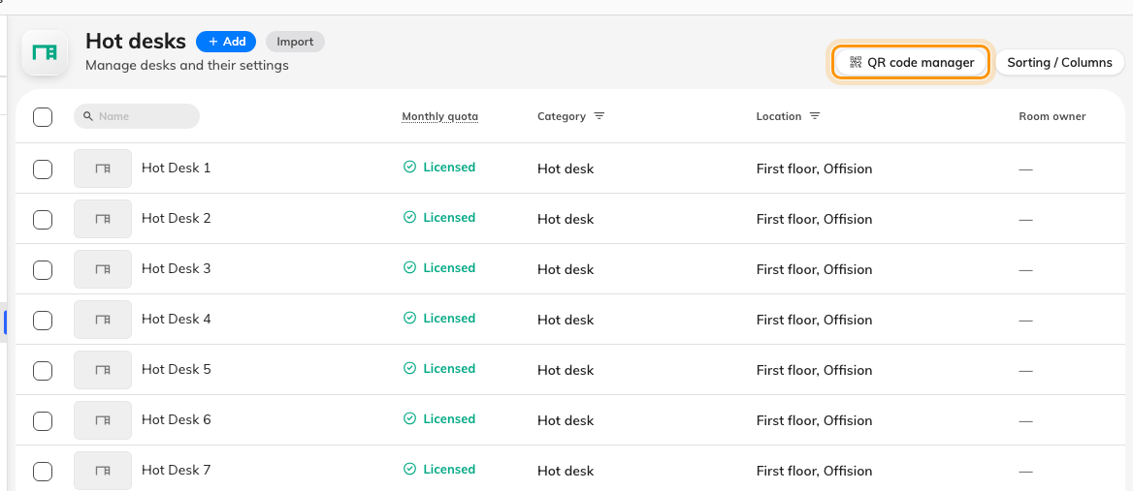
The Hot desks list — no Capacity column, and the QR code manager top right.

2. Add it — one field, as on the room list
Add opens the same small panel with a single Name field, pre-filled with
the next number in the list — Desk 38. Change it or accept it.
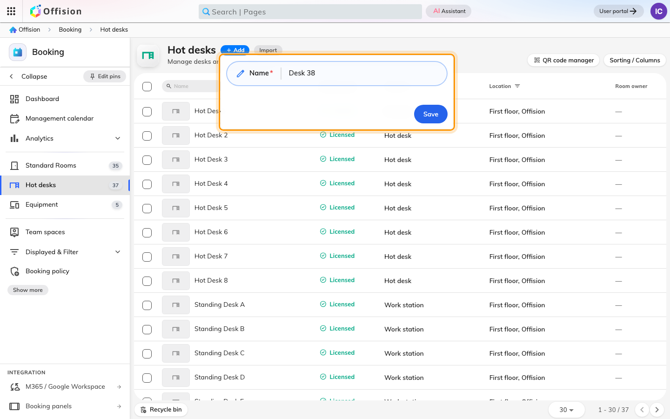
Add asks for a name and nothing else, and the number it offers counts every desk on the tenant.
Save creates the desk and closes the panel — no settings open, nothing
announces success but a new row. Check the list before clicking Add again.
The offered number counts the whole list rather than the floor you are working
on, so on an estate of any size it is a placeholder, not a suggestion. Desks are
found by name far more often than rooms are — a floor of Desk 38, Desk 39,
Desk 40 is unusable on a map — so this is the moment to name it something a
person could say out loud.

3. A desk has no capacity, and its own list of categories
Open the row, choose Edit, and the form is the room's form with two
differences on the Basic page:
- There is no Capacity field. Not hidden from you — absent from the record.
A desk is saved with no capacity at all, which is why nothing searches desks
by how many people they seat, and why the booking form never warns a desk
booker about numbers.
- Category offers the desk categories only. A category is tied to one
resource type, so a desk can never be given a room's category and a room can
never be given a desk's — the picker here holds whatever your administrator
made for desks, which on a new tenant is Hot desk, Workspace, Work
station, Phone booth and Other desk type. An empty list means
nobody has made any yet; see
Set up categories and amenities.
It is worth filling in: the category is what people filter a floor of eighty
desks down by.
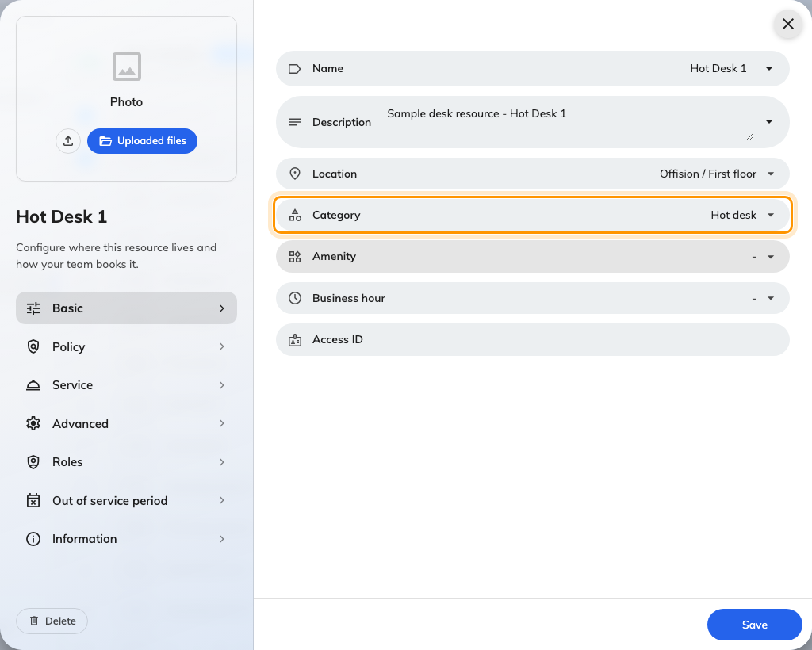
Basic on a desk. Category has the row to itself — on a room it shares it with Capacity.
Everything else on the page — name and description per language, amenity,
business hour, organization unit, Access ID — works exactly as
Add a room describes it.

4. Put it on the floor plan, not just on a floor
Location matters more on a desk than on anything else in Booking, so be
deliberate about it here rather than coming back to it.
A room has a door with a name on it: somebody told to use Board Room can find
Board Room. A desk has neither — Desk 34 is a word, not a place — so the point
you click on the floor plan is the desk's address. It is what puts the desk
on the map people pick desks from, what lets a colleague be found at their seat,
and what makes a scan of the sticker on it mean something in a building rather
than in a list.
A desk with a floor but no point saves happily, appears in searches, and never
appears on the plan. That is the commonest reason somebody reports a desk
"missing" when it is not.
The picker itself — building, then floor, then a click on the plan — is the same
one described in Add a room, step 3.

5. Give it a sticker, because it will never have a panel
A meeting room gets a screen by the door. A floor of eighty desks does not: a
panel per desk costs more than the desk is worth, which is why almost every
hot-desk floor runs on printed QR stickers instead.
One goes on each desk, and it is the whole booking interface for it — take the
desk, confirm the booking you already made, add half an hour, or hand it back on
the way out, from an ordinary phone with nothing installed.
Three things are worth knowing while you are still on this page:
- Every desk already has its code. There is nothing to switch on; the
sticker exists from the moment the desk does.
- The dialog opens on the right size for you. A desk starts on Small —
a square sticker carrying Scan to book — where a room starts on the large
portrait door poster.
- A whole floor is one operation. The QR code manager at the top of the
list produces every sticker as a single archive, which is what you hand to a
print shop.
The rest — the sizes, the print resolutions, where on the desk to stick it, and
the settings that decide what a scan is then allowed to do — is
Print and put up resource stickers.

6. Do a whole floor from a spreadsheet
Import, beside Add, creates and updates desks in one pass, and a desk sheet
is the simplest one Offision has: an ID column and a name column per language,
and nothing else. Capacity is a room column and Has EV Charger is a
parking one, so neither appears on a desk import.
Everything a desk actually needs — its location, its policy, its category — is
set on the desk afterwards, per steps 3 and 4. Import is how you get eighty
named rows into the list in a minute; it is not how you finish them. The
mechanics, including the preview that counts what is new before anything is
written, are in Add a room.

7. Check it worked
Not in the console, which shows you every desk whatever state it is in. Open the
user app as an ordinary account, search for the desk by name, and book it. Then
open the floor plan and confirm it is where you put it.
If it does not come back at all, it is the same two answers as for a room:
Booking settings is off on the Policy page, or the desk is on a team space
you are not a member of.

A desk that belongs to one person
Everything above is a desk anybody may take. A desk permanently assigned to one
employee is a different thing in Offision, on a different page, and the
difference is worth knowing before you build a floor the wrong way.
Where in Offision: admin app → fixed-seat/fixed-desk (Fixed Desks)
Fixed Desks is its own module. A fixed desk is assigned, not booked, and
its form says so — a photo, a name, a User, a location and a description.
There is no booking toggle, no booking policy, no quota and no booking form,
because nobody is going to reserve it.
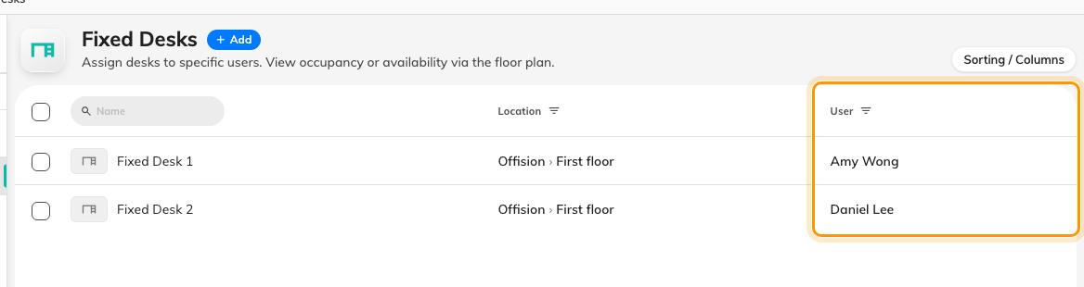
Fixed Desks. The User column is the whole point: a fixed desk names its owner instead of a policy.
The two convert in both directions from the row menu — Change to Fixed on a
bookable desk, and back again on a fixed one — so a floor that turns out to need
more shared seating is a change of type rather than a rebuild.

What booking one then looks like
Everything above is the admin side. The person taking the desk meets it in the
user app, and three screens are most of the experience:
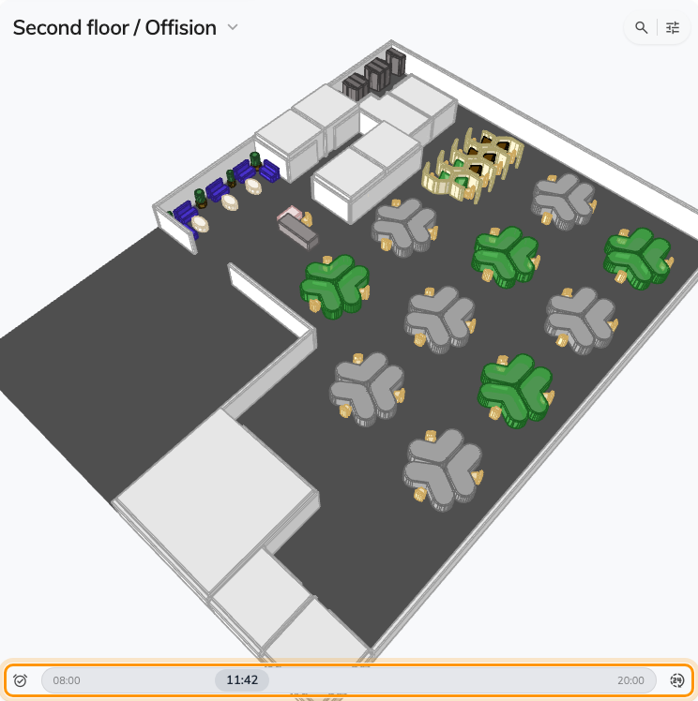
A desk is booked from the floor plan: every desk on the floor, coloured by availability for the time on the slider.
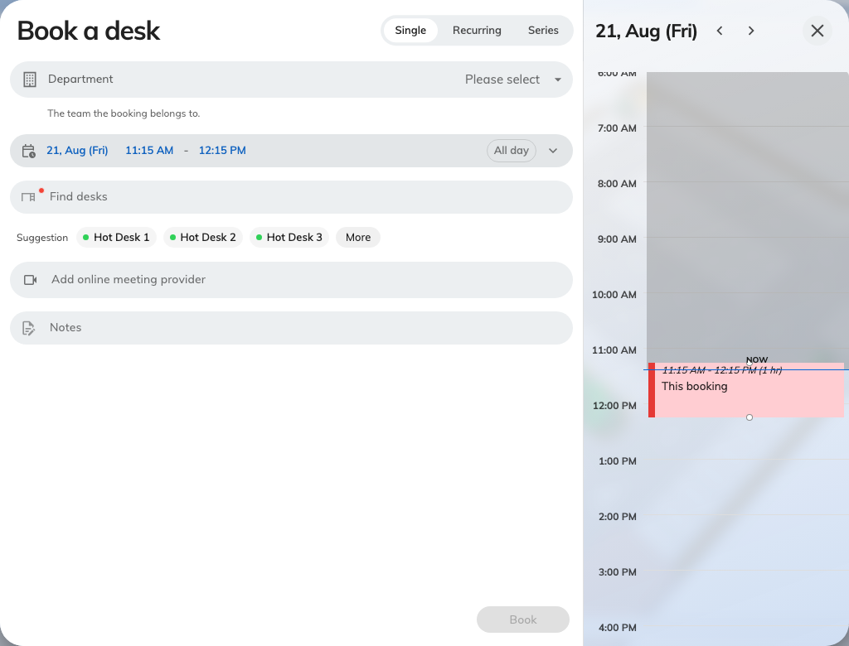
The desk booking form asks for a desk, a time and optional notes — no subject, no attendees, none of the room form's other fields.
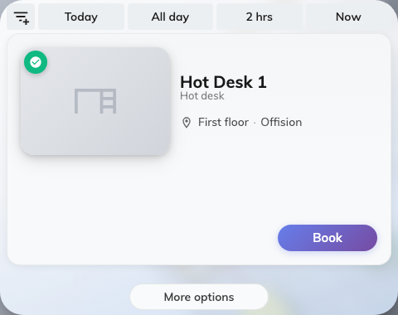
Find a desk now is the quick booking: every desk free for the asked-for length, each row with its own Book button.
The walkthroughs are in the user guide —
Book a desk and
Find a desk on the floor plan.

What this does not cover
- The rules a desk floor needs. Walk-in only, all-day bookings, the
check-in window that reclaims an empty desk — see
Set the rules a hot-desk floor needs.
- Charging desks and rooms separately. A month of hot-desking eating the
meeting-room allowance is a quota question — see
Charge desks and rooms from separate budgets.
- AM and PM desks. Half-day desks are a Booking hours time-slot
schedule, not a desk setting — see
Restrict bookings to fixed time slots.
- Scanning the sticker. What a scan of the desk's QR code lets a person do —
book, check in, extend, release — is in the
user guide.

