Tapping a staff card does nothing at the panel
The panel does not react at all to a card. Five causes, all of which look identical from the corridor because the panel stays exactly as it was.
2026-08-17 · https://offision.com/help/en/booking/a-card-tap-does-nothing/
Does the panel react at all?:
This page is for a tap the panel ignores completely — no message, no flicker, the
screen exactly as it was. A panel that answers with a refusal has recognised the
card and turned the person down, which is a different problem: start at
Checking in at the booking panel instead.
A tap that produces nothing is deliberate rather than broken. The panel drops a
card it cannot act on silently, because a room panel in a corridor that
complained about every card carried past it would be unusable.
That silence is the difficulty here: five quite different causes all look
identical from where the person is standing. Work down the list.
Solution 1 — Staff Card is off in both places (most common)
Two switches govern this and a tap needs only one of them, so both have to be off
for nothing to happen — which is exactly what a panel set up before cards were
introduced looks like.
Check Staff Card on User identify settings first, since that one covers
the whole organisation.
Where in Offision: admin app → device/check-in-method (Check-in method)
Then open the panel's configuration and its Check-in method page. If
Override the system user identification settings is on there, this panel is
ignoring the organisation's list entirely and needs its own Staff Card turned
on.
Where in Offision: admin app → device/booking-panel/configuration (Panel configurations)
A configuration is shared, so one panel behaving differently from its neighbours
usually means it is on a different configuration rather than a different setting.
Solution 2 — The number on the card is not stored against anybody (most common)
The panel reads the card, finds nobody holding that number, and stops. Nothing is
shown, because from the panel's point of view somebody walked past with a card
from another building.
Search the number under Access cards. If it is not there, the card was never
enrolled; if it is there against the wrong person, the slots were filled from a
list that had drifted. Either way the fix is on that page — see
Issue an access card to someone.
Where in Offision: admin app → directory/access-card (Access cards)
The common version of this is not a missing card but the wrong number: an
ordinary MIFARE or DESFire card is enrolled by its chip UID, which is not the
number printed on the card. Tap one card at a panel that works, see what it
accepted, and check the imported list against that. Upper and lower case do not
matter, so case is never the problem.
Solution 3 — Something is already open on the panel (common)
A tap is only acted on when the panel is showing its ordinary screen. With a
dialog open — a walk-in form somebody abandoned, a confirmation nobody answered,
a language picker — the card is ignored until the dialog goes away.
This is the one that reproduces on demand: press a button on the panel, leave the
dialog open, and tap. Nothing. Dismiss it and the same card works.
If a panel goes deaf in the middle of a busy morning and comes back on its own,
this is almost always the reason. Panels left showing an abandoned form are worth
a look during setup: shortening the confirmation timeouts, or turning off the
confirmation taps the panel does not need, keeps the ordinary screen in front.
Solution 4 — One tap gives a success and an error together (common)
Not silence, but the same root: some readers register one physical card under two
different identifiers and send both. The panel treats them as two taps, resolves
one and fails the other, and shows both results.
Handle duplicate card readers fixes it — the panel waits briefly, collects
everything one tap produced, and resolves the whole lot together so only one
result is shown. It is on the panel configuration's Check-in method page,
with Wait time (ms) underneath it.
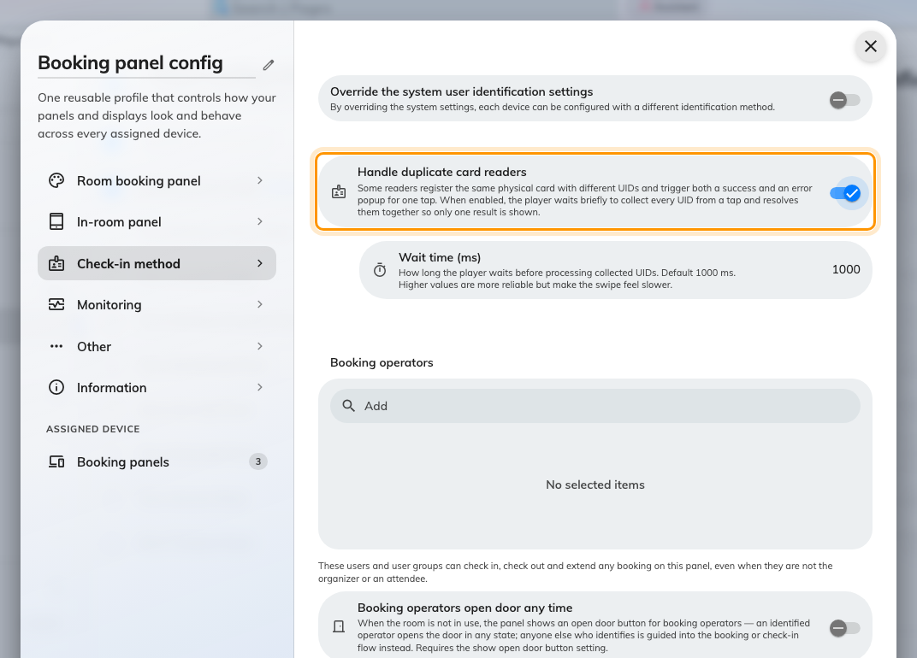
The wait that turns one reader's two identifiers back into one tap.
Leave the wait at 1000 ms unless taps still double up. Raising it is more
reliable and makes every tap feel slower, so raise it in small steps.
The panel has to be restarted afterwards. The setting is read once when the
panel starts, so a panel that has not been reloaded will behave exactly as it did
before you changed it — which reads as the setting not working.
Solution 5 — The room only takes bookings made at the panel (rare)
A resource set to be booked only from its own panel refuses card taps outright,
including on a booking that already exists.
It is rare because few estates use it, and it is worth knowing about because
nothing on the panel hints at it — the room looks like any other. Check the
resource under Booking › Rooms if the first four solutions came to
nothing and the same card works on the panel next door.
Where in Offision: admin app → booking/room (Standard Rooms)
Before you open a ticket:
Collect these four, because between them they separate every cause above:
- The card number as enrolled, and the number a working panel reads from the
same card.
- The panel's name, and whether the card works on a different panel.
- What the room was doing at the time — free, waiting for check-in, or in
use.
- Whether any other method works at that panel. A QR code that checks in
fine narrows it to the card; one that also fails points at the panel.

