Working schedule settings reference
Every setting in the working schedule editor, page by page — Basic Info, Check-in rules and Security & location — with what each one does and when to change it.
2026-09-02 · https://offision.com/help/en/attendance/working-schedule-settings-reference/
The working schedule editor is three pages of settings on the left — Basic,
Check-in rules, Security & location — plus an Info page of audit
metadata on a saved schedule. This page lists every setting in screen order;
the task articles link back here rather than repeating it.
Where in Offision: admin app → attendance/working-schedule (Working schedule)

Basic Info
Setting | What it does | When to change it
Name | Names the schedule everywhere — the list, the report filter, the app. Must be unique. | Name it for the team, not the times: times live on the working hour and may change.
Working hour | The business-hour definition this schedule reads its expected times, working days and holidays from. | Point several schedules at one working hour when teams share times; give a team its own only when its hours differ.
Worker | The people who clock in against this schedule — individual users and/or whole user groups. | Prefer groups: membership changes then maintain the schedule for you.
Supervisors | Users and/or groups who can view and export this schedule's results in the user app. They cannot edit records. | Name team leads who need the numbers without console access — see the supervisor article.
Organization unit | Scopes the schedule to one unit. Shown only where organization units are enabled. | Only in a multi-unit estate.

Check-in rules
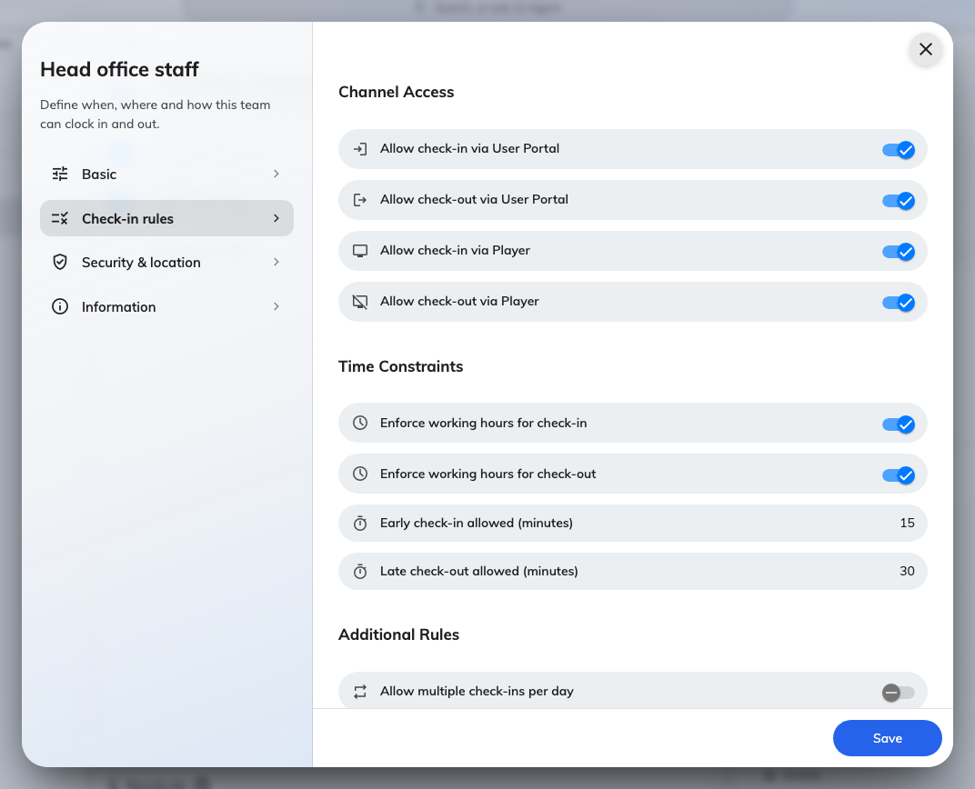
Check-in rules: the four Channel Access switches, the Time Constraints pair with their minute allowances, and the Additional Rules.

Channel Access
Setting | What it does | When to change it
Allow check-in via User Portal | The app's Sign in button works for this schedule's workers. Off, the app never offers it. | Off for teams that must punch at the door kiosk in person.
Allow check-out via User Portal | Same, for signing out. | Commonly left on even where check-in is kiosk-only, so people leaving late need not find the kiosk.
Allow check-in via Player | A kiosk (signage screen or panel) accepts sign-ins for this schedule. | On wherever a Take attendance widget is deployed.
Allow check-out via Player | Same, for signing out. | As above.

All four off means nobody on the schedule can punch at all — the editor does
not stop you.

Time Constraints
Setting | What it does | When to change it
Enforce working hours for check-in | A sign-in outside the working hour is refused with Outside of working hours. | Off for teams with genuinely flexible starts; the report still marks lateness either way.
Enforce working hours for check-out | The same, for sign-outs. | Usually paired with the one above.
Early check-in allowed (minutes) | How long before the working hour opens a sign-in is still accepted, when enforcement is on. | Give at least 15–30 minutes — people arrive early, and zero refuses them at the door.
Late check-out allowed (minutes) | How long after the working hour closes a sign-out is still accepted. | Same reasoning, for people leaving late.

The two minute fields matter only while their enforcement switch is on;
without enforcement, any time is accepted.

Additional Rules
Setting | What it does | When to change it
Allow multiple check-ins per day | Off, a second sign-in the same day is refused with Already signed in today. On, each punch is recorded. | On for split shifts or people moving between sites; off keeps one clean in/out pair per day.
Require remarks on late arrival | A late sign-in cannot be confirmed until the person types a reason; it lands on the record's Remarks. | On where lateness needs a paper trail; the report shows the lateness either way.
Require remarks on early departure | The same, for signing out before the working hour ends. | As above.

Security & location
The proof a punch must carry. The GPS, IP and selfies
article walks these; the rows
here are for completeness.
Setting | What it does | When to change it
Require IP validation in User Portal | An app punch must arrive from one of the Allowed IP ranges (IP or CIDR, with an optional description) or it is refused. | On to pin punches to the office network. An empty list refuses nothing.
Require location in User Portal | An app punch must carry a GPS position inside one of the Allowed geofences — each a named map circle with a Radius (meters) from 10 to 10,000, default 100. | On to require presence on site. One fence per legitimate work site; keep the radius generous.
Require selfie on check-in (User Portal) | The app pauses the sign-in for a photo, stored on the record. | On where who-was-holding-the-phone is the question. Selfies auto-delete per the Selfie privacy retention period.
Require selfie on check-out (User Portal) | Same, for sign-outs. | As above.
Require selfie on check-in (Kiosk) | The kiosk takes the photo instead. | On where the kiosk identification (QR, card, PIN) alone is not proof enough.
Require selfie on check-out (Kiosk) | Same, for sign-outs. | As above.

Notification Rules
Setting | What it does | When to change it
Send push notification when attendance | The person gets a push confirming each accepted punch, with its time. | Off only where the confirmations annoy more than they reassure.
Send email when attendance | The same confirmation, by email. | On where punches are disputed and people want a receipt.

What this editor does not control
The times themselves — weekdays, start and end, holidays — are on the
Working hours page, not here. The selfie retention period is on Selfie
privacy. And whether Attendance exists at all is the Enable Feature
switch on the module's overview page — a schedule saved while the module is
off does nothing until it is enabled.
Where in Offision: admin app → attendance/working-hour (Working hours)

