Set up a working schedule
Creating the schedule a team clocks in against: define the working hour, assign workers by user or by group, name supervisors, and open the channels they may punch from. About ten minutes, plus a test punch.
2026-09-02 · https://offision.com/help/en/attendance/set-up-a-working-schedule/
A working schedule is what makes clocking in possible at all: until a person
is on one, the app shows them no Sign in button and a kiosk turns them away.
This walk-through creates one schedule and puts a team on it. Done means one
of those people has clocked in and the punch shows in Attendance Records.
Before you start:
You need write access to Attendance, and Attendance must be enabled — its
overview page carries the Enable Feature button if it is not. Have the
team's user group ready in Directory; assigning a group beats picking people
one by one.

1. Define the working hour
A schedule does not carry times of its own — it points at a working hour,
which says which weekdays count and when work starts and ends, and carries the
holiday calendar. Open Working hours in the Attendance menu and add one:
tick the working days, set the daily time range, and attach holidays if your
estate keeps a holiday list.
Where in Offision: admin app → attendance/working-hour (Working hours)
One working hour can serve several schedules, so a company on uniform office
hours defines it once. Only teams whose times differ need working hours of
their own — teams that differ in people or rules but share times can share it.

2. Add the schedule
Open Working schedule and select Add. The editor opens on Basic
Info, with the rest of the pages on the left.
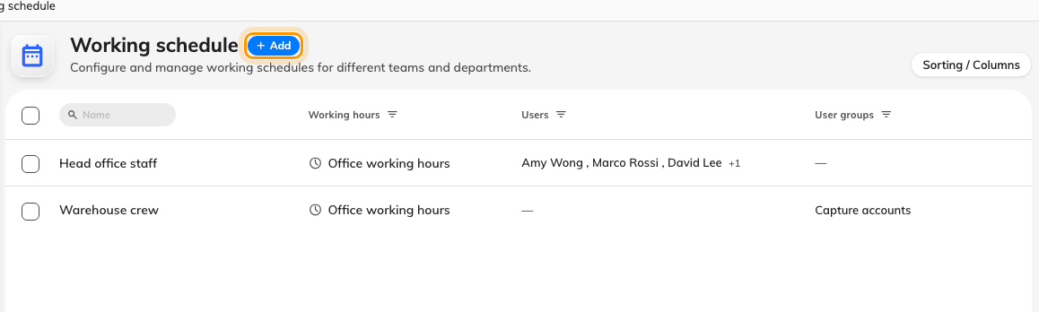
The working schedules on this tenant — each row shows its working hour and who is on it. Add opens the editor.
Where in Offision: admin app → attendance/working-schedule (Working schedule)
Name it for the team, then set:
- Working hour — pick the one from step 1. The add button beside the field
creates one inline if you skipped ahead.
- Worker — who clocks in against this schedule. Pick user groups where you
can: a person added to the group later is on the schedule automatically,
which is the difference between maintaining a schedule and maintaining a
list.
- Supervisors — optional. Anyone named here can view and export this
schedule's results in the user app, and nothing more — the field's own hint
says as much. Covered separately in
Give supervisors a team view.
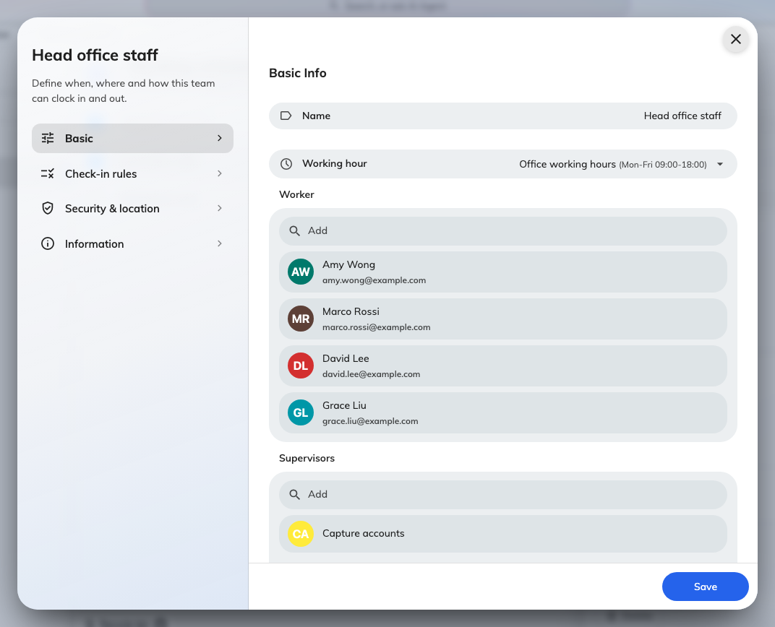
Basic Info: the name, the working hour it reads times from, and the Worker and Supervisors pickers — both take users and whole groups.
One person, one schedule in the app:
The app clocks a person in against the first of their schedules that allows
it. Someone on two schedules will not be asked to choose — so keep each person
on one schedule unless the overlap is deliberate.

3. Open the channels
Switch to Check-in rules on the left. Channel Access holds four
switches — check-in and check-out, via User Portal and via Player. A new
schedule should open at least one pair, or nobody can punch at all. The rest
of this page — timing tolerances and remark requirements — has sensible
defaults; the full list is in the
settings reference.
If punches should also prove where they came from — GPS, office network,
selfie — that is the Security & location page, and it has
a walk-through of its own.

4. Save, and make a test punch
Save closes the editor and the schedule is live. Now verify it end to end:
sign in to the user app as one of the workers — the home screen's My
attendance action and the footer's Sign in appear once the schedule
covers them. Punch in, then open Attendance Records in the console: the
record should be there with today's date, type Sign in, method Manual.
Where in Offision: admin app → attendance/records (Attendance Records)
If the button never appeared, the account is not a worker on any schedule that
allows check-in via User Portal — reopen the schedule and check the Worker
list and the Channel Access switches.

