How attendance works
A working schedule joins a working hour, the workers who clock in against it, the supervisors who read the results, and the rules a punch must pass — GPS, IP, selfie, timing. Understand this one object and the rest of the module is just its screens.
2026-09-02 · https://offision.com/help/en/attendance/how-attendance-works/
Attendance records who was at work and when, and it does it with one object:
the working schedule. A person with no working schedule cannot clock in at
all — the buttons simply never appear in their app. Everything the module does
is decided on a schedule, so the first surprise is worth stating plainly:
there is no company-wide attendance setting. Two teams under two schedules can
live under completely different rules.

What a working schedule joins together
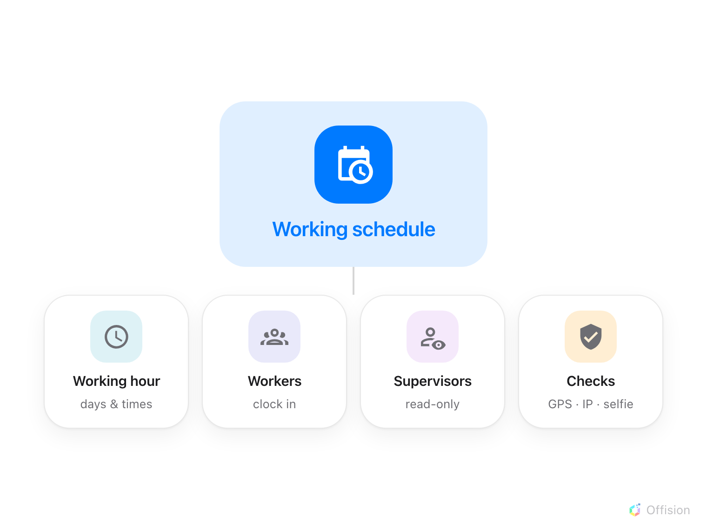
One schedule, four parts: when work happens, who clocks in, who may look, and what a punch must prove.
- A working hour says when work happens: which weekdays are working days,
what time work starts and ends, and which dates are holidays. The schedule
does not carry times of its own — it points at a working hour, so several
schedules can share one and a changed start time propagates to all of them.
- Workers are the people who clock in against it — assigned one by one, or
as whole user groups. Assigning a group is the practical choice: a new hire
added to the department group is on the schedule the same moment.
- Supervisors may read this schedule's results in their own app — a team
list, not the console — and nothing more. They cannot edit a record.
- Rules are what a punch must pass before it counts: which channels are
open, how early or late a punch may come, and what proof it must carry —
a GPS position inside a geofence, an IP address on the office network, a
selfie.

Where a punch comes from
Staff clock in from two places. The user app carries Sign in and
Sign out on the home screen; the punch is checked live and the person sees
which conditions passed or failed before confirming. A kiosk — a signage
screen or panel running the Take attendance widget — takes the punch at the
door instead, after the person identifies themselves at the screen. Each of
the four combinations (in or out, app or kiosk) is a separate switch on the
schedule, so a team can be required to sign in at the lobby kiosk but allowed
to sign out from their phone.
Attendance can also arrive without anyone pressing a button: a desk booking
check-in or an access-control door opening can record a sign-in automatically,
and such records are marked Auto rather than Manual.

What comes out the other end
Every accepted punch is an attendance record: who, when, in or out, from
which channel, and whatever proof was demanded. Records are raw material — the
attendance report reads a month of them against the working hour and
delivers a verdict per person per day: On time, Late, Early leave,
Absent, and so on. The verdicts live in the report, not on the records, so
correcting a record is enough to correct
the month.
Where in Offision: admin app → attendance/working-schedule (Working schedule)

What a working schedule does not control
It does not decide who may be at work — it only measures who was. Booking
check-in is a different mechanism with its own GPS setting, decided per
resource in Booking, and event check-in belongs to Events. And a person on no
schedule is not "absent" — they are simply invisible to this module.

