Give supervisors a team view
Naming supervisors on a working schedule gives them a Team attendance view in their own app — summaries, daily details and an Excel export for just that schedule — without console access, and without the selfies, IPs and coordinates behind the punches.
2026-09-02 · https://offision.com/help/en/attendance/give-supervisors-a-team-view/
A team lead needs to know who was in this month — but the console's report
lives behind Attendance write access, which is far more than a team lead
should hold. The Supervisors field on a working schedule is the answer: a
per-schedule role, not a permission. Requires 4.5.10.
Before you start:
The schedule must exist with workers on it. The supervisor needs an ordinary
Offision account — no console permission of any kind.

1. Name them on the schedule
Open the schedule's Basic Info page and add the person — or a group of
team leads — to Supervisors. The field's own hint states the deal: Can
view and export this schedule's attendance results in the user app. Cannot
edit records.
Where in Offision: admin app → attendance/working-schedule (Working schedule)
Being a supervisor of one schedule grants nothing on any other. Someone
supervising two teams sees both, each through its own schedule.

2. What they get
From then on their app carries Team attendance — in the footer actions,
alongside their own Sign in and records. It is the report scoped to their
schedules: a schedule picker where they supervise more than one, the summary
per person, the daily details, a per-person drill-down, and an Excel export.
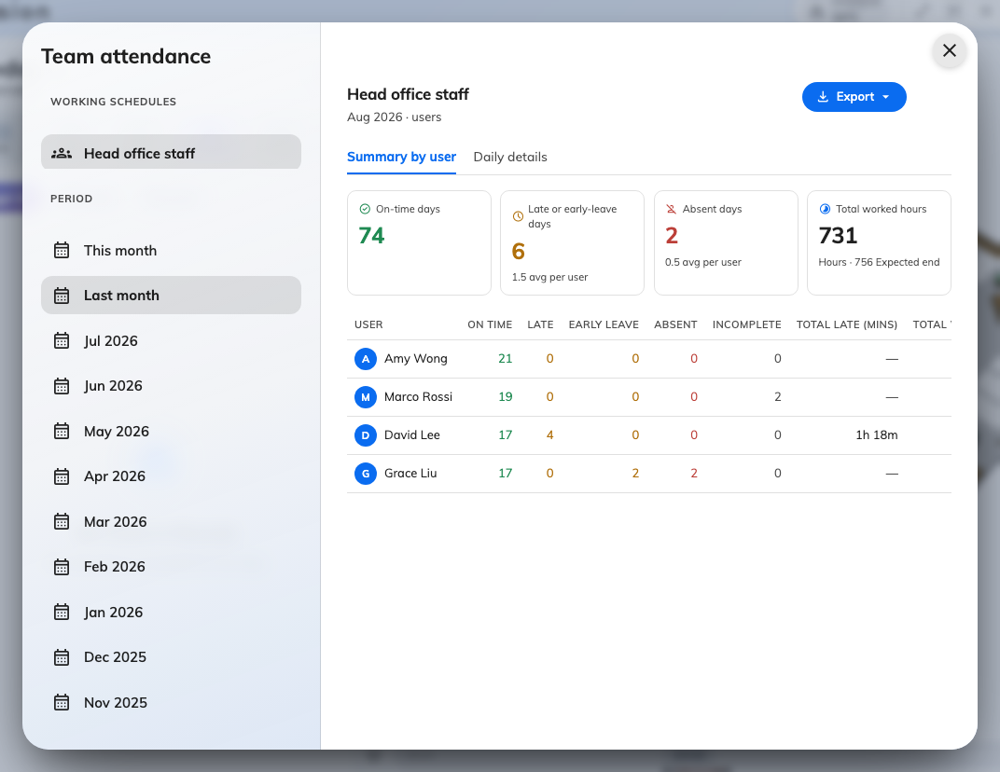
Team attendance in the supervisor's own app: their schedule's people, this month's verdicts, and an export — no console involved.

What a supervisor never sees
The view is deliberately thinner than the console's. A supervisor gets each
punch's time, type and the worker's own remarks — and not the selfie, the IP
address, the coordinate, or an administrator's manager remarks. Those stay in
the console's Attendance Records. A supervisor also cannot add, edit or
delete anything: when a record needs fixing, that is
an administrator's job.
If someone opens Team attendance and sees You do not supervise any
working schedule, they were removed from the field — or were added as a
worker instead. The two lists sit side by side in the editor and it is an
easy swap to make.

